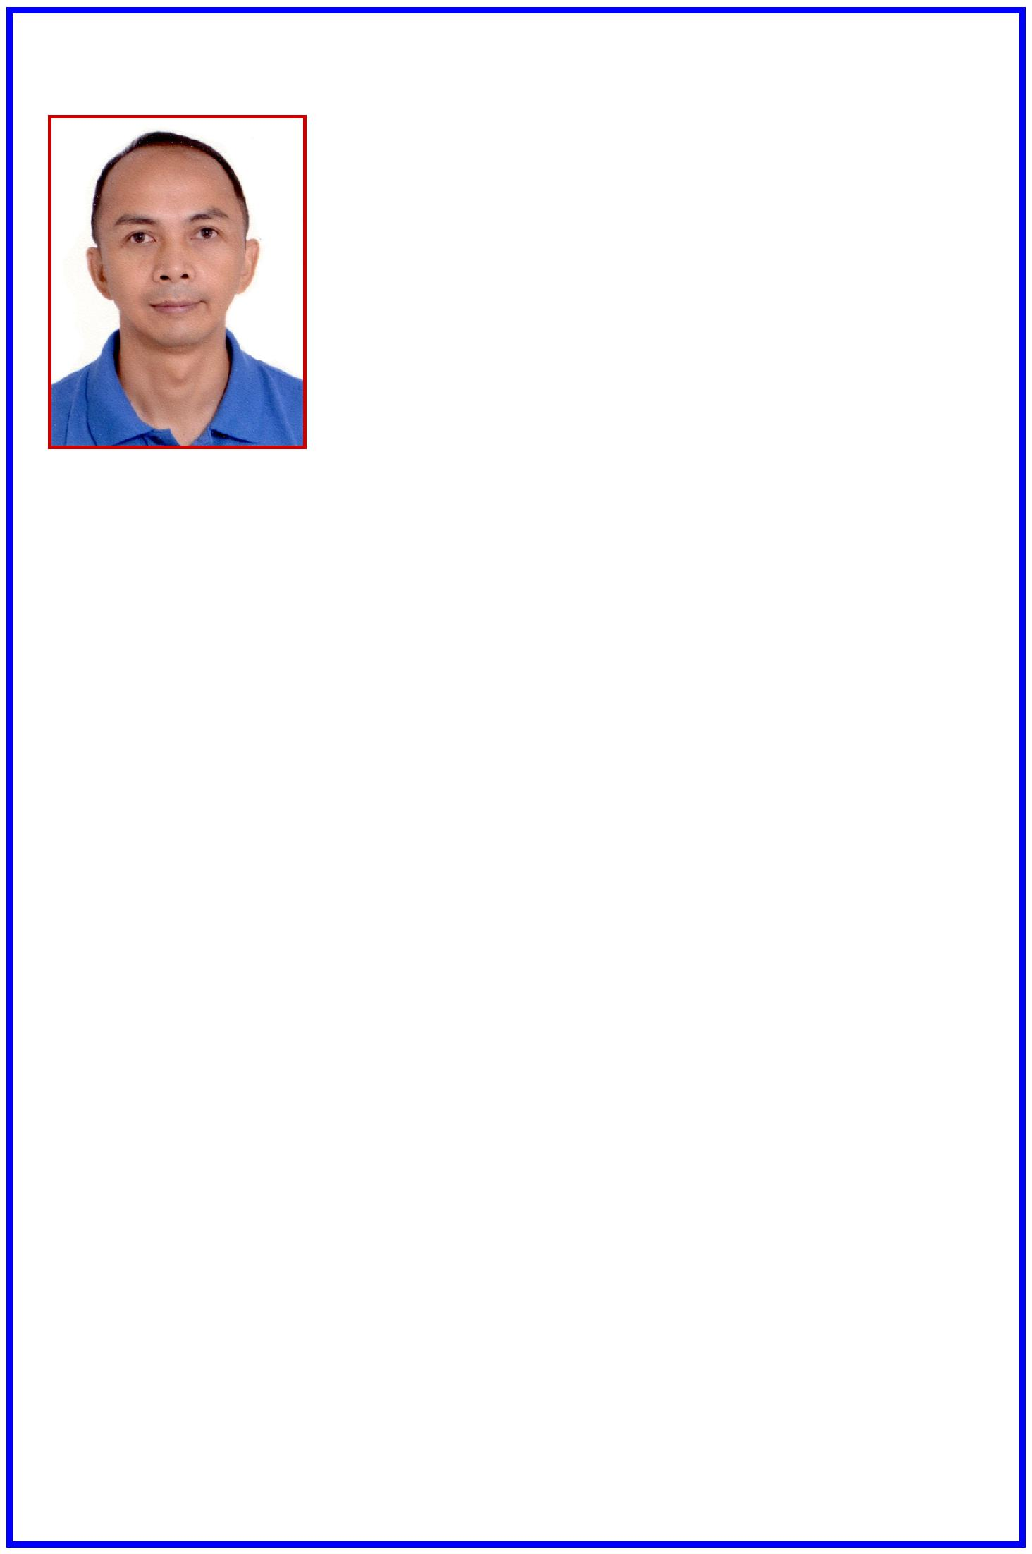
ERNESTO
Ernesto.181911@2freemail.com

MACHINE OPERATOR

Al Estiqlal St., Abu Shagara
Sharjah, United Arab Emirates

Mobile:
E-mail:

A goal-oriented person, team player with ten (10) years work experience in industrial and manufacturing field. I have developed my analytical and keen observation in machine operation which is my strength in carrying out my job duties and responsibilities.

EDUCATIONAL QUALIFICATIONS
Tertiary:
Marine Engineering - |  | Mariners’ Polytechnic Colleges Foundation
 |  | Baras, Canaman, Camarines Sur
 |  | Philippines
 |  | Year Graduated: | 1996
Secondary:
High School Graduate - |  | University of Nueva Caceres
 |  | Naga City Philippines
 |  | Year Graduate: | 1991
Elementary:
Elementary Graduate - |  | Pagatpat Elementary School
 |  | Calabanga, Camarines Sur
 |  | Philippines
 |  | Year Graduated: | 1985

ORGANIZATIONAL AFFILIATION

Member, Alpha Phi Omega (APO) International Collegiate Fraternity and Sorority

WORK EXPERIENCES
Machine Operator |  | - | EPSON Company
 |  |  | Semi-Conductor IC Assembly Department
 |  |  | Singapore
 |  |  | 1997 to 2002

•

•

•

•

Nature of Work:

die-attached machine operation

maintenance and quality assurance of safety of machine while in operation
production of integrated circuit
machine set-up

- automated recording in computer before transferring to the next level/ phase

Operational Staff - KOTECH GEOMET Company
South Korea

2006 to 2007
Nature of Work:
- bolt coating

Automatic Press Machine

Operator - BUMCHEON PRECISION ENGINEERING South Korea

2007 to 2008
Nature of Work:
- automatic press machine operator

- quality assurance of the product
- machine set-up

Robotic Machine Operator - DTR COMPANY
South Korea

2008 to 2012
Nature of Work

- machine operation on the production of anti-vibration parts of automobile
- maintenance, set-up and quality assurance of production

SKILLS:
- driving skills (can drive forklift)
• Communication skills I hereby certify that the above
• Basic computer skills information are true and correct.

ERNESTO

