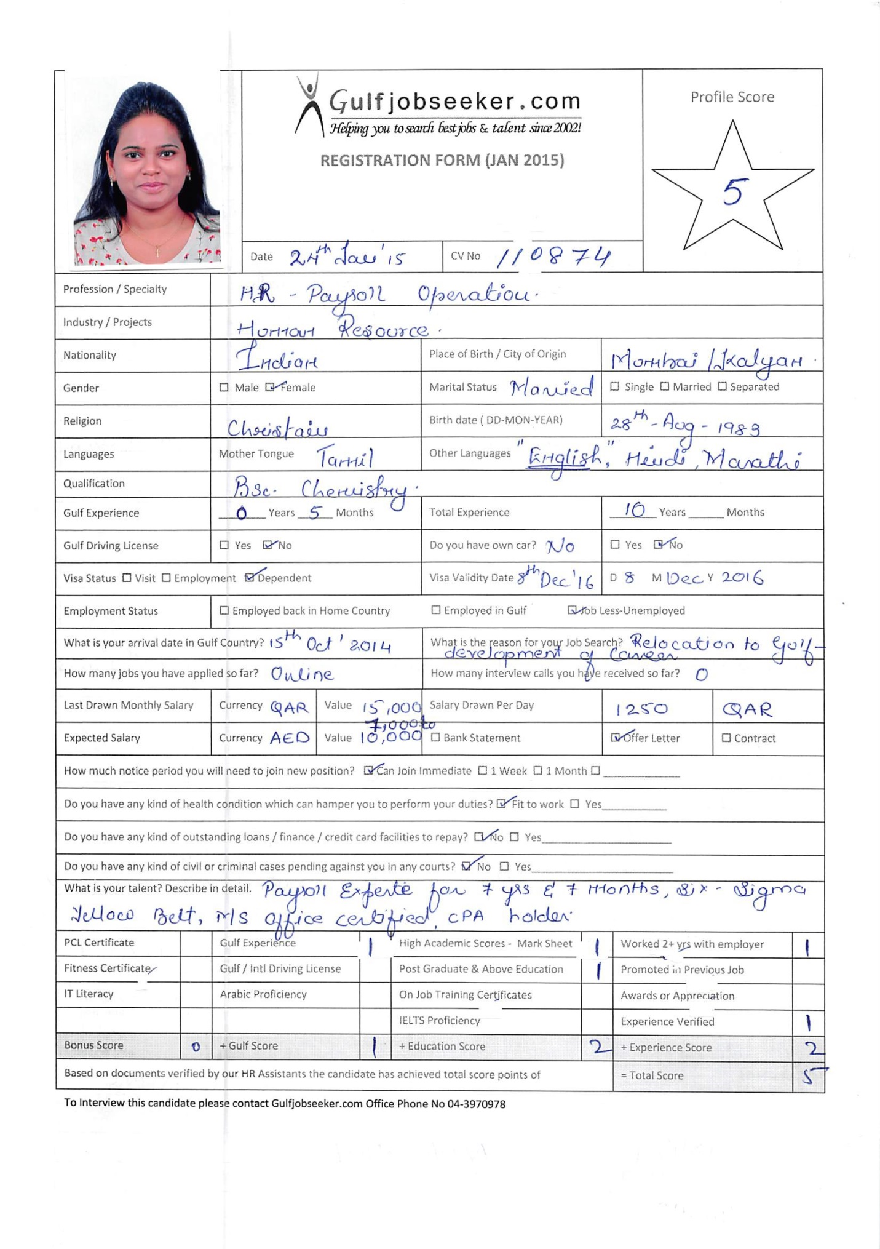

|  |  |
| --- | --- |
| Gulfjobseeker CV No: 110874  To interview this candidate call: 971505905010  Or email us back filled up Vacancy Form  <http://www.gulfjobseeker.com/Free_Job_Posting_Form.doc> |  |

**Profile Synopsis**



|  |
| --- |
|  |

Competent, Dynamic and Gulf experience Professional equipped with 10+ year’s track record of delivering top quality performance in carrying out multifaceted functions.

Demonstrated robust competency in directing wide range of duties within the domains of HR Operations Manager, HR Liaison Officer, Accounts, General Administration and Customer Service;

Acquire strong leadership in carrying out multiple tasks simultaneously, performing well under pressure, meeting client SLA, maintaining strict confidentiality and performing assigned tasks;

Possess enthusiasm, tenacity and initiative in achieving performance goals with admirable qualifications, excellent communication skills, planning, coordination, supervision, time management, decision making, problem solving and ability to adapt manage in a high pressured environment.

Seeks a challenging work profile where gained skills, experience and industry knowledge will have a valuable impact.

|  |  |
| --- | --- |
| **Strengths** | |
| * Gained 10+ years’ experience in diversified industry * Well versed in Siebel CRM & MIS reporting system * Expertise in Payroll Process & Implementation * Good knowledge of UAE Labour law * Excellent Communication & Interpersonal Skills | * Extensive background in Payroll/HR/Admin/Accounts * Proficient in PeopleSoft 9 as HRMS, QTP & Cognos * Exemplary with Oracle Software, Excel etc. * Acquired six sigma & CPA Certified in Payroll * Versatile, Enthusiastic, Performance-driven |

|  |
| --- |
| cc  **Educational Background** |

**Bachelor’s Degree in Chemistry – Mumbai University, Mumbai 2003 – 2004**

First Class (61.62%)

|  |
| --- |
| **Career Snapshot** |

**HR Liaison Officer – BPO plus Doha, Qatar Mar 2014 – Oct 2014**

*BPO plus - is a leading provider of World-class Contact Center, BPO services, Telecom System Integration and IT services in the Middle-East.*

**HR Operations Manager – Aon Hewitt Associates (IT& BPO), Mumbai Jun 2006 – Jan 2014**

*Aon-Hewitt Associates – is the leading provider of human resources, pension, retirement, investment management, health &management compensation and talent management strategies*

**Customer Care Representative - Reliance Info streams Private Limited, Navi Mumbai Jul 2004 – Jun 2006**

*Reliance Info streams Private Limited – provides services such as customer care, account receivables, account management, technical support, back office management, transaction processing, and analytics services.*

|  |
| --- |
| **Achievements** |

* Gained 10+ years’ experience with one of the leading organization in GCC and India in domains of Operation Manager, Project Management, Liaison officer and Customer Service.
* Acquired (CPA) Certified Payroll and Six Sigma yellow belt.
* Successfully completed the Leave of absence process implementation for one of the fortune 500 Companies in the United States and working as an Operations-Manager for the client: Bank of America.
* Lead the transition process for Leave of absence workgroup& successful streamlined the process within offshore group.
* Won the Platinum award for Best team for the annual year 2010 – Successfully implementing and streamlining the transition process for the client Bank of America.
* Spearheaded the team as a participant in US Payroll Week (Inter Domain competition) and won the competition for the fiscal year 2008-09 and 2009- 10
* Played significant role in executing six sigma project helped for 3FTE and 9FTE release.
* Obtained Certification from American Payroll Association-Knowledge of US Tax structure and their payroll activities.
* Possess capabilities in providing solutions to complex natured operations issues plus strong commitment to deliver excellent work performance even in difficult and pressurized environment.

|  |
| --- |
| **Core Competencies** |

**Payroll Management**

* Manage all aspects of the payroll for employees to ensure that payroll transactions were accurate and in accordance with regulations, policies and procedures.
* Oversee all payroll reports, time sheets, individual attendance and production records, and other related documentation; ensuring all data is updated within organizational Human Resources Information Systems (HRIS) in a timely manner.
* Administer regular preparation of relevant management reports, including weekly, monthly, quarterly and year-end reports (gross payroll, hours worked, vacation accrual, tax deductions, benefit deductions, etc.)
* Process and team deliverables activities viz, MOM, Error report & Analysis, task management, Volume tracker, key talent retention, team utilization report, FTE analysis etc.
* Partner with HR and benefits in aligning and implementing a more sophisticated payroll and benefits system.
* Directed a team in responding to inquiries related to payroll and providing guidance on the prevailing laws governing payroll, employee benefits, garnishments, reimbursement policies and other statutory pay and related entitlements.
* Audit W-4s, payroll balance sheets, YTD (Year to Date) earnings, etc.
* Overseeing payments of every employee in a company and make sure that the amount and details are all accurate before releasing them to transactions.
* Ensure that company policies and procedures were properly followed as well as maintaining accurate payroll internal controls and SOP compliance documentation.
* Focus on process improvements to ensure efficiency through automating functions and creating interfaces**.**
* Submit management reports, liaise with HR staff regarding new appointments, terminations and other relevant matters
* Develop payroll procedures by controlling & supervising the preparation, documentation, disbursement of payroll-related payments.

**HR Management**

* Participate human resources programs by providing human resources services, including talent acquisition, staffing, employment processing, compensation, health & welfare benefits, training & development, records management, safety and health, succession planning, employee relations & retention labor relations; completing personnel transactions.
* Managed and develop vendor and community relationships, participate in recruitment outreach to strengthen the candidate pipeline and build employment brand.
* Coordinated with various Departments and provided needed assistance in the implementation and interpretation of various policies, current employment and labor laws.
* Managed learning & development; conducted training, training needs analysis in coordination with various Departmental Heads as well as training plans for the organization. Handled induction of newly hired employees.
* Handled employee relations; employee grievance, disciplinary actions as needed. Promoted corporate culture of equality despite diversity at all times.
* Consult with team manager regarding employee turnover, absenteeism, changes in work settings, employee motivation, recognition and other employee-related aspects.
* Help identify training and development needs within organization through employee performance analysis, appraisal schemes and regular consultation with business managers and human resources department.
* Keep records of benefits plans participation such as personnel transactions such as hiring, promotions, transfers, performance reviews, terminations, and employee statistics.

|  |
| --- |
| **Proven Job Role** |

**HR Liaison Officer – BPO plus Doha, Qatar Mar 2014 – Oct 2014**

* Assist and participate in the implementation of ongoing corporate department and unit performance reporting/improvement initiatives (regular reports/data provided to hospital admin, Quality, hospital specific action plans developed in response to complaints, suggestions, operations requirements etc)
* Participates in the interviewing process function and assists in coordinating the scheduling of interviews with department/section heads.
* Coordinates with all departments to assist in identifying their staffing needs.
* Answers employee related benefits question and performs payroll/benefit-related reconciliations to the employee benefits system
* Assists with all benefit processing and the Annual Open Enrollment process and data collection
* Consult with Team leads/ Hospital Heads regarding employee turnover, absenteeism, changes in work settings, employee motivation, recognition and other employee-related aspects.
* Assists with the new hire process and benefits enrollment fotr all hospital employees

**HR Operations Manager – Aon Hewitt Associates (IT& BPO),Mumbai Jun 2006 – Jan 2014**

* Directed the whole gamut related to Minutes of Meeting reports, Error report & analysis, Work Load Management reports from Cognos, Volume Tracker from MIS, Queue Management from MIS, Shift plan, FTE Analysis from MIS, Maintain SLA, Maintain Internal Accuracy, Maintain Overall Team Utilization, Transitions / Implementation new process, Handle Escalations – Onshore, Share monthly score card with offshore management, Share monthly score card with onshore, Maintain Attrition, Key Talent Retention, EWS update.
* Co-ordinate with HR and have the queries solved of employees related to company policy, and other issues.
* Process training to the team on new process off shored and new updates and share yearly appraisal rating.
* Ensure process is going smooth by producing timely and accurate paychecks.

**Payroll Process implementation - Aon Hewitt Associates**

*Scope of Activities included in Process Implementation*

* Direct meeting from Mumbai side, Recruiting analytical skilled team for this new process, Process Solution Creation and Validation, Documentation of Systematic Operating Procedure (SOP),
* Liaise between the client, Charlotte counterpart and IT department for the Oracle set up for payroll process and pay-slip creation, Internal Acceptance testing, User Acceptance Testing, Full Time Equivalent Calculation, Imparting process training to the team, Presentation to client: Bank of America the end product of Payroll process in Aon Hewitt and Clearing backlogs which was piled up due to payroll migration from Fidelity to Aon Hewitt within the SLA.

**Payroll Process Expertise in Aon Hewitt Associates**

**1) Leave of absence (LOA)**

* Conducted and update Military taxation row effective 31st from the Leave initiation day. Calculating the Military differential payment based on the leave earnings statement.
* Oversee Paid Family Leave (PFL) deductions in parental leave and update PeopleSoft accordingly.
* Calculate and Reconcile the ABBR amount for commission employee s on leave and update People soft accordingly.
* Research and calculate the retro pay and following Reclassification, underpayment and overpayment process.
* Administered LOA Reports, Queries and Quality Audit and providing feedback.

**2) Business System Integration (BSI)**

Creating Pay sheets and time load/ Confirming Pay line to generate the paychecks

**3) Quality Audit (QA)**

* Conducted Gross Audit & check if any difference with more than $500, then employee’s paycheck will be rectified.
* Administered Net pay query as to check whether the Net pay is correctly paid to the Employee
* Address changes query on daily basis so that his deductions is calculated as per the State/Local tax applicable.
* Oversee Exempt & Nonexempt query for those employees who are non-exempt but are given exempt code & vice versa.
* Performed some of the miscellaneous queries such as Regular Hrs. Verify query, Standard Hrs. Audit, Employees paid with No. Hours i.e. to check the Regular Hours, off cycles& Employees not processed in current payroll etc.

**4) Work force Management (WFA)-** *Lead the transition process for Personal action details EDM workgroup and successful streamlined the process within the offshore group.*

* Facilitate Employee’s Job data and Personal Information such as Name Change, Address Change, SSN No, Contact Details, Compensation, FLSA, and Job code, Department ID, etc. in PeopleSoft.
* Managed Leave accruals and paying the vacation pay out, updating the Direct Deposit and Tax information.
* Worked on Time sheet Entry Maintenance i.e. employees Timesheets received & updating information such as Paid Time offs, Holidays, Vacation Balances, Calculating their Regular hours & Overtime Hours as per US Laws (Fair Labor Standards Act), making the appropriate entries in Pay line according to the Pay calendars of different companies.
* Process Special Pay forms received from the Employees such as Awards, Bonus, Referral bonus, Sign on Bonus, on call Pay etc. and make their entries in the pay line according to the payroll calendars of different companies.
* Prepared Off-cycles i.e. to prepare online check request form in respect of any Special Pay or Timesheet pay.

**Customer Care Representative - Reliance Info streams Private Limited, Navi Mumbai Jul 2004 – Jun 2006**

* Attended calls for Reliance Postpaid Cell phone users.
* Performed clearing Bill and Network Related issues.
* Managed complains and forwarded to the concerned department.
* Conducted and facilitated Training for team members on the latest up gradations.

|  |
| --- |
| **Focal Points/Projects** |

* Designed and conducted Excel training to HPCC staff.
* Construct character enhancement and inbound call conduct workshop for HPCC staff.
* Executed LEAN project - APT reduction in Operational process 10 FTE released in the process.
* Rendered support to Service Manager in resolving various technical, quality and managerial issues

**Quality Operation**

* Facilitated in HPCC Staff performance evaluation sheet and monitoring Quality Audit for the team.
* Customize Six Sigma methodologies and contributing to business process improvement initiatives at team level.
* Quality Ambassador for Mumbai Team: Imparting training on Quality tools, bringing Quality awareness amongst the colleague, organized Quality Blitz for the increase the internal Quality ideas target.
* Executed LEAN project - APT reduction in Operational process (Leave of absence process-Client: Bank of America).
* Created an automated Process calculator with intend to release 2 FTE in the process.

|  |
| --- |
| **Accolades & Recognition** |

* Won best Quality Idea (Accuracy enhancement from 95% to 100%) and presented to the prospective client.
* Won Best Operations Manager of the Quarter Oct-Dec’13.
* Received copious Appreciation Certificates and Mails from Onshore /Client for good work, Informal Awards.
* Submitted 20 Quality Quests and 2 Quest Plus for Process. Recognized as a GOLD CLUB MEMBER for fiscal year 2008-09 and 2009-10
* Rewarded as a Star of the Month for best performance in Hewitt in March 2008/2009.
* Rewarded as a Champion of the Month, May 2010 & Dec 2011 for better performance and handling processes and successfully completed migration and implementation of New Client.
* Lead the team as a participant in US Payroll Week (Inter Domain competition) and won the competition for the fiscal year 2008-09 and 2009-10.
* Lead the team as a participant in Global Quality Week (Inter Domain competition) and won the competition for the fiscal year 2008-09 and 2009-10.
* Won the Platinum award for Best team for the annual year 2010 – Successfully implemented and streamline the transition process for the client Bank of America.

|  |
| --- |
| **Affiliation** |

* Active member of Euphoria (Fun squad for Mumbai center),
* Participation in Annual /Occasional events of Aon Hewitt

|  |
| --- |
| **IT/Technical Skills** |

|  |
| --- |
|  |

* Proficient in Siebel CRM(Client Relationship management), PeopleSoft 9 as HRMS, MIS for team performance reports, Cognos for Work Load Management, QTP (Quick tool processing)
* Proficient in MS Office application (Word, Excel, PowerPoint, Email application & Internet)

|  |
| --- |
| **Personal Details** |

Nationality : Indian

Date of Birth : 28th Aug 1983

Marital Status : Married

Visa Status : Husband Visa

Languages : English, Hindi, Marathi, Tamil

Reference : Available upon request