AFNAN AHMAD
R
E
S
U
ME
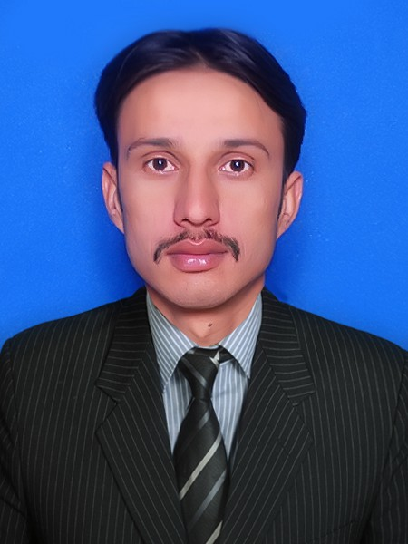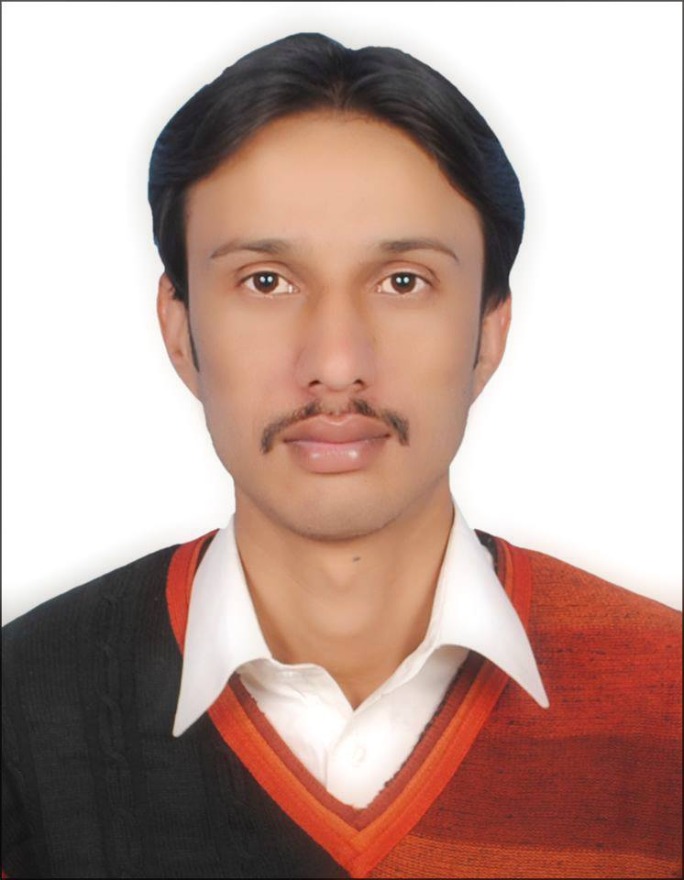
Address: House #1603/9 Mohalah Masjid Loharran Tehsil Fateh Jang, Pakistan.
Nationality: Pakistan
Passport Number: PK1163711
Mobile #: +971-562405311, +92-306-5454414
E-mail: afnan023@gmail.com
DOB: 01/03/1989

OBJECTIVE:

Ambitious, Hardworking Organized Skill Personal Willing To Start Career In Reputed And Dynamic Organization Where I Can Be A Key Team Member, Making An Important Contribution In The Growth Of The Organization By Utilizing All Of My Communication Skills.
PROFESSIONAL QUALIFICATION:
Diploma in Accommodation Operation & Services,
Sep 01, 2013 to Feb 28, 2014 Level-II
“Hospitality Management Training Program” (HMTP), Human Development Resource Center, Hashoo Foundation Rawalpindi.
Major Theoretical Sessions Are: Introduction to Hospitality, Fundamentals of Hotel, Housekeeping & Front Office Operations, Fire Safety, HACCP, Design & Décor, Reservations. Banquets Life Skills, Interpersonal & Communications Skills, and IT Skills.
WORKING EXPERIENCE:
Trainee Islamabad Marriott Hotel “October, 2013 to February, 2014”
Major Responsibilities:
Asst. Reservations:
Makes Room Reservations, Respond to E-mails, Phone Calls and Fax, Negotiate the rates on Telephone Calls with Guest, Maintains the Morning Briefing Reports, Update the Groups Reservations.
Front Office:
Assist the Guest during their Stay, maintain the inter-Office Correspondence, Supervise the Concierge Operations, Cooperation with Guest relation Staff regarding Guest’s Stay & VIPs Arrival, etc.
Asst. Housekeeping Supervisor:
Supervises the Bedroom Making, Public Areas Maintenance and Cleaning, Working Experiences on Opera: “Making of Daily Task Sheets, Room Discrepancies, Weekly Reports, Daily Arrivals & Departures, Maintain Log Book”, Conduct Morning Briefing Sessions for Staff.

Receptionist “June, 2014 to February, 2015” Hotal One
▀ Performs check-ins & check-out ▀ Handling the cash at counter ▀ Get customer feed back

Customer Relations Officers “December, 2012 to August, 2013” TelenorPakistan
Manages sales operations
Handing and taking stock and cash.

Field Supervisor (BISP) “September, 2010 to March, 2011”
National Rural Support Proggrame of Pakistan

PROFESSIONAL COMPETENCES:
IT Skills:
Microsoft Office (MS Word, MS PowerPoint, MS Excel)
Internet Browsing & Searching, Software Installations
Opera Property Management Software:
Reservations Operations
Rooms Management (Housekeeping)
Professional Skills:
Good Interpersonal & Communication Skills
Organizing & Negotiating Skills
Working under pressure and to meet deadlines
Good Team Working Skills
Ability to learn and adapt

TRAINING & WORKSHOPS:
Life Skills Training September 12, 2013
HDRC (Hashoo Foundation Rawalpindi)
Trainer: Ms. Farmuda Baig (Job Placement Officer)

Fire Safety Workshop September 05, 2013
HDRC Hashoo Foundation Rawalpindi
Trainer: Mr. Waqar (Safety Officer Marriot Hotel & Resorts Islamabad)

Hygiene & HACCP Training September 04-06, 2013
HDRC Hashoo Foundation Rawalpindi
Trainer: Mr. Noman Abdullah
(Quality Assurance Officer Marriot Hotel & Resort Islamabad)
Mr. Faisal Siddque (Chief Steward Marriot Hotel & Resort Islamabad)

ACADEMIC QUALIFICATION:
B.A 2010 Punjab University Lahore
Intermediate 2008 Rawalpindi Board

LANGUAGE SKILLS:
English: Speak, Read, Write, Listen
Urdu: Speak, Read, Write, Listen

REFERENCES:
Reference should be furnished on demands.

