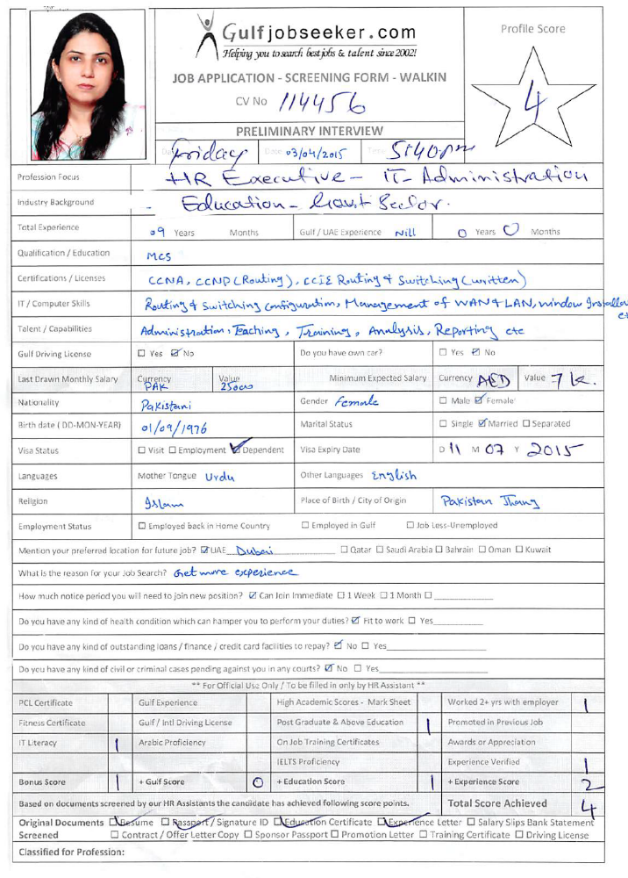
Gulfjobseeker CV No: 114456
To interview this candidate call 971505797566
Or email us back filled up Vacancy Form
http://www.gulfjobseeker.com/Free_Job_Posting_Form.doc




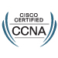

Career Objective
To become an active Network / Systems Engineer of your organization as an IT professional where creativity and management can be utilized to produce a professional and profit minded work force while allowing the growth within an IT organization and to give the extra repute and profit with my full devotion to the work.

International Industry Certifications
- Cisco Certified Network Associate (CCNA) 640-802
- CCNP ROUTE 642-902
- Juniper Networks Certified Internet Specialist (JNCIS-ES) JNO-330
- Juniper Networks Certified Internet Specialist (JNCIS-ER) JNO-350
- Juniper Networks Certified Internet Associate (JNCIA-EX) JNO-400

Work as a IT Network Administrator in Asia Academy (Dubai) June,2012 to Dec,2012
Professional Experience
College Of Physician & Surgeons of Pakistan Islamabad |  | Feb,2011 to June,2012
Role | IT Administration Network Officer
Job Summary | Audio/Video conference monitoring  Audio/Video polycom device configuration and maintenance  Endian firewall Appliance monitoring  Monitor Router and Switch  2800 series router IOS backup, update IOS and password recovery  Management of Cisco ASA 5100 series adaptive security appliance  Management of LAN & WAN  Linux squid proxy server for user management  Contents filtering on proxy server  Active directory window 2003  Provide technical support for all LAN users  Window installation , maintenance and administration of window xp  User rights review (privileges, access level)  Apply Security parameter of LAN
The First Micro Finance Bank Ltd |  | April,2008 to Feb,2011
Role | IT Administrator Network
Job Summary | TSM(Tivoli Storage Management) installation on server & client side ,implementation & backup management  Monitor routers & switch  Video Audio conference configuring and monitoring  DR(DISASTER RECOVERY) backup & configuration  User Review ( user rights such as administrator or read only)  Management of SAN storage ( generate volume & cluster , Assign space according to requirement )  HA Configuration , create role & access privileges  Monitor SPAM Firewall & juniper firewall services  Management of Barracuda Spam firewall (Administration, installation, management, backups)  CISCO ROUTER 1800,2800,2600,7200  Generate System Log file  Apply contents filters on web proxy server  Management of LAN/WAN  Implement system security parameters of LAN  Data Collection  Data Restoration  Data Backup Management of nationwide branches  Verification of Data Backups  Performs technology needs analysis.  Data Backup Management of nationwide branches  Data Consolidation  ECIB data migration & uploading  ECIB Reporting  Report Generation and verify through database queries.  Rolls out hardware and software to ensure optimal deployment of resources.  Responsibilities may require evening and weekend work in response to the needs of the system being supported.  Other duties as assigned.
The First Microfinance Bank Ltd, Rawalpindi Branch |  |  | 18 September,2007
Role | Working as a MFO, Co-coordinator FBT & Research Analyst
Job Summary | The First Microfinance Bank Ltd  - Public dealing  - provide information to prospective customers on all the bunk products  - Brief clients on detailed procedure for obtaining loans.  - maintain on going contact with client and facilitate clients in opening deposit account with the bank  - Loan appraisal  - arrange and conduct group meeting of borrowers  - conduct verification check from the neighbors about the client  - undertake the stock valuations of the enterprise of the client where ever applicable and visit the business enterprise of the client  - write the evolution report on the client  - loan disbursement and recoveries  - complete all loan documents and other formulation before the disbursement of loan  - prepare all loan vouchers (disbursement and recoveries)and post them in relevant software  - Enter and manage client information in to loan data base.  - visit clients to recover due installments  - Follow up delinquent loan client regularly and ensure recovery of stuck up loan. Also prepare follow up reports, as required.  - loan reporting :  - extract relevant reports as requires under the policies relating to review of report for manager review  - prepare NPL report on weekly basis for discussion in the branch committee meeting  - Prepare and extract any other report as required by the Bank.  - First Bachat Committee (FBC)  - Achieving the vision & mission of Bank.  - Increasing its client’s base.  - Contributing to poverty alleviations & development of overall economy  - Mobilizing the local market saving.  - Provide insurance services  - Generate System & Management Reports
Govt.Girls College for Women, Jhang. |  | 4 year
Role | Project Manager/ IT Administrator & Lecturer
Job Summary | Worked as IT Project Manager, The prime job responsibilities to maintain all over enterprise network including the administration of network devices such as servers, systems, ensure security features switches. Throughout as well as consulting on general measures. Coordinates the development, implementation, and administration of high-level policies, practices, standards and programs. Coordinates the assessment of computer systems security risks, investigates and develops incident plans by undertaking risk analysis.
The City School |  | 1 Year
IT Administrator & lectureship ‘Tier5 to OLevel
Tools & Technologies | Laptops, Servers, Systems Hardware and Network Support.
Role | IT Administration
Job Summary | Involved in providing support such like (Laptops, Server Machines, Desktops etc) Network business. Part of the technical support team responsible for Support of LAN users in all aspects of desktop/network users, Maintaining, Installation/Uninstallation, Configuration, Fault Diagnosing. Installation & administration of Windows XP based network using all renowned Networking products & and trouble shooting of hardware.

Academic Qualifications
Degree | Discipline | University / Board
MCS | Computer Science | Mohiuddin Islamic University
Post Graduate Diploma | Computer Science | Skill development Council
Bachelors in Arts | Arts | University of Punjab
HSC | Arts | Faisalabad Board
SSC | Arts | Faisalabad Board

Technical Skills
- Installation and configuration and trouble shooting of Cisco Router 2500, 2600, 2800, 3800 series.
- Extensive working knowledge and experience of multi-protocol environment like RIP, OSPF, EIGRP, TCP/IP and UDP Routed and Routing Protocols.
- Installation, Configuration and Management of DSL /ADSL Routers.
- Telecommunication hardware (Routers/Switches configurations, Access networking, IP,
Ethernet and Serial interfaces) installation, management and networking.
- Cisco Catalyst Switches 1900, 2950, 2960 and Layer 3 Switches 3550, 3560, 3750.
- Administration and configuration of Ms Windows 2003 Server based local and remote area network connectivity with dedicated Leased Line and Dial-up connections.
- Confident using Active Directory to set up users, groups, policies, computers, printers related objects in a domain local and remotely network.
- Designing & implement system security parameters of LAN. Have good working experience of SCSI/IDE hard disks, Tape/DAT Backup drives in multi environment for data backup and security. Can efficiently provide technical support in the management of LAN/WAN for Microsoft and Linux/Unix along with the professional teaching and documentation.

Personal Information:-
- Nationality : Pakistani
- Visa status : Residence

