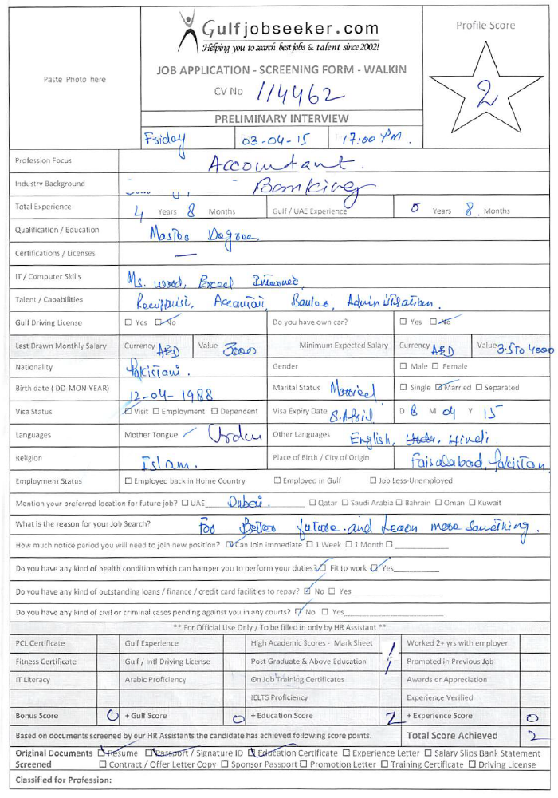

Gulfjobseeker CV No: 114462
To interview this candidate call 971505797566
Or email us back filled up Vacancy Form
http://www.gulfjobseeker.com/Free_Job_Posting_Form.doc

CAREER OBJECTIVE

Seeking a challenging career in the suitable field, where my conceptual skills could be utilized to best of my abilities to contribute to the organization and proving myself as an asset for the organization.

WORKING EXPERIENCE

Organization. SINO LINKS BUSNIESS CENTRE (REAL ESTATE)
Designation. Accountant
Tenure. 06-july-2013 to January 2014.

Key Skills

- Thorough knowledge of the internet, MS Office, database management and desktop publishing.
- Skilled in drafting emails, letters, memos and official activities.
- Good knowledge of clerical tasks.
- Good Communication skills and telephone etiquettes.
- Proficient using office equipments such as fax and photocopy machines, scanners and telephones.
- Comfortable to work with staff, supervisors and managers.
Managerial & Operational

- Coordinate with Department Heads in recruiting activities
- Informs employees on benefits, policies, etc.
- Special attention for First month Salary of New joiners for NIL Salary deduction.

Bank Alfalah

- 2 Year Experience in Bank Alfalah as a Clearing Officer (Main Branch) FSD Pak.
Job Description/ Role & Responsibilities.

- Outward clearing: Receive and verify outward cheques from branches and process them for clearing.
- Inward clearing: Attend clearing house sessions to collect inward cheques and thereafter post and distribute them to branches.
- On a daily basis balance Head Office clearing accounts.
- Process funds transfers (both internal and internal bank) as instructed by your supervisor.
- Post salaries for all ABC Capital Bank staff as per Finance Department’s advises.
- Reconcile cheques both inward and outward on head office clearing account and DTB statement.
- Perform any other work as assigned by management from time to time.

1 Year Experience in Bank Alfalah as an Admin officer (Main branch) (FSD Pak).

Job Description/ Role & Responsibilities

- Assist with preparation of the budget.
- Implement financial policies and procedures.
- Reconcile the general ledger.
- Prepare and reconcile general bank statements.
- Establish and maintain supplier accounts.
- Ensure data is entered into the system.
- Ensure transactions are properly recorded and entered into the computerized Accounting system.
- Prepare income statements.
- Prepare balance sheets.
- Assist with the annual audit.
- Maintain financial files and records.
- Administer employment agreements.
- Verify and report on benefits payments.
- Maintain the leave management system.
- Review remittances.
- Supervise completion of the payroll
- Review payroll reports.

1 Year Experience in Bank Alfalah as Personal Assistant Of branch & Regional Manager (Main branch) FSD Pak.

- Manage incoming and outgoing telephone, fax, and e-mail traffic
- Manage all incoming and outgoing correspondence, i.e., sort and read mail, draft responses, maintain network database, receive and send overnight packages;
- Manage incoming and outgoing telephone, fax, and e-mail traffic.
03 Month Internship at ASKRI BANK FSD.
ACADEMIC QUALIFICATION

- M.A | Punjab University Lahore | 541/1100
- B.Com | Punjab University Lahore | 749 / 1500
- F.A | Board Of Intermediate  FSD | 590 / 1100
- Matriculation  (Science) | Board of Intermediate and Secondary Education FSD. | 450 / 850
PERSONAL DETAIL
Date of Birth : 12-04-1988
Marital Status : Married
Religion : Islam
Nationality : Pakistani
Language : English, Urdu, Punjabi

COMPUTER SKILLS
- MS Office (Suit) {MS Excel, Word, Power point etc.}
- Internet Surfing.

