Curriculum vitae
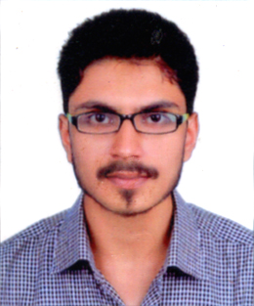
MANEESH
MANEESH.182098@2freemail.com

:: CAREER OBJECTIVE:

To enhance my knowledge and capabilities by working in dynamic organization that prides it self in giving substantial responsibility to new talend.

:: Experience Details:

- 2 Years, Experience as Accountant, Data Entry, Sales and Purchase Department KVT HardwaresShop at Kerala, India.
10Months Experience as Data Entry Department InAptara M N C At Delhi, India.
:: OTHER QUALIFICATIONS:

- One Year Diploma In Graphic Design In Don Bosco Technical Institute At Delhi.
- One Year Diploma In Web Design In Arena Animation Institute At Kerala, India.
Tally Completed InAptech Institute At Kerala, India.

::EDUCATIONAL QUALIFICATION:

10th Completed InKerala Board.

12thCompleted In Kerala Board.
Bcom Completd In MKDU.

:: PERSONAL PROFILE :

Sex : Male
Father’s Name : Kunjumon K
Nationality : Indian
Religion : Christian
Marital Status : Married
Languages Known : Malayalam, English and Hindi

:: DECLARATION

I here by declare that the above mentioned information is correct to best of my knowledge and belief. I bear the responsibility for the correctness of the above mentioned particulars.

Place : Dubai
Date : MANEESH

