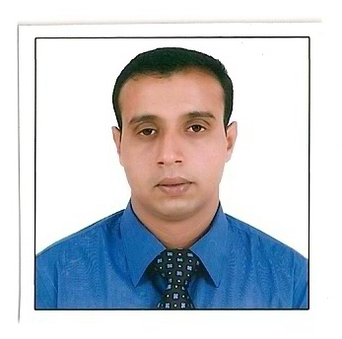  Tabrez  Tabrez.183001@2freemail.com | Career Objective :  - To seek a job in an organization that will help me to enhance my skills and to work for the prosperity and benefit for the organization.  Educational Qualification :  - Graduation ( ART’S ) Agra University, India (2004)  - Senior Secondary Education, Aligarh Muslim University, India(2001)  - High School, Aligarh Muslim University,india(1999)  COMPUTER AWARENESS  MS Office, Internet, Operating system.  experience:  - Working with Leading Company as merchandiser since 27th Jul 2011  Till date in UAE.  NOW RESPONSIBLITES ARE  - Working On the behalf of western digital.  - To serve a customer of the electronic stores  - Provide services of our product to the client as well as the customer  - Manage a stock in store and give updates to our company.  - Handling sales, display and stock.  Worked with Syed-real estate as sales executive since 1^{st Dec} 2009  to 15^{th Apr} 2011.  Responsibilities  - Provide service to company as well as Clint.  - Generate business & achieve targets.  - Maintain relations between company and Clint  - Handling properties details of the company.  References:  Shall be provided on request.

Personal Data :  Gender Male  Date of Birth : 08/07/1982  Marital Status : Unmarried  Nationality : Indian  Hobbies  Surfing net,playing snooker,  Interacting people.  Languages Known :  - English  - Urdu  - Hindi | - Worked with Barclays bank as a Sales Relationship Officer  (S.R.O ) Since 15thoctober 2007 to 5th November 2009 in INDIA.  - Worked with ICICI Bank as a Sales Officer (S.O) since 25th Aug 2005 to 10th October 2007 in INDIA.  Duties & responsibilities  - Selling bank’s current a/c & saving a/c (CASA) to salaried as well as self-employed customers.  - Responsible to explore and generate the business by identifying good companies.  - To solve all the issues regarding the approvals and disbursal of my client’s cases.  - To achieve my individual target to help the bank to achieve their target.  - Making long term relationship with customers.  - Coordinating the activities between management and customers  - Managing banking operations for productivity and quality  Achievements in sports :  Sports person played national levels.  Other activities:  - Done certificate course STCW in merchant navy  From HIMT Chennai India.  - HAVING U.A.E VALID DRIVING LICENSE.

