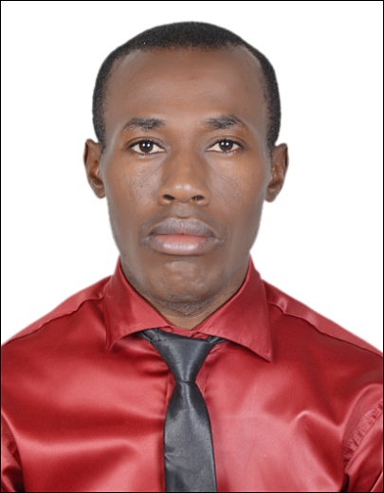
Owodeha.185385@2freemail.com

Owodeha
Personal Skills
- Excellent communication skills to negotiate and influence.
- Critical thinking and organized.
- Passionate and a good manager.
Area of expertise:
- Management Relations.
- Instructing in curriculum.
- Instructing in meta-skills.

Educational Background:
- American advanced diploma in pre and primary education(ATI )-September 2014
- TESOL Certificate, Eton institute, Dubai knowledge village, UAE. (Dec 2013- March 2014).
- Ekiti state university, Nigeria.2012.Mathematics (Masters.) M.Ed.
- University of Ado-Ekiti, Nigeria.2000-2004 .Mathematics (Bachelors) B.Ed.
- Igbobi College, Yaba, Lagos State, Nigeria. 1993-1999
Working/professional Experience:
COMPANY:
Rapha Educational institute, U.A.E
Position Held: Tutor for Mathematics, Physics and Chemistry
Date: December 2013- December 2016
Responsibility:
1. Use modern methods to explain SAT and IGCSE topics to students.
2. Solve and explain examples to students
3. Give exercises and evaluate the student

Company:
Dobbie High School, Nigeria
Position Held: Teacher
Date: March 2006 to March 2013

Responsibilities:
1. Prepare lesson plans, teach and evaluate the students
2. Motivating and encouraging the students to learn.
3. Running extracurricular activities, sports and clubs
4. Maintaining discipline.

