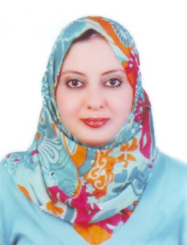
Randa

Email: randa.193236@2freemail.com

Objective:

To obtain a job that unlocks my potential for creativity, utilizes energetic and self-motivated nature through synergy, dynamic, and harmonious work settings, with opportunity for advancement and growth.

Professional Experience and Details of Key Responsibilities / Duties:

Worked as HR Administrator in maintenance Company M/s Juma Al Majid Group dealing with Properties in U.A.E, U.S.A. and U.K., working from June 2007 till May 2011. Key responsibilities involve:

HR Administrator:

- Handling basic administrative skills.

- Excellent planning and organizational skills.

- Doing independent correspondences as having good command over English both written and spoken also having excellent communication skills.

- Maintaining high level of confidentiality in handling projects, contracts documents etc.

- Knowing shorthand hence taking minutes of inter office weekly meeting, presentations.

- Coordination and link between the head of the department with other staff members.

- Having time management ability and demonstrated commitment to completion of projects on timely basis.

- Analyzing HR related issues, recruitment and selections.

- Arranging of visit / employment visas / labor cards.

- Cancellation of visas.

- Maintaining of data / records of trade licenses, passport / visas / labour cards.

- Handling consulate / embassy documents work.

Sales Coordinator:

Currently working as sales coordinator in M.S Swaidan Trading Co. agriculture division of Al Naboodah Commercial Group, dealing with agricultural products which include seeds, garden tools, sprayers, agriculture tractors , pest control & disinfection products.

Key Responsibilities / Duties:

- Responsible for accurate and timely issue of quotations, Performa invoices and delivery orders to the customers as required.

- Meet customers to discuss their requirements.

- Maintain good relations with local/international customers.

- Investigate order discrepancies with vendors and other customer satisfaction issues to assist Sales team.

- Monitoring of all shipments, documentation, and weekly and monthly payment sales report.

- Maintain an efficient working environment.

- Provides support and assistance to fellow team members/departments, as needed, in order to meet company/team goals including but not limited to assisting with general business letters.

Academic Qualifications:

- Bachelor of Arts University of Tanta (English department), Egypt 2002.

Educational Highlights:
- Poetry.
- English literature.
- Translation.
- Shakespearean novels.
- Criticism.
- Drama.
- Phonetics.
- American literature.

Professional Qualifications:

- Training program for graduates – sponsored by Tanta University. (Content: m.s. word, excel, PowerPoint, access).

- ICDL (international computer driving license) - provides international certification for all office application.

Skills:
- Able to communicate effectively.
- Able to work in teams.
- Able to work under pressure.

Personal Details:

• Nationality: Egyptian.
• Date of Birth: September 1981.
• Marital status: Single.
Driving License: Available.

