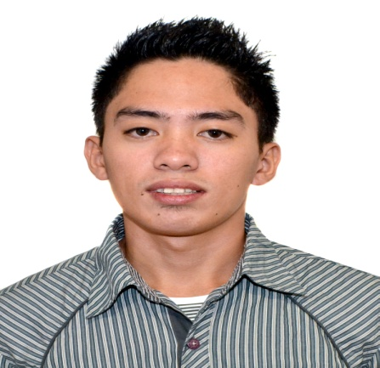
Michael
E-mail Add: Michael.194489@2freemail.com

Objective

To seek employment in a position that I will be suited for, and to be a part of an organization where hard work will be rewarded and where career advancement will always be a possibility.

Work Experience:

August 15, 2012- October 1, 2013 Cashier and Technician
Water Purified and Refilling Station
Sto. Nino Cagayan, Philippines

June 2010- December 2010 Service Crew Member
Jollibee Food Chain
Tuguegarao City, Cagayan, Philippines

May 2009-April 2010 Receptionist front of the House
Candy’s Hotel
Tuguegarao City, Philippines

Trainings and Seminar:

- Certificate in Restaurant and Coffee shop Services
KitchenLink and Recipes Training Center
October 3-19, 2013

- Certificate in National Competencies in Food and Beverages Services

- Certificate in Vessel Familiarization Hotel Operation and Services and Basic Safety on the Ship

Skills:

- Proficient in writing and communicating in English
- Food and Beverage Servicing
- Prepare and Serve Espresso Coffee
- Fire prevention and Fire fighting
- Provide Specialist advice on Wine (Fine Dining)
- Personal computer and Microsoft Office literate
- Able to work with minimal supervision
- Values the meaning of team work
- Able to adjust in different working environments

Educational Attainment:

Hotel and Restaurant Management (Seafarer)
Florencio Vargas College
2010-2011

Personal Information:

Age: 21
Date of birth: April 11, 1992
Civil Status: Single
Nationality: Filipino
Language Spoken: Filipino, English

