Gulfjobseeker.com CV No: 1182360
Mobile +971505905010 / +971504753686

To get contact details of this candidates
Submit request through Feedback Link
http://www.gulfjobseeker.com/feedback/submit_fb.php

CURRICULUM VITAE

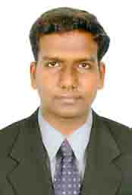
Personal Details

Date of birth : 09th July 1987
Age : 26 Years
Sex : Male
Nationality : Indian
Religion : Christian
Marital Status : Single

LANGUAGES KNOWN
To Write : English & Tamil
To Speak : English, Malayalam & Tamil

ACADEMIC QUALIFICATION

COURSE | NAME OF INSTITUTION | BOARD
Diploma in General Nursing & Midwifery | Nightingale School of Nursing, Bangalore. | Board Examination  Karnataka
12th Standard | Seventh day Adventist Matriculation School, Vellore | Board of Tamil Nadu
S.S.L.C. | G.A.W Hr. Sec. School, Vellore. | State Board of Tamil Nadu

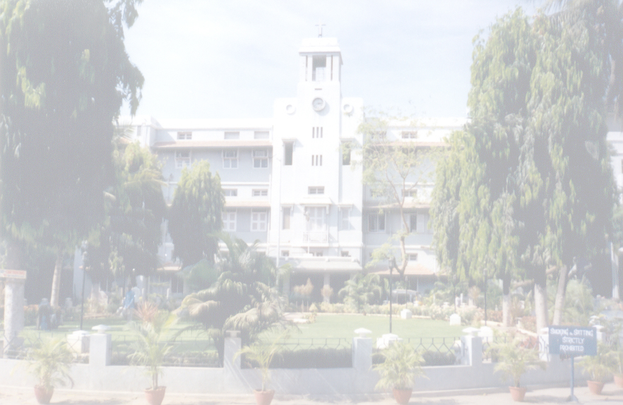
MY INSTITUTION:

Christian Medical College is one of the standardized hospital in Asia. It is a private University Teaching Hospital (Medicine, Nursing, and Allied Medicines). College of nursing Christian Medical College is a WHO COLLABORATING CENTER FOR NURSING AND MIDWIFERY DEVELOPMENT. In 2001 the National Assessment and Accreditation Council (NAAC) on autonomous institution of the University Grants Commission awarded a FIVE STAR RATING to the Institution.

In 2002 the Institution was awarded a H.I. H-ONE FOR SUPER SPECIALITY TEACHING HOSPITAL rating by ICRA (Investment Information and Credit Rating Agency). It is also known for the outstanding and multidisciplinary departments and excellency in clinical work. CMCH has bed rate 2622 and an average inpatient of 1500 and an average 3382 out patients are treated everyday with 55 wards 27 clinics and 105 departments.

CMCH trains us with technical competence to secure the needs of a whole person according to its motto

“NOT TO BE MINISTERED UNTO BUT TO MINISTER”

PROFESSIONAL EXPERIENCE
- From 23.08.2010 to 11.10.2012, working as a Staff Nurse in Accident and Emergency and Medical ward from 12.10.2012 to 19.09.2013 in Christian Medical College & Hospital, Vellore.
- From 09.07.2009 to 20.08.2010, worked as a Staff Nurse in Casualty & Theater in Life line Multi Specialty Hospital, Chennai.

ACCIDENT AND EMERGENCY DEPARTMENT
The Accident and Emergency department of the Christian Medical College is one of the few academic emergency departments in the country. It is a level I Trauma Center a full-fledged independent clinical unit with 40 beds and is the largest emergency department in the private sector in India. The WHO and Nursing Council of India have recognized the department as an accredited regional training center for emergency nursing in 1997. The set up consists of triage, consultation room resuscitation area, center observation area, side observation area for 24 hours observation, minor procedure room, splinting room, ENT, ophthalmic and gynaecological examination room. The department trains students sponsored by WHO in accident and emergency services. The department runs a training course in early management of trauma biannually.

GENERAL MEDICAL WARD:
It is a 35 bedded unit. Take care of 8 to 10 patents in a shift. During cardiac and respiratory arrest giving cardiac pulmonary resuscitation and assisted in endo tracheal intubation. Responsible for maintaining adequate supplies in the ward, supervision of junior nurse, students and non professional workers in the absence of ward sister. Attending rounds and maintaining census.

DUTIES AND RESPONSIBILITIES 8 Hrs/day (44 Hrs per week)

- Nurses prayer
- Taking over the report from the previous shift
- Nurses bedside rounds
- Assessing the physical and psychological needs
- Planning the patient care
- Monitoring vital signs Q2H
- Packing and sending things for sterilization
- Nutritional needs of patients (Oral, Total parental nutrition, Intravenous infusion)
- Checking glascow coma scale
- Monitoring fluid balance
- Drug administration
- Checking random blood sugar
- Checking central venous pressure
- Cardiac monitoring
- Maintaining dangerous drug and administration
- Tracheostomy care
- Tube feeding including bolus feeds
- Continuous drip feeds
- Resuscitating during cardiac and respiratory arrest
- Inserting nasogastric tube
- Administration of infusions like dopamine, nitroglycerine, morphine, lasix, adrenaline, atropine, noradrenaline, dobutamine, lorazepan, amiadarone.etc..
- Dressing
- Catheter care including subclavian and foleys
- Blood administration
- Taking laboratory specimens including arterial blood gas
- Giving injections (IV, SC, IM) and medications
- Giving chest physiotherapy and suctioning
- Family advice, counseling and support patients and relatives
- Family teaching (Eg: Diabetes)
- Care of patients on chest drainage
- Giving active and passive exercise
- Hot and cold application
- Attending seminars
- Death care

ASSISTED IN

- Endo tracheal intubation
- Putting central line, cutdowns (brachial, femoral, subclavian)
- Lumbar puncture
- Tracheostomy
- Bone marrow aspiration
- Thoracentesis and paracentesis
- Liver and lung biopsy
- Bronchoscopy and endoscopy
- Chest tube insertion

SPECIAL DUTIES

- Incharge of the ward in the absence of ward sister
- Supervising non professional workers
- Attending rounds
- Taking special classes
- Teaching and supervising students in the absence of tutors
PATIENTS TAKEN CARE
- Systemic Lupus Erethematus (SLE)
- Poisoning (organophosphorus, odanthalai, oleander, acid)
- Drug over dose
- Cerebro vascular accident
- Septic shock
- Seizure disorder
- Meningitis
- Hepatic encephalopathy
- Cerebral malaria
- Tetenus
- Systemic lupus erythemetosus
- Typhoid
- Lung abcess and Liver abcess
- Brochial asthma
- Pulmonary embolism
- Chronic obstructive pulmonary disease

- (COPD)

- Diabetic keto acidosis
- Scrubtyphus and acute respiratory distress syndrome

- IC bleed
- Congestive cardiac failure
- Acute and chronic renal failure and End Stage Renal Disease (ESRD)
- CNS infection
- Disseminated TB
- Chronic liver disease
- Meningoencephalitis
- Pleural effusion
- PCP pneumonia and HIV infection
- GI bleed
- Cirrhosis of liver
- Multiple myeloma
- Aplastic anemia
- AML, ALL
- Lymphoma
- Pancytopenia
- Arthritis
- Hypertension
- Diabetes Mellitus

- Low back ache
- Disc prolapse and dislocation
- Metabolic bone disorders
- Osteoporosis
- Septic osteoarthritis
- Spontaneous vertebral structures
- Osteomylitis
- Paget’s disease
- Patients on cast, traction, external fixators
- Patients undergoing total hip replacements, total knee replacement, reconstructive joint surgery, open reduction and intra medullary nailing
- Patients with bone tumors, TB spine, fractures

PATIENTS DEALED IN EMERGENCY SERVICE

- Medico legal cases like road traffic accidents (Head injury, abdomen injuries like liver laceration, spleen laceration and urethral injuries), hanging, assault, poisoning, cracker burst, burns, drowning, crush injuries, electric shock, fall from height, gunshot injuries, occupational injury, rape, attempted suicide, septic abortion, stab injury.
- Medical emergency cases (Stroke, acute exacerbation of bronchial asthma, bites, stings, hypoglycemia, ARF, CRF, acute gastro enteritis),
- Surgical emergency cases (acute appendicitis, liver disease, peritonitis, intestinal obstruction, deodenal perforation),
- Other paediatric emergency cases like obstetric emergency cases, orthopaedic emergency case, neurological emergency cases (Seizure disorder, head injury), cardiac emergency cases and hematological, dermatological, ENT, medical oncology cases.

EQUIPMENTS KNOWN TO HANDLE

- Pulse Oximeters
- ECG monitor (Hewlett Packard, Larson and Turbo Monitors)
- Glucometer, ECG machines.
- Infusion pumps (JMS, Terumo), syringe pumps.
- C-PAP machines and Bi-PAP circuit
- Hewlett Packard Defibrillator
- Laryngoscope
- Jet nebulizer

PERSONAL AND PROFESSIONAL QUALITIES

An enthusiastic nurse with four years of experience providing expert nursing care to patients with a range of dieases conditions. A conscientious organized professional committed to improving the standards of care.

DECLARATION
I here by declare that the above said information are true and correct to the best of my knowledge and belief.

