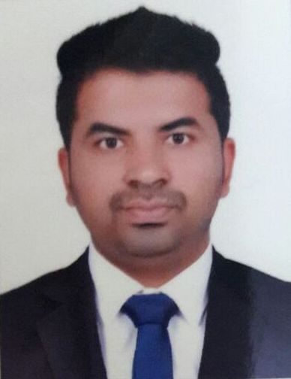
FAWAD

E-mail: fawad-197666@2freemail.com

PROFILE SUMMARY

Well qualified and self-motivated professional with extensive experience in the spheres of accounting, finance, payable receivable follow up, reconciliation, cash flow management, bookkeeping, MIS reporting, document control. Displayed competency in overseeing overdue accounts, document controlling, providing administrative support, handling multiple tasks, fulfilling organizational objectives and dealing with multicultural clientele. Consistently contributed to previous company in safeguarding finances by preparing accurate accounting reports, ensuring reliability and worthiness. Well-organized and innovative team player with excellent communication, analytical, problem solving, decision making, time management skills.

WORK EXPERIENCE
Accountant Cum Document Controller (Aug-2015 to Present)
Dubai

General Accounting

- Handling books of accounts including books of transaction, cash, payroll, supplier-vendor ledger, stock, sales and purchase.
- Managing final account statements such as trial balance, Profit & Loss Account and balance-sheet.
- Handling collections of due account receivable and arrange on time payments to payable accounts including processing of invoice and expense forms.
- Monitoring and maintaining journal vouchers, cash and payment statement and stock reports of material.
- Check computations and accurately input codes to accounting system.
- Preparing various accounting reports as requested by superiors.
- VAT Return filling
Document Control & Assistance to Manager

- Coordinating with all departments of company to ensure all documents are kept in right place and in right department file archive.
- Review and proofread documents for consistency of format and system concerns. Check and edit documents with errors to maintain accuracy and correctness of documents.
- Post changes to computerized or manual control records and maintain related files.
- Ensure timely and accurate completion of document control tasks.
- Preserve proper records of incoming and outgoing correspondence, file documents and letters systematically and keep all assigned files up to date. Managearchival activities for controlled documents and validation files.
- Work alongside team to ensure consistency of document management process and use of data and document control procedures. Implementdocument control processes and tools.

- Controldocumentation produced internally/externally andprovides system reports.
- Coordinating with manger in organizing and running operations, planning purchases and sales accordingly.
- Finding Logistics services for Import & Exportoperation of Company.
Accountant (Feb-2014 toAug-2015)
Dubai
- Handling all books of accounts.
- Responsible of all purchase, sales posting in system, maintaining cash flow reports, day to day transactions, petty cash handling.
- Coordinating with Japan company for purchase record (Auction bills).
- Coordination with all departments of company to ensure all documents are kept in right place and right department file archive.
- Dealing with banks for day to day transactions.

Accounts Officer (July-2012 to Dec-2013)
At “DP WORLD, Lahore” Pakistan
- Preparing invoices using oracle system.
- Collection payment against invoices from customer, managing collection to be depositing in bank.
- Preparing daily collection statement to report up to CFO.
- Dealing with petty cash, preparing monthly reports and reimbursements sheet.

QUALIFICATIONS
- Masters: M.Sc. (Accounting and Finance) (CGP 3.61/4)
Specialization: (Advanced Accounting, Cost Accounting, Financial Accounting & Finance)
2010-2012 Bahaudin Zakariya University, Multan

- Bachelors: B.Com(Bachelors in Commerce) (957/1500 Marks)
Specialization: (Management, Accounting, Finance & Auditing)
2008-2010Superior Group of Colleges, Multan.

Intermediate: D.Com(Diploma in Commerce) (872/1200 Marks)
Specialization: (Computer,Accounting, )
2006-2008 Punjab Board of Technical Education Lahore.

SKILLS
- Fluent in: English, Urdu
- Possess good Inter-Personnel, Leadershipand Analytical skills
- Self-Motivatedand a Team-Player
- Customer Services/Relations Skills.
- Communication and Interpersonal Skills
- Microsoft Office (Mainly Microsoft Word, Excel & PowerPoint)
- Can handle all type of accounting software.

PERSONAL DETAILS
Date of Birth: 17/10/1989
Marital Status: Married
Nationality: Pakistani
Visa Status: Employment Visa
Valid U.A.E Driving License

REFERENCE
Will be furnished upon request.

