Curriculum vitae | IMRAN  C/o- Phone: +971503718643  E-mail: imran.198601@2freemail.com | 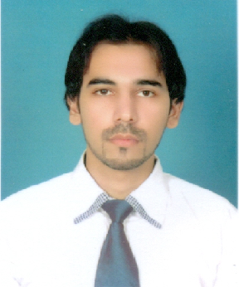

OBJECTIVE
To work in creative challenging environment that will hone my design skills and help me grow as professional.
EDUCATION & ACHIEVEMENT
- Bachelor of Business Administration from Pakistan Air Force-Karachi Institute of Economics & Technology, Karachi.
- H.SC from College of Accounting and Management Science (CAMS), Karachi.
- S.SC from Karachi Model School, Karachi.
- Participated in project conference & and poster exhibition in PAF-KIET-2008 as volunteer.
- Diploma in ASM (Advance Shift Management) from McDonalds Pakistan.
- Diploma in BSM (Basic Shift Management) from McDonalds Pakistan.

EXPERIENCE
- McDonald’s Pakistan.
Designation : 2nd Assistant Manager
Duration : 15-Feb-2012 to 23-Aug-2013
Job Responsibilities are as follows:-
“To manage whole restaurant operation which includes: people management, product management, equipment management, waste management, customer dealing/handling, cash handling, training to crew member, sales-building and promotion of products, manage inventories, assist to Restaurant Manager in hiring new staff for the restaurant operation, manage store marketing, manage safety, security, service and cleanliness of restaurant and manage opening and closing of restaurant.”
- United Bank Limited.
Designation : Internee
Duration : 15-March-2010 to 30-April-2010
Job Responsibilities are as follows:-
“Responsibility of whole retail branch banking including: cheque clearing, cheque book dealing, customer services representative (CSR), cash dealing and Assist to operation manager.”

- 3CS (client centric consulting solutions).

Designation : Internee
Duration : 01-June-2009 to 31-July-2009

RESEARCH REPORT
- Made a report on consumer preference toward music channels in Karachi.
- Made a report on Johnson&Johnson’s brand, Tylenol, by using SWOT analysis.
- Created a report on marketing plane of Pakistan State Oil (PSO) and launched a new brand by current marketing situation and SWOT analysis.
SKILLS
- Quick learning and efficient time management skill.
- People and customer management skills.
- Good command in English (Written & Speaking).
- Good command over Ms Office.
- Training skills.
- Team leading skills.
- Complaint handling skills.

PERSONAL INFORMATION
- Date of birth : 12-sep-1986
- Nationality : Pakistani.
- Current location : UAE.
- Visa status : Visit visa
- Religion : Islam.

HOBBIES & INTEREST
- Internet browsing and reading newspaper.

