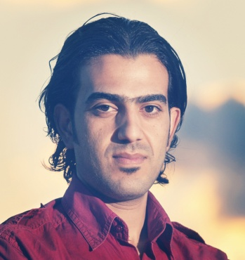
Curriculum Vitae

Gulfjobseeker.com CV No: 1203888
Mobile +971505905010 / +971504753686

To get contact details of this candidates
Submit request through Feedback Link
http://www.gulfjobseeker.com/feedback/submit_fb.php

Objectives:

A motivated assistant pharmacist with a real passion for healthcare. Seeking a Challenging position in a growing organization to be part of their team and to work in a creative environment to the best of my ability. I expected to be a team player, professional, reliable, and playing an
active role in a multinational firm.

SKILLS/ ABILITIES:
- Giving healthcare advice and help to the public.
- Hard working, team work with great communication skills.
- Good customer service skills.
- Presentation, counselling, sales & management skills.
- An interest in the health and wellbeing of people.
- A high level of scientific understanding and ability.
- A logical approach to problem solving.
- Good math skills, with the ability to calculate and use scientific formulae.
- Accuracy and attention to details.
- The ability to organize and prioritize the work.
- A responsible and security-conscious attitude.
- The ability to train and supervise others.
- Computer Skill& Technology: competent in using Microsoft office suite (word, Excel, Power point).
- Well versed with the use of Internet for researches.

Personal information:

- Nationality : Syrian
- D.O.B : 11-05-1987
- Sex : male
- Marital status : single

Qualification:

- High secondary school certificate 2007

- Diploma in pharmacy 2010

- DHA license

- MOH license in Yemen

Professional experience:

- Al Safeer pharmacy in Fujairah from:12/03/2012 to: 21/03/2013

- Fujairah government hospital as volunteer 4 month period

- Eibn Esmaeil pharmacy in Yemen from: 01/09/2010 to: 10/09/2011

Languages known:

- Arabic
- English

