#### **CURRICULUM VITAE**

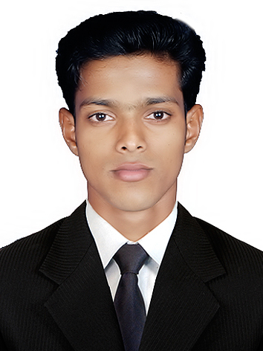

**RAFI**

C/o-Mob: +971504973598

[rafi.3201077@2freemail.com](mailto:rafi.3201077@2freemail.com)

#### ***Objective***

I would like to be part of progressive organization to complete the challenging opportunities, to highlight and contribute the skills with active involvement and self esteem.

#### ***Education***

|  |  |  |  |  |  |
| --- | --- | --- | --- | --- | --- |
| **Course** | **School / College** | **Discipline / Specialization** | **University / Board** | **Year Of Passing** | **Aggregate (%)** |
| B.Com | Prathibha College,  Punnayoorkulam | **Corporation** | CALICUT | 2012 | **56%** |
|
|
| XIIth | GHSS, Chalissery | **Biology & Mathematics** | KERALA STATE | 2009 | **62%** |
| Xth | GHSS, Chalissery | **Xth** | KERALA STATE | 2007 | **79%** |

#### ***Language Skills***

|  |  |  |  |  |  |
| --- | --- | --- | --- | --- | --- |
| Languages | Read | Write | | Speak | Understand |
| English | Yes | Yes | | Yes | Yes |
| Hindi | Yes | Yes | | No | Yes |
| Malayalam | Yes | Yes | Yes | | Yes |
| Tamil | No | No | Yes | | Yes |

#### ***Technical skills***

**MS OFFICE,TALLY, PEACHTREE, DACEASY, QUICK BOOK**

#### ***Experience***

* June 2012 to till present working as accounts executive in akbar travels of india pvt ltd.

#### ***Strengths***

* Analytical and logical reasoning skills.
* Good leadership qualities with shear hard work
* Positive attitude and enthusiastic in teamwork.
* Ability to generate creative/innovative solutions.
* Confident to take up new challenges and keen to learn new concepts.
* Have enough Patience to face difficulties.
* Optimistic.

#### ***Achievements***

* Member of college union during graduation (B.com)
* Lead the college football team for two years

#### ***Hobbies***

* Listening music
* Browsing internet for gathering knowledge
* Playing Football and volleyball

#### ***Personal Details***

* Age : 21
* Date of Birth : 03-12-1991
* Gender : Male
* Marital Status : Single
* Nationality : INDIAN

#### ***Declaration***

I hereby solemnly declare that information given above is true to the best of my knowledge and belief. I also understand that any discrepancy found in the above information will render me liable for cancellation of my candidature.