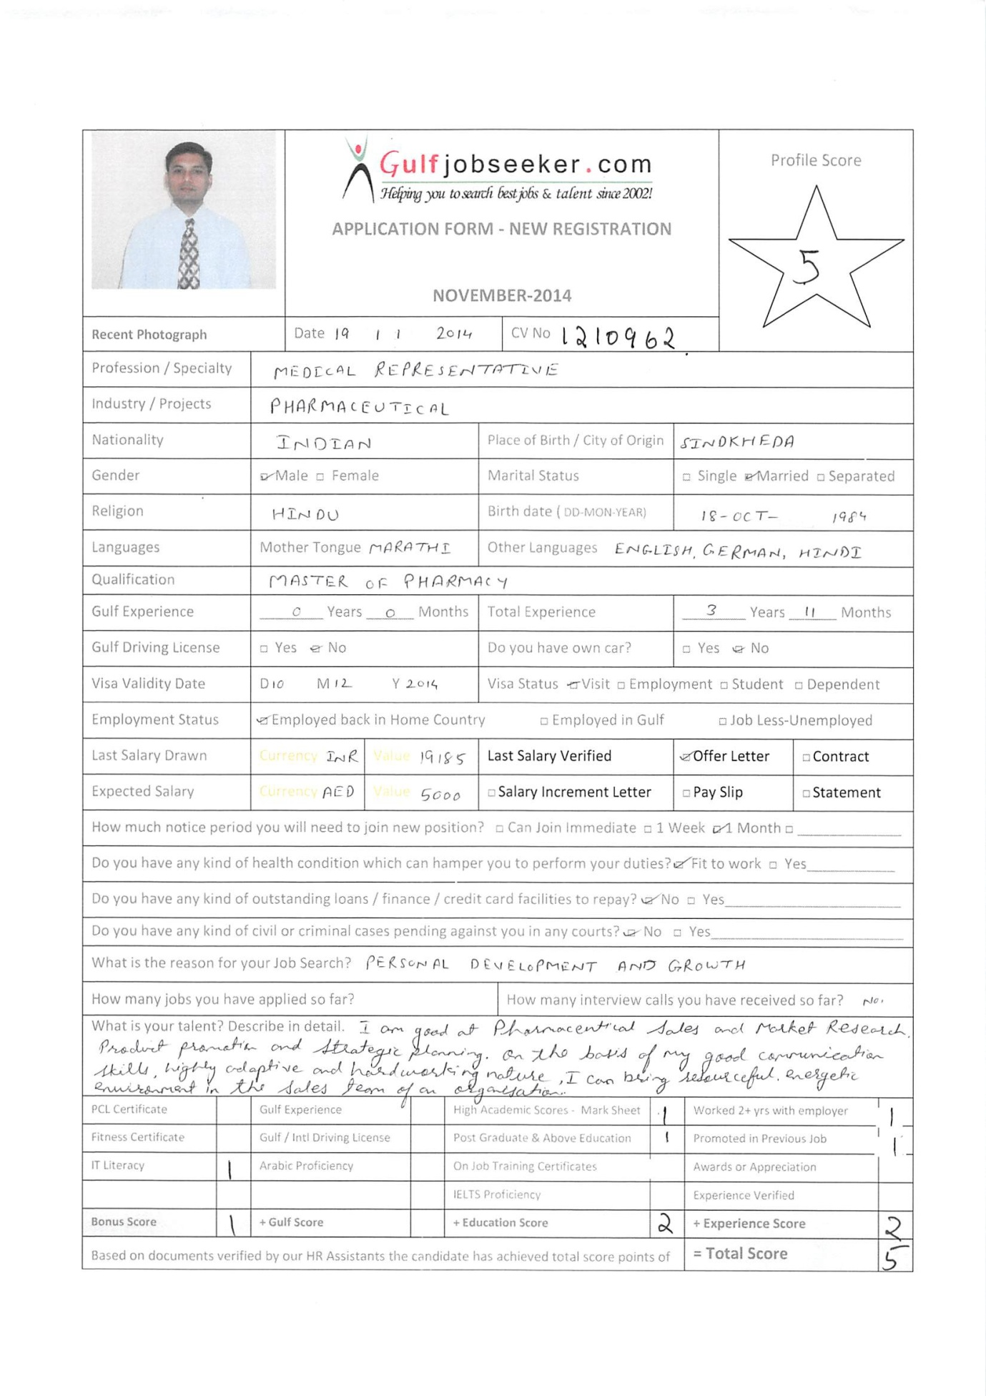

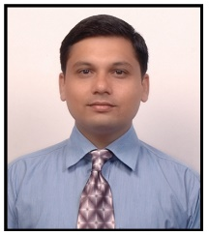
Visa Status: Visit Visa

Seeking challenging assignments in Pharmaceutical Sales and Marketing in UAE, where I can utilize my broad skills and expertise for organizational and professional career growth

- Organized professional with around 1 year of experience in Pharmaceutical Sales with expertise in promoting Pharmaceutical products.
- Excellence in promoting Pharmaceutical products in Gastroenterology, Orthopedics, Gynecology and Dentistry segments
- Organized professional with 3 years of experience in Pharmaceutical Industry with expertise in developing and validating Bio analytical methods
- Knowledge of regulatory affairs
- Good at MS Office (Word, Excel, Power Point, Access) and Windows based environment
- Conversant with English, German, Hindi, and Marathi

Areas Of Exposure

- Market Research and Market analysis
- Product promotion and sales strategy planning
- New product launching
- Analytical / Bio analytical Research
- Data Analysis, Quality Assurance & Quality Control
- Inventory Management
- GLP Compliance
- Coordination

Education

Master of Pharmacy (Pharmaceutical Chemistry) from NMIMS University with 3.23/4.00 (CGPA) | 2011
Bachelor of Pharmacy from Dr. Babasaheb Ambedkar Marathwada University with 62.74% | 2008
Diploma in Pharmacy from Maharashtra State Board of Technical Education with 74.66% | 2005
H.S.C. from Maharashtra State Board with 63.17% | 2002
S.S.C. from Maharashtra State Board with 72.80% | 2000

Professional Experience

Oct’ 2008 – Jul’ 2009
Trainee Professional Sales Representative - Aurangabad Division
Key Deliverables:
- Handled the promotional activities of the product and met the Doctors in the field of Gastroenterology, Orthopedics, Gynecologists, Dentists, and Physicians
- Visited the Chemists and Stockiest to ensure product availability
- Developed strong communication network with subject leaders such as – physicians, staff members, hospital managers and pharmacists.
- Researched market regularly in order to keep up with competitors and their products to generate greater sales.
- Worked in coordination with managers in preparing strategies to promote products on the market.
- Maintained accurate records including date and contact information of doctors contacted for maintaining future sales.

Oct’ 2011 - Present
Senior Research Associate - Bioanalytical Section, Clinical Pharmacokinetics & Biopharmaceutics Department
Key Deliverables:
- Performing research on literature
- Involved in processing and analyzing biological samples for drug / metabolite concentration
- Ensuring all activities are performed as per in house SOPs and GLP
- Facilitating the Senior Analyst and Group Leader in data analysis and compliance of reports
- Responsible for developing and validating Bioanalytical methods
- Handling, receipt, transfer, storage and disposal of biological matrix
- Raising indent for purchase and oversee storage for Bio analytical lab inventory
Instruments Handled:
- LC-MS/MS: Thermo Finnigan TSQ Quantum, TSQ Quantum Ultra, TSQ Quantum Discovery MAX
[System Software: LC Quan 2.5.6, LC Quan 2.8]
- LC-MS/MS:AB Sciex Triple Quadrapole API-3000, API-4000, API-5500 [System Software: Analyst 1.4.1, 1.4.2and 1.6.2]

Projects Handled during M. Pharmacy

Major Project:
Title: Method Development and Validation of Related Substances of Compound-A
by HPLC
Organization: Wockhardt Research Centre, Aurangabad
Functional Area: Analytical Research & Development
Duration: June 2010 – Jan’ 2011
Role: Project Trainee
Instruments Handled:
- HPLC Waters 2695 Separation module with 2996 PDA detector(Software: Empower-2)
- UV Spectrophotometer (Perkin Elmer)
- FTIR (Perkin Elmer)
- Polarimeter (Jasco)
- Chemical analysis (LOD, ROI, Heavy metals testing)
- Moisture Content (Mettler Toledo)

Minor Project:
Title: Effect of Various Starches on Tablet Properties
Functional Area: Quality Assurance
Duration: Feb’ 2011 - May 2011
Instruments Handled:
- Weighing Balance(Mettler Toledo)
- Compression Machine(Karnavati)
- Hardness Tester(Monsanto)
- Friability Tester(Roche)
- Vernier Caliper Scale(Mitutoyo)
- Dissolution Test Apparatus(Electrolab (USP-Ι, II))
- UV Spectrophotometer (Perkin Elmer)

Publications

- Poster presented on Rapid Cleaning Validation Method for Colored Formulation Ingredients by Visible Residue Method in Academic Laboratory at 58th IPC, Dec.2006, Mumbai
- Poster presented on Utility of HPTLC in Analysis of Herbal Oils at National Conference on Polyherbal Formulations : Perspectives and Challenges, Nov.2009, Loni (Dist. Ahmednagar)

PERSONAL DETAILS

Date of Birth: 18th October 1984
Marital Status: Married
Nationality: Indian

