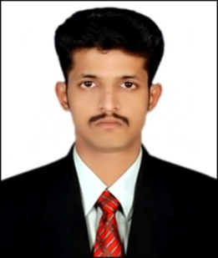
CURRICULAM VITAE
Gulfjobseeker.com CV No: 1217670
Mobile +971505905010 cvdatabase[@]gulfjobseeker.com

To contact this candidate use this link
http://www.gulfjobseeker.com/feedback/contactjs.php
APPLY FOR JOB TITLE : Any Suitable Job
OBJECTIVE:
Willing to work in a challenging and creative environment in a reputed organization which appreciates professional approach and handwork, where I can utilize my knowledge, various skills in contribution the company’s growth objective develop my career and excel in the field.
ACADEMIC QUALIFICATIONS:
B.Sc. (Bio Chemistry)@ Eanathi Rajappa Arts & Science College, Bharathidasan University (2009 – 2012)

WORK EXPERIENCE:

BAWAA MEDICALS
Position Held: Sales Representative
Duration: Oct 2012 to Dec 2013

RESPONSIBILITY:

Responsible for the day to day running of the Pharmacy. Providing a professional sympathetic and supportive service to patients and identifying the right healthcare solution to meet their needs.
- Accurately dispensing drugs to patients according to a doctor’s prescription.
- Checking prescriptions for errors & making sure they are appropriate for patients.
- Measuring, packaging, labelling and recording medications issued to patients.
- Instructing patients on how to use medications, possible side effects and storage.
- Contacting and working closely with other healthcare professionals.
- Answering questions from patients and staff about medicines.
- Ensuring the accuracy of all prescriptions, products and services supplied.
- Helping to develop the pharmacy's electronic discharge system.
- Managing and resolving complaints.
- Able to trains and supervise Pharmacy Assistants.
- Communicating with customers sympathetically and supportively.
- Giving private consultations when required.
- Maintaining pharmaceutical stock, creating inventories and ordering more drugs.

KEY SKILLS AND COMPETENCIES:
- Hardworking, motivated and goal oriented
- Can work late evenings and weekends consistent with pharmacy opening hours.
- Customer care , Product display
- Computer: C program, Email, Internet Browser, and word processing software

PERSONAL DETAILS:

Date of birth : 26th apr 1991
Nationality : Indian
Religion : Islam
Language known : English, tamil
Marital status : Single

Declaration

I hereby declare that all the above furnished informations are true to the best of my knowledge.
Thank you

