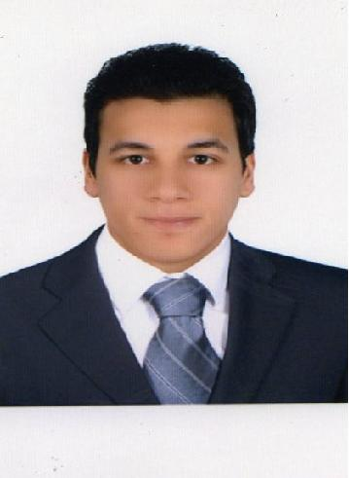Anwar
Anwar.203426@2freemail.com

Objective:

Seeking a challenging position in a reputable company where I can be of a great benefit in processing all the official documents of the company and employees and at the same time improve my skills.

Personal data:
Date of birth: 1/7/1989
Place of birth: Cairo, Egypt
Nationality: Egyptian
Social status: Single
Military status: Exempted
Emirates Driving License: 22/12/2013

Profile:

A hard worker with strong personality. Having the ability to face different kinds of problems and solve them. Having a good experience in giving perfect output under stress, as well as working individually or among a team.

Language:

Arabic: Mother Tongue

English: Good

Graduation:

Cairo Aeromechanic - May 2007

Professional experience in UAE

- The company name : On Time Business Services

Period: from 2012 till now
Position : Data entry

Duties and Responsibilities :

- Knowledge of Arabic & English documents Typing Work relating to
- Economic Department, Marriage contract, Ejari, Immigration, Emirates Id, Medical, Saudi Visa, Schengen Vis, UK visa, USA visa, Iraq Visa, Oman Visa, Egypt Visa, Libyan Visa, &. etc
- Typing also in this system.
- Responsible for the day to day operation of the branch.
- Having idea about Enjaz system to follow up the approved invitation letter and pre approved.
- Explain properly to the customer the procedure of the transactions
- Coordinate with the supervisor regarding the daily transactions

The company name: Estabraq Consulting Engineers
Period : from 2009 till 2011
Position : public relations representative

- Duties and Responsibilities :

- Processing the transactions of the Ministry of Labor .
- Processing the transactions of the immigration and passports.
- Processing the transactions of the Human Resources Department.
- Processing the transactions of medical examination at government hospitals.
- Processing the transactions of Tas’heel.

Computer Skills:

Good User Microsoft Windows,

Internet Browsing, Office Package and Hardware knowledge

INTERESTS & ACTIVITIES:

Reading.

Swimming.

Football.

