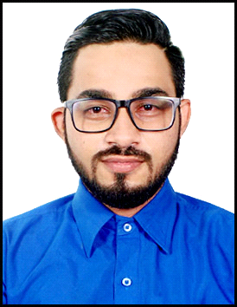 Aiyub

Aiyub.203876@2freemail.com

Objective
To succeed in an environment of growth and excellence and earn a job which provides me job Satisfaction and self development and help me achieve personal as well as organization goals.

Work Experience (Assistant ,Health and Safety Supervisor)
M.E. Karodia (78, Rabindra Sarani, Rabindra Sarani, Kolkata, West Bengal 700001) 10
(10/06/2010-04/04/2011), (20/06/2012-10/04/2013),(10/03/2016-17/03/2017)
Accounting Functions:
- Bank reconciliation
- Assisting monthly and yearly closing to the C.A.
- Accounts payable handling (cheque/cash).
- Communication with bank for the transactions.

Key Responsibilities
- Admin: Disbursement of Staff/Associates Expenses.
- Attending queries of suppliers.
- Making and receiving phone calls
- Taking orders from customers
- Supervising the staff
- Handling communications
- Monitoring supplies and prepare for the supplies.

Health And Safety Responsibilities
- Carrying out safety inspection according to the checklist throughout the premises on the monthly basis.
- Checking safety equipments and materials.
- Giving training to the labour
- Inspecting the hygiene in the premises
- Reporting the owner if any equipments is required.
Education
M.B.A (Finance) Gujarat Technological University 2013-2016
(Narmada College of Management,
Bharuch)

B.B.A (H.R.) Veer Narmad South Gujarat University 2008-2012

H.S.C. V.S Patel, High School, Kosamba 2008

S.S.C. Sarvajanik High School, Kosamba 2006

Corporate Training
- financial statement analysis in Asian paints 10th largest paints making company in the world
- Health and safety training in Asian Paints 10th largest paint making company in the world. (With the use of SAP )
Skills

- Excellent writing and verbal communication skills in English, Hindi, Gujarati, Urdu.
- Ability to balance workload efficiently and able to work in constant changing environment and long period of time.
- Solid organizational skill with ability to multi- task, quick learner
- Flexible and ready to leadership and responsibilities
- Ability to maintain strict level of confidentiality.
- Critical observant and supervisor whenever as necessary.
- Ability to work for long period of time.
- Adaptability and independent.
- Often curious to learn new things
- Time manager
- Ability to take decision under any circumstances with calm manner.
- Computer skills

I.T Skills
- Well versed with Microsoft Office
- Possess good knowledge of Tally ERP 9
- Internet savvy
Personal Details
- Nationality - Indian
- Languages Known - English,Urdu, Hindi, Gujarati
- Marital Status – Unmarried
- Passport –

Hobbies
- Participating in various sports events.
- Photography.
- Reading articles over internet.
- Travelling
- Hiking
- Creating business ideas
- Drivin

Declaration
The above-mentioned details are true to the best of my knowledge.

Aiyub

