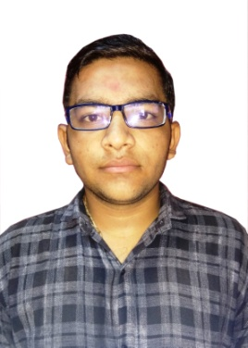
RESUME

Parth
Email: Parth.203985@2freemail.com
Objective:
Looking for an opportunity to work in an organization where my skills and knowledge form a part of organization goals and work in teams to achieve the objectives.
Qualification:
Qualification | Institute | University/ Board | Year of passing | CGPA/  Percentage
Diploma Civil | Dr. J.N.Maheta Govt. Polytechnic | GTU | 2016 | 7.55
S.S.C | Ku. R.R. Gardi Vidhyalaya,  Bhader, Taluka: Dhari | GSEB | 2011 | 75.80 %

Project:
“Recycled Aggregate Application For Concrete ”

Takes 50% of row materials from nature aggregate for the production of cement and concrete.
Consumes 40% of totalenergy for the production, transport, use of row material and final ones, as cement and concrete.
Creates 50% of total waste from old construction works (demolition waste.)

Personal Skills And Strengths:

Always learning attitude, Management skills and Habitat to accept challenging tasks.
Ability to learn and support new applications and systems.
Amiable and Amicable nature.
Zeal to learn emerging Technologies.

Experience:

Site Engineer at Vraj Construction, Amreli Since 01-June-2016 to 11-Aug-2017.

Job Profile:
- Civil Audit.
- Quality Control Inspection Programme.
- R&B Project Work.
- Supervision of civil works.

Declaration:

I hereby declare that all the information furnished above is correct to the best of my knowledge.

