Bebatto.204007@2freemail.com

BEBATTO 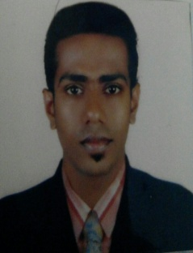
VADAKKAN HOUSE
AMBAZHAKAD
THRISSUR

CAREER OBJECTIVE
To work for an organization which would offer a competitive work environment
And improve in performance level.
ACADEMIC QUALIFICATION
- S.S.L.C (pass out in 2009 with 72% mark)
- Plus two (bake paper)
- I.T.I (production and manufactory cluster) specialized in
PLC & Automation (bake paper, course completed )
TECHINICAL QUALIFICATION
- PLC & SCADA
- COMPUTER SKILL
WORK EXPERIENCE
Organization : FCI OEN Connecters
Location : cochin
Nature of work : machine operating
Position : machine operator
Period : from 18th march 2013 to 14th September 2013
From 10th Januvary 2014 to 16th April 2016
Organization : Almari
Location : Soudi arabia
Nature of work : Machine operator
Position : Machine operator
Period : 20th april 2016 to still working at Almarai
Key skills
- Organization & planning
- Good internet and computer skill
- Optimistic & self conscious
PERSONAL DETAILS

Father’s Name : V.O Francis
Religion/cast : Christen ; R C
Sex : Male
Nationality : Indian
Marital status : single

Place of issue : Cochin
Languages known : English, Thamil and Malayalam
DECLARATION
I hereby declare that all the fact stated above is true and correct
In best of my knowledge and belief .

Sincerely Place :
BABATO RANCIS

