**ASHRAF**

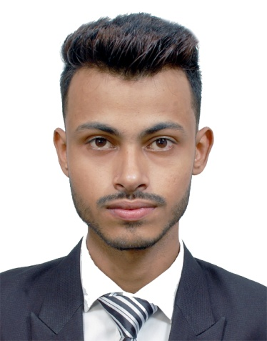

E mail:[**ASHRAF.204100@2freemail.com**](mailto:ASHRAF.204100@2freemail.com)

# Objective

“To work in association with professional groups who offer me the opportunity for career advancement and professional growth.”

**Academic Qualifications**

|  |  |  |  |
| --- | --- | --- | --- |
| **Year** | **Examination** | **Board/University** | **Rank** |
| 2010 | Class-XII (W.B.B.S.E) | Higher Secondary | 1st |
| 2008 | Class-X (W.B.B.S.E) | Madhyamik | 3rd |

**Work Experience**

**2016-2017: SWIGGY FOOD DELIVERY (INDIA PVT LTD)**

**Post:** Delivery Executive

**JOB DESCRIPTION:** Receiving online orders

Picking up the order from the different restaurants

Delivering the order to the respective customers

**2015:** **TATA SKY (SATALITE INDIA PVT LTD)**

**Post:** AS A Tele-caller (Customer Care Service)

**JOB DESCRIPTION:** Handling the customers queries

Resolving the customers issues

#### 2012-2014: AUSPICER (BPO INDIA PVT LTD)

**Post:** AS A Tele-caller (Customer Care Service)

**JOB DESCRIPTION:** Handling the customers queries

Resolving the customers issues

Customer Support

Sales Management

**Achievements & Certifications**

* CERTIFITED by **SWIGGY FOOD DELIVERY** (INDIA PVT LTD) as a best performance.

**Computer Proficiency**

* Basic Knowledge on computers
* Hardware and Networking on 2011 (**N**ational **I**nstitute of **I**nformation **T**echnology)
* Working knowledge of MS-Office, Excel, Word and PowerPoint
* Email etiquettes

**Soft Skills, Interests and Strength**

* Leadership Skills and Team Building Spirit.
* Football & Music.
* Perseverance, Patience and Initiative to Learn and Accept New Challenge.
* Finishing work within a deadline.
* Skilled in delegating tasks and motivating team players to achieve the best goals.
* Friendly and open-minded; committed to client satisfaction.
* Excellent communication and customer service skills.
* Highly interest in electronic devices.
* Good learner in short time.

# Personal Details

* Date of Birth: 15th SEP, 1991.
* Sex : Male
* Languages known: English, Hindi, Bengali and Urdu.
* Nationality : INDIAN
* Marital Status : Unmarried

Date: Signature: