CURRICULUM VITAE
Gulfjobseeker.com CV No: 1238424
Mobile +971505905010 / +971504753686

To get contact details of this candidates
Submit request through Feedback Link
http://www.gulfjobseeker.com/feedback/submit_fb.php
Objective

Acquire a challenging career in analyzing, developing and implementing, as per my capability and talent with possible avenues for creativity, self improvement and grow up the company rungs as per my potential.

Work Experiences
- M

- Ms/Group Pharmaceuticals Ltd.
(As Assistant Production Manager from Dec. 2006 to Nov. 2012 Production Executive from Apr. 2002 to Dec. 2006)

- M/s Falma Laboratories Pvt. Ltd.
(As Quality Assurance from Dec. 2000 to Dec. 2001)

- M/s B.E.L Ltd.
(Apprenticeship for six months in B.E.L Hospital Pharmacy Department from Jan. 2000 to Jul. 2000)

- M/s Colinz Laboratories Pvt. Ltd.
(As Medical Representative for one year)

- M/s Pallavi Creations.
(As DTP operator for Eight months)

Areas of interest

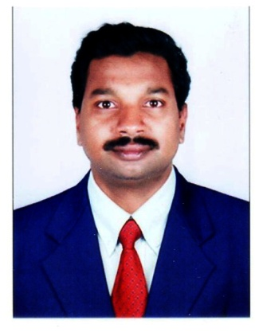
.

Personal Data
Date Of Birth: 02-02-1975
Sex : Male
Nationality : Indian
Religion : Hindu
Marital status: Married

Languages
English, Hindi, Malayalam, Kannada & Tamil.

- Liquid orals, Liquid externals, creams, ointments and medicated toothpaste Production in Pharmaceuticals.
- Quality assurance in Pharmaceuticals.
- Hospital Pharmacy Department.
- Management jobs.
- Administrative and Human Resources.

Work profile
- Plan the activity as per the cGMP standards (Documentation / Man and Machine) in respective area of work.
- Planning the Production through ERP and executing the required production on date and time.
- Preparations of Documents, SOPs and Production Monthly and yearly statements.
- Anticipate and work out necessary steps to get optimum productivity.
- Ensure quality and safety.
- Maintain discipline with good relations with operators on shop floor.
- Handling Manufacturing and Packing activities.
- Online completion and review of production documents.
- Manpower utilization and allocation.
- Daily Calibration of balances, updating of daily log sheets, Equipments - Temperature - Humidity- Environmental condition log sheets.
- Review of Calibration status of different equipments in production area (Daily, Monthly and Yearly Calibrations.
- On Job training to workers and staff.
- Ensuring Preventive maintenance of Production equipment is done as per schedule.
- Daily ERP entries.

Equipments Handled

- Enterprise Resource Planning software (ERP)
- Manufacturing Vessels (Liquid orals, Liquid externals, Creams, Ointments and Medicated toothpaste)
- Bottle Washing Machines (Liquid orals and Liquid externals)
- Filling Machines (Liquid orals, Liquid externals, Creams, Ointments and Medicated toothpaste)
- Packing activities (Liquid orals, Liquid externals, Creams, Ointments and Medicated toothpaste)
- Sticker and Glue Labelling Machines.
- Over Printing Machines (Batch Details printing for Labels and Cartons).
- Ink-jet Machines (Batch Details printing for Labels and Cartons.

Educational qualifications
Exam Passed | Institution | University/Board
Diploma in Pharmacy | P.E.S College of Pharmacy  (Approved by Govt. Of Karnataka) | Affiliated with Rajiv Gandhi University of Health Sciences, Bangalore (RGUHS), Accredited by National Board of Accreditation (NBA), approved by AICTE and PCI.
S.S.LC | Vidya Mandir,  Bangalore | Karnataka State Syllabus

Additional Qualification

- Diploma in Computerized Office Automation (Innovative Computer Center, Bangalore)

Declaration

I hereby declare that all the statements made in this resume are true and to the best of my knowledge and submitted for your kind perusal.

Place: Kerala

