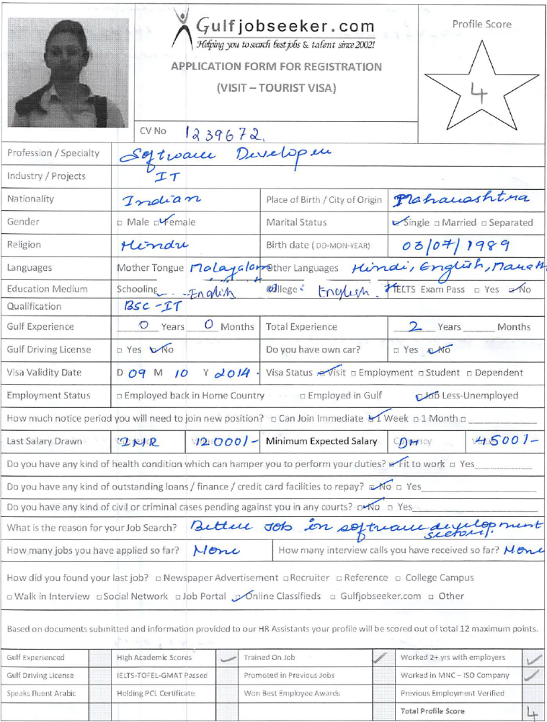
- Gulfjobseeker CV No 1239672
To get contact details of this candidate call +9971505797566
Or leave message on following link
http://www.gulfjobseeker.com/feedback/submit_fb.php

With more than 2 year of experience in application software development field, I am looking for a technically challenging position in the area of Software Design and Development where my skills and abilities can be put to use for improving organizational productivity, career advancement, expanding knowledge and skills.

Executive Synopsis

- Technical expertise in all aspects of the SDLC involving requirement analysis, design, development, testing, implementation and enhancement as well as troubleshooting
- Experience in database management.
- An effective communicator. Ability to relate to people at any level of business and management.
- Ability to work well under pressure, independently.
- Strong computer skills.

Technical Skill Set

Systems : Windows XP, Windows (Advanced)
Applications : SQL Server 2005/2008, MS-Office,.NET framework(2.0,3.5,4.0)
Programming : ASP.Net, Dev Express, Vb.net, SQL Server 2005/2008, C/C++,
AJAX, Javascript.
Employment Scan

Since September 13 Mighty Systems LLC,Al Rigga ,Dubai(Present)

Software Professional specialised in web/Windows Application for Systematic Money Exchanges using Microsoft Technologies.Activities included design, development, implementation, testing and debugging. Consistently meet tight deadline schedules within dynamic environments. Is equally effective working independently or as part of a team. Excellent oral and written communication skills.Developed Api (Application program interface)for banks, different file formats, dealing with different transactions of foreign currencies in market.
Exchanges Supported : Nonoo Exchange,Cash Express Exchange

Project Summary
Project 1

Project Name | Symex Online System
Client | Nonoo Exchange-Bahrain
Role | Team member
Responsibilities | Design, Coding, unit testing, debugging and Maintenance of Concerned Module
Duration | 6 Months
Team Size | 4
Software | Languages: Asp.Net, Devexpress-xtrareports, crystal reports.  Database: SQL-server 2005
Platform | Windows 7

- Symex Online System is a systematic online money exchange system which is developed for money exchanges for doing the daily transactions related money. Activities included designing, development , implementation , testing and debugging. Created reports using crystal reports and Devexpress - xtrareports based on requirements. Created file formats i.e xml , .txt and excel file for payment order generation based on the requirement of different banks. Developed Uremit Api for Cash Express exchange and supported the requirements.

Since September’11 Sands Lab, Info park, Koratty(Software Developer)

Software Professional specialized in Web/Windows Application Development using Microsoft Technologies now Working in Sands Lab Pvt ltd as Software Developer. Activities included design, development, implementation, testing and debugging. Consistently meet tight deadline schedules within dynamic environments. Is equally effective working independently or as part of a team. Excellent oral and written communication skills.
Project Summary
Project 1

Project Name | Divine Retreat System
Client | Divine Retreat Centre
Role | Team member
Responsibilities | Design, Coding, unit testing, debugging and Maintenance of Concerned Module
Duration | 6 Months
Team Size | 5
Software | Languages: Asp.Net, Devexpress  Database: SQL-server 2005
Platform | Windows XP

- Divine Retreat System is developed for Divine Retreat Center in Kerala. It is developed using ASP and SQL-sever. The project entailed the software for keeping track of various retreaters, their retreat events, managing room allocation for retreaters. Worked with a group of 5 members for this application.

Project.2
Project Name | Divine Magazine Manager
Responsibilities | Requirement gathering, business logic, coding, deployment, implementing, maintenance and training.
Software | Languages: Vb.Net, Devexpress  Database: SQL-server 2005
Client | Divine Voice
Team Size | 4
Platform | Windows XP

- Divine Magazine Manager is developed for Divine Voice Center in Kerala. It is developed using Vb.net and SQL-sever. The project entailed the software for keeping track of various subscribers, magazines, issues handling of magazines, post-offices, keeping track of delivery reports of various magazines. Worked with a group of 4members for this application.

Project.3
Project Name | Sands Clinic Management
Responsibilities | Requirement gathering, business logic, coding, deployment, implementing, maintenance and training.
Software | Languages: Vb.Net  Database: SQL-server 2005
Client | Lissie Hospital
Team Size | 7
Platform | Windows 7

- Sands Clinic Management is developed for Lissie Hospital in Kerala, developed using Vb.net and SQL-sever. The project entailed the software for keeping track of various patients, doctors, keeping track of schedules of doctors and managing I, stocks and inventory supplies. Worked with a group of 7 members for this application.

Project.4
Project Name | Attendance Labor Card
Responsibilities | Requirement gathering, business logic, coding
Software | Languages: Vb.Net  Database: SQL-server 2005
Team Size | 3
Platform | Windows 7

- Attendance Labor Card was developed using Vb.net and SQL-sever. The project entailed the software for keeping track of various labors, maintaining their records, attendance, salary account. Worked with a group of 3 members for this application.

Academic Projects

- Share Broking System using ASP.net and SQL-server from NIIT for a duration of 4 months. It demonstrated the transactions held in stock market i.e. the sale and purchase of shares, Keeps the track of details of different users.
- Core Banking System using ASP.net and SQL-server from NIIT for a duration of 6 months. It performs the various banking transactions like online payments, internet banking etc.
- Learned VB.net from LCC.

Educational Credentials

- Bsc-IT from Siena College Of Professional Studies, Edacochin (Kerala) in 2011(aggregate-75%).
- HSC from RYK& HPT Science and Arts Junior College, Nasik(Maharashtra)in 2007(69.17%).
- SSLC from Sacred Heart Convent High School, Nasik(Maharashtra)in 2005(81.46).

