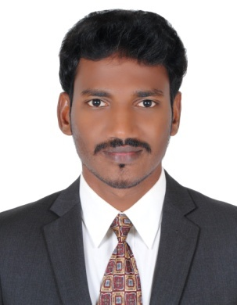
CURRICULAM VITAE

SATHAM
sadham-208341@2freemail.com

OBJECTIVES:
Seeking a suitable position of responsibility in your esteemed organization with my past experience, ability and Qualification. Where I could make significant contribution to the growth of the organization, which would gain me also a carrier advancement opportunity

EXPERIENCE:
- A/C technician at AL Zarooni Real Estate (building maintenance) Sharjah UAE
- Worked Sales Executive at Doha Modern Refrigeration Qatar (2013 May –Nov)
- Two year experience in Cold Storage Installation and Technician at Snow land Air-Conditioning System LLC Dubai
- presently working in Intercool air conditioning system LLC dubai.

ACADEMIC QUALIFICATIONS:
- SSLC – Government Higher Secondary School Vaithesswaran koil

TECHNICAL QUALIFICATION
- MR AC &CP( Mechanical Refrigeration Air-Conditioning and Central Plant)

COMPTER KNOWLEDGE
- Diploma In Computer Application (National Literacy Promotion Council - Chennai )

COMPUTER SKILLS
- MicroSoft Excel, Microsoft Power Point ,Photo Shop and different Computer software.

PERSONAL SKILLS

- Exceptional ability to setting up process for HVAC system or repair and maintenance of system that are previously position
- Able to install HVAC Walk in Freezer &chiller system making sure the installation is conducted in compliance with local regulation
- Able to work as independent contractor or as on employe
- Trouble shot &repair heating , air conditioning and controls. Performed a preventive maintenance program on all HVAC Equipment.
- planned preventative maintenance .
Job Description:
Responsibilities:
Seeking an opportunity as an HVAC /Refrigeration technician utilizing my training experience with an employer who offers advancement and initiative
INFORMATION:
Gender : Male
Marital Status : Single
Nationality : Indian
Visa status : Employment visa
Languages known : English , Hindi, Malayalam, Tamil

