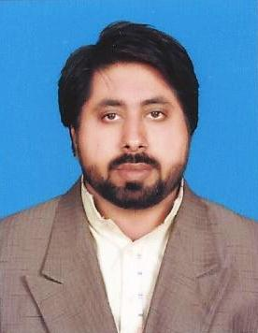
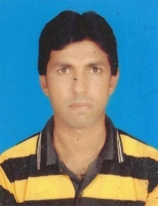
YASIR
YASIR.208459@2freemail.com

PERSONAL  DETAIL  DATE OF BIRTH .  01-04-1983  NATIONALITY  Pakistani  DOMICILE  Muzaffar Garh  MARITAL STATUS  Single  RELIGION  Islam | Objective :  To be pragmatic by putting my knowledge into practical. To join a highly professional team in a dynamic and global organization with challenging work environment to execute my skills.  EDUCATION  Degree University /Board CGPA/ Marks Percentage % Session  Matric B.I.S.E D.G Khan 480/850 56% 2000  F.A B.I.S.E D.G Khan 561/1100 51% 2007  B.A BZU Multan 512/800 64% 2009  M.B.A MBA Continue ----- 2013  EXPERIENCE  - Worked as “Admin Assistant” Reporting Admin Officer/IC Admin in Descon Engineering Qatar L.L.C  From November 2011 to October 2013 my key responsibilities were as below  Manpower Coordination  - Applying Visas on E-government medical appoints and visa renewel.  - • Lining up candidates for interview, selection test and documentation.  - • Hire needed manpower in assigned business unit according to manpower plan, Screening CV’s, interviewing process, offer letters, hiring documents  - Applying their visas and after issuance of visa coordinating for their mobilization providing all the docs to sites for gate passes.  - • Preparing salary agreements and record maintenance.  - • Ensuring documents completion for mobilization of both management and non-management staff.  - • File number generation in Centralized Manpower System (CMPS),  - • Coordination with site offices for manpower data and monthly manpower report compilation & dissemination.  - • Manpower sourcing through local and overseas manpower agencies. Assisted in the whole staffing process  - Sourcing on web portals for local and gulf hiring  - C.V Screening & short listing  - Scheduling, status making, case preparation & Filing  - Successfully coordinated local and overseas hiring campaigns  - DESCON official web recruitment portal handling.  - Issuing Inter Project Movement Orders considering the requirement analysis report.  - Prepare Documents for Exit (Kharooj) Process for Leave / Terminates / Resigned cases.  - Daily manpower status both for direct & indirect staff & updation of mobilization status.  - -Daily Attendance on Site & Office.  - -Computerization of Attendance and Report to Planning Department.  - -Daily Time Sheet Entries  - -Weekly and Monthly Reports as per Requirement.  - -Record & Complete Procedure of New and Old Employees.  - -Prepare Monthly Salaries.  Time office and Manpower Inductions:  - Assist in arrangement of manpower at site , induction of new mobilized candidates and arrangement of their PPEs.  - Assist time office supervisor in scanning, maintaining attendance records and allocation of manpower.  - Visit site regularly for identifying employees sitting idle and make report for future actions.  Manage and Keep record of following Activities:  - Sewage Removal  - Skip Removal  - Drinking water usage  - Inward and Outward passes for vehicles and tankers  - Invoice Verification  Housekeeping:  Manage housekeeping at site office and ensure maintenance & cleaning of ablution blocks.  Transport:  - Keep record of company owned and rental vehicles.  - Monitor and keep record of fuel consumption.  - Manage and Verify OT and SOT of drivers and staff.  - Invoice Verification (Rental Vehicles & Fuel Consumption).  - Manage maintenance of vehicles.  - Vehicle deployment as per site requirement.  - Assist Transport Coordinator in all matters related to transportation.  Recordkeeping:  - Responsible for maintaining records of all designated activities.  - Worked in EKL as a “Computer Operator” from 6-02-2005 to 23-07-2006  - Worked in HRL as “Computer Operator” from10-11-2006 to 24-12-2007  - Worked with UBL Bank  - Worked with Turkish Red Crescent  - Worked with Pattan Org  COMPUTER KILLS  - CCNA(Cisco Certified Network Associate)  - D.C.A(Diploma in Computer Application)  - D.C.I (Diploma in Computer Information)  - MS-Word, MS-Excel, MS-PowerPoint  - MS Windows  - Internet  - Installation  - In page  - Adobe Photoshop  CABABILITY  - Strongly Motivated and Quick Learner  - Able to Work both independently and as a part of team.
 | WORKSHOP AND TRAININGS
- Workshop on Active citizens”SYCOP” NGO.
- Workshop on Youth participation grass rout democratic development(YPGDD)
- Workshop on Power and Governance “PATTAN” NGO.
- Trainings on “Monitoring and Evaluation” and “Voluntarism” and “Advocacy”

