Mohammed
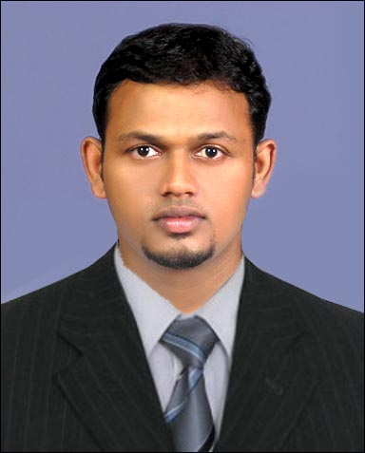

Mohammed.209697@2freemail.com

Document Controller

OBJECTIVE

Eager to contribute for a progressive company with quality management, provide good career growth, personal development and opportunity to learn new concepts, tools and techniques in a highly dynamic and fast paced environment.

PERSONAL ATTRIBUTES

- Self-motivates solutions provider with a creative approach to problem solving and a consistent team player. Catalyst for initiating positive change with exceptional skills. Result-oriented & multi-task professional with solid experience of more than 11 years in handling as a Doc. Controller

- Over 11 years of working experience in Electronic (ACONEX, Info Works & SAP) & Manual Document Control field

WORK EXPERIENCE

September 2014 to date : Salini Impregilo Spa Co.
Doha, State of Qatar
Project: Doha Metro – Red Line North Underground – Design and Build Package

March 2011 to Dec 2013 : Bechtel

(Raz Al Khair Aluminum smelter Project)
Saudi Arabia

Feb 2007 to Jan 2011 : Bechtel & Technip Joint venture

(Kahursania Gas Plant)
Saudi Arabia
- June 2006 to Feb 2007 : United Petrochemical Company
Saudi Arabia

- Jan 2006 to June 2006 : Saudi Toyo Engineering Company
Saudi Arabia

Working Experience in India

- 2004 to 2005 : Airtel Mobile Company
Kadavandra, Ernakulam Position: Data Entry Clerk

Duties & Responsibilities

- Responsible for developing comprehensive systems and procedures for maintaining document control and change control of documents. Enforce procedures governing document creation, document publication, use, archival and responsible for implementation of EDMS and Document Control Process.
- Responsible for arranging the training of all staff within the Engineer’s Organization in the use of ACONEX.
- Maintain Contract Execution.
- Ensures data control and distribution of project documents through EDMS (Aconex Transmittal and Workflow), including registration.
- Responsible in the Daily, Weekly and Monthly Report.

- Chair site meetings and distribute minutes to all project team members.

- Provide guidance and support to document controller to ensure effective document distribution process.
- Responsible for processing all incoming hard copies, as follows: providing a registry number, listing them in the Incoming Registry, indicating a due date for response, allocating the Team Coordinator and Reviewers as verified by the Project Director
- Generate and maintain the document registration ensuring updated daily

- Finalization of drafts in Aconex by making sure the necessary documents is attached to it before Project
- Director’s signature

- Responsible for processing/sending all outgoing documents through Aconex, providing a system- generated number, registering sent documents on the Incoming Registry as a reply
- Generating overdue transmittals via Aconex and preparing them together with the other correspondence types that will be due and are overdue that are listed in the Incoming registry for distribution to the corresponding secretaries and their managers every Thursday
- Changing status of Document in Aconex as per Engineer’s Design/ Documentation Review
- Filing, storing and data maintenance in such a manner that information should be available for all concerned persons at any time.
- Handling an informative system of matrix for distribution of project correspondence, Inspection Requests, shop drawings, Engineer's comments/approvals on site clarifications, work notifications, document submittals, material submittals, area of access handovers, developed by the project management.

- Performed administrative functions for the organization such as creating and administrating new member accounts and organization security.

COMPUTER SKILLS

  - Diploma in Computer Application (DCA)
  - Microsoft office applications (97 & 2000)

  - Proficient in Word, Excel & Power point

TECHNICAL QUALIFICATION

Graduate Diploma in Business Administration

(National Institute of Management, Recognized by Government of Maharashtra)

Plus Two

(Higher Secondary Examination, Recognized by Government of Kerala)

PERSONAL DETAILS

Name : MOHAMMED

Date of Birth : 04.01.1984

Marital Status : Married

Citizenship : Indian

Religion : Islam

License : Saudi Arabia / Qatar

Languages known : English, Hindi, Tamil & Malayalam

In conclusion, I would like to assure that I am capable of handling any job assigned to me, which suits my qualifications and experience with almost care coupled with Leniency and my efficiency towards work to the total satisfaction of my employer

Mohammed

