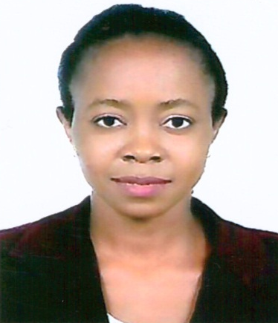

SHOYEMI
SHOYEMI.210268@2freemail.com
SUMMARY
- Profile: Female , 36 , Married
- Nationality: Nigeria
- Current Location: UAE
- Current Position: Housekeeping Attendant
- Company: Abedous Building Maintenance and Cleaning Services, UAE.
- Preferred Location: Anywhere.

CAREER OVERVIEW: Dedicated caregiver with over 10years of experience. Committed to improving overall patient wellbeing and health through personal care and energetic engagement.

ATTRIBUTES & SKILLS: Schedule management, Medication Administration, Housekeeping and laundry, Grooming and bathing assistance, Meal preparation, Personal care, Doctors Visit, Fit and able to move patient, Mobility Assistance, Calm and level-headed under duress.

EDUCATION:
FILIPINO INSTITUTE, Dubai-UAE (JULY 2017)
CAREGIVER (Certificate course)
- Caregiver Intermediate Level
- Caregiver Basic Level
EWUSU HOSPITAL LTD, IKORODU, LAGOS-STATE, NIGERIA (2009)
PRACTICAL NURSING AND DISPENSING (Certificate course)
KEME BALOGUN COLLEGE IBESE (1999/00)
SENIOR SECONDARY SCHOOL CERTIFICATE (SSCE)
WORK EXPERIENCE:
2016 – Present ABEDOUS BUILDING MAINTENANCE AND CLEANING SERVICES
Housekeeping Officer
- Attending to client various house shore needs and general home care services.

2010 - 2016 OREOFEOLUWA COMMUNITY BIRTH ATTENDANT, IKORODU, LAGOS-STATE, NIGERIA
Birth Attendant
- Assisting Pregnant women in child delivery
2014 - GENERAL HOSPITAL, IKORODU, LAGOS-STATE, NIGERIA
Industrial Training Student
- Vital Signs and Drugs dispensing

2008 - 2009 RHAFA MEDICAL CENTRE, IKORODU, LAGOS-STATE, NIGERIA
Nursing Assistant
- Clean and bathe patients or residents
- Help patients use the toilet and dress
- Turn, reposition, and transfer patients between beds and wheelchairs
- Listen to and record patients’ health concerns and report that information to nurses
- Measure patients’ vital signs, such as blood pressure and temperature
- Serve meals and help patients eat
- Dispensing of patient drugs
2005 - 2008 EWUSU HOSPITAL LTD, IKORODU, LAGOS-STATE, NIGERIA
Birth Attendant
- Assisting Pregnant women in child delivery

LANGUAGES:

- English National Language (Excellent in Reading, Writing, Listening and Speaking)
- Yoruba Native Language (Excellent in Reading, Writing, Listening and Speaking)
PERSONAL ATTRIBUTES:
- Good team player
- Self-starter and goal oriented
- Honest, Intelligent and Articulate
- Ability to face challenges
- Ability to lead and focus under pressure
CERTIFICATES:
- Certificate of Completion of Caregiver Intermediate (August 2017)
- Certificate of Completion of Caregiver - Basic (June 2017)
- Certificate of Membership (Faith-Based Community Birth Attendants Association) October ‘2015.
- Certificate of membership (The Association of Christian Mid-Wives) November 2012.
- Certificate of Proficiency (Ewusu Hospital LTD) February, 2009
- KEME BALOGUN COLLEGE, IBESE, IKORODU, LAGOS STATE

