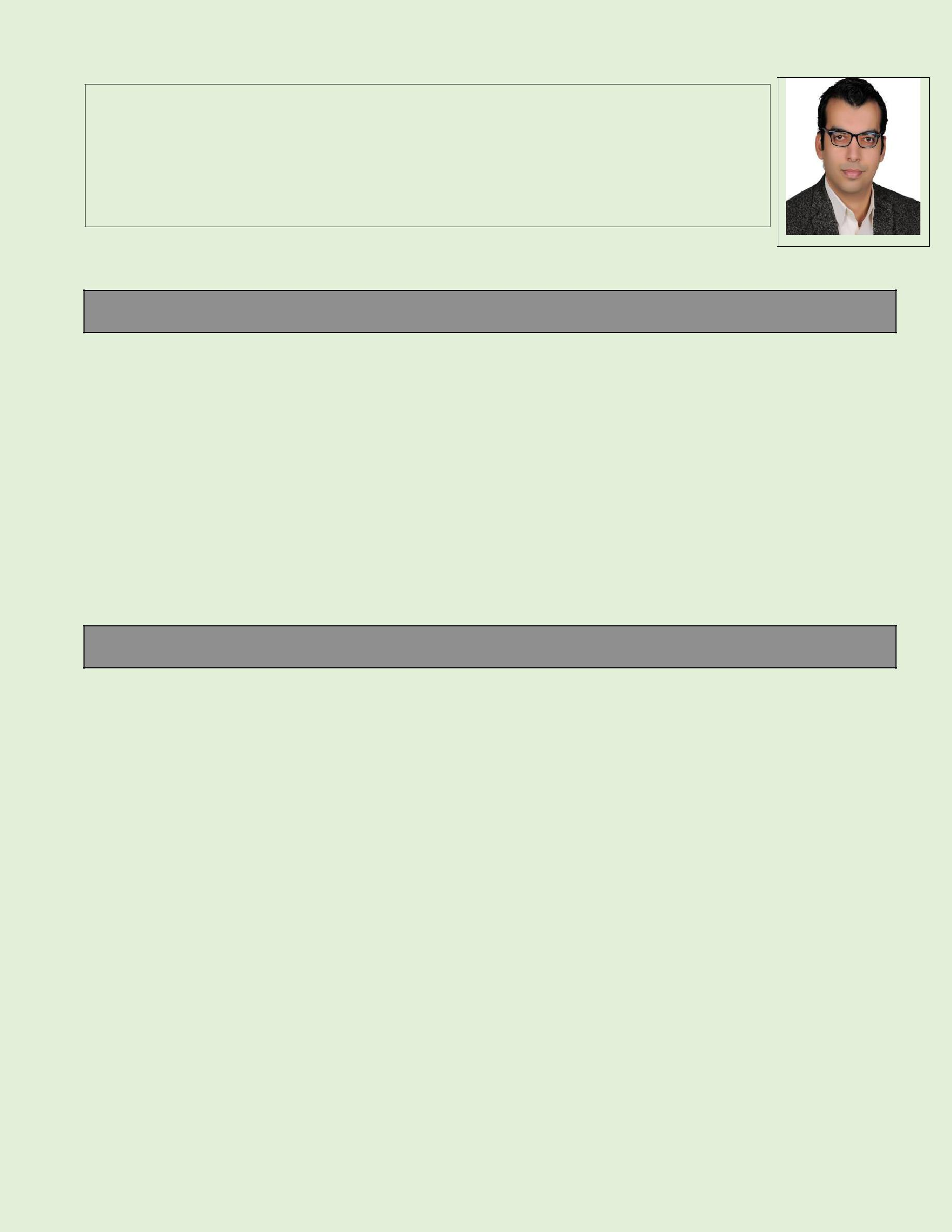
IBRAHIM

Address : Dubai – UAE

Email Ad. : ibrahim.210568@2freemail.com

OBJECTIVE

To join company that promotes experience in professional growth among its employees thus enabling me to maximize my potentials and capabilities as a person and as a professional and would help me build my career that is based on continuous education and professional development, in additional, to contribute for the financial and status growth of the company through me and the company’s contribution.

Civil Engineer, 3 years’ experience, I seek to join a challenging job in a progressive organization, where I can be the best utilized according to my abilities performance, Efficiency in civil engineering department. Experienced in project management international standard from the American university, Two years’ experience in site supervision and construction.

EDUCATIONAL BACKGROUND

Diploma FROM American University for the Project Management International Standard

JUN "2017”

BACHELOR OF General civil engineering

MANSOURA UNIVERSITY

Egypt

Graduated May 2015

Project degree Excellent

(Properties and resistance of engineering materials)

Cumulative grade good

I

COURSES AND CERTIFICATES

- Certified PRIMAVERA Project Management from the American University.

- Certified the Project Management International Standards from the American University

- Certificates in General English Course from the British Council.

- Course design kinds of the foundations.

- Course Autodesk Revit structure.

- Course Autodesk robot structure analysis professional (self-study).

- Course AutoCAD at Mansoura university scientific computing center.

SKILLS

- Planning and scheduling in detail for executing the various stage of the project within the stipulated time as required the management.

- Estimate and planning labour requirements to ensure effective time management.

- Monitoring and controlling quality of materials, equipment’s workmanship on a regular basis.

- Preparing cost and time estimates of completing the project.

- Understanding the plane and design drawings of the proposed structure.

- Knowledgeable in computer applications such as; MS Word, Excel, PowerPoint and Internet

- Good command in oral and written communication.

- Adaptive to individual and teamwork environments.

- Ability to grasp things fast and maintain good relationship with my team.

- I’m a positive team player with a flexible and friendly attitude, I’m hard working, punctual and very creative.

II

(2010 to 2012)
WORK EXPERIENCES

Civil Engineer, Engineering Authority of the armed force (18th Oct 15 to 1st Dec 16)

I implemented and supervised some projects for the Egyptian Armed forces, Construction of a command building. Repairing and strengthening some command, Centers and automated control centers in Ismailia city, Egypt. Supervising the construction, of a 50-km wall in Ain sukhna, Egypt .Worked in the table of quantities before the implementation. Of any project, worked in some schemes for some projects

Trainee in the Arab Contractors Company, water structure projects. (2012 to 2015)

Construction of a treatment plant, a group of the tank under and above ground, execution of, The Arab contractors company, group of construction bridge on the canal in algamalia city, Egypt Training in material resistance laboratories and conducting some test for the company.

Trainee in many Construction sites in Mansoura, and ministry of water Resources, Egypt.

PERSONAL INFORMATION

NAME | : IBRAHIM
BIRTHDATE | : | 6TH MARCH 1991
NATIONALITY | : | Egyptian
JOIN TO TEAM | : | Immediately
EMAIL | : | Ibrahim.210568@2freemail.com
PROFESSION | : | Civil Engineer
LANGUAGES | : | Arabic, English
Status visa | : | Visit visa, valid to 20 Dec 2017

III

