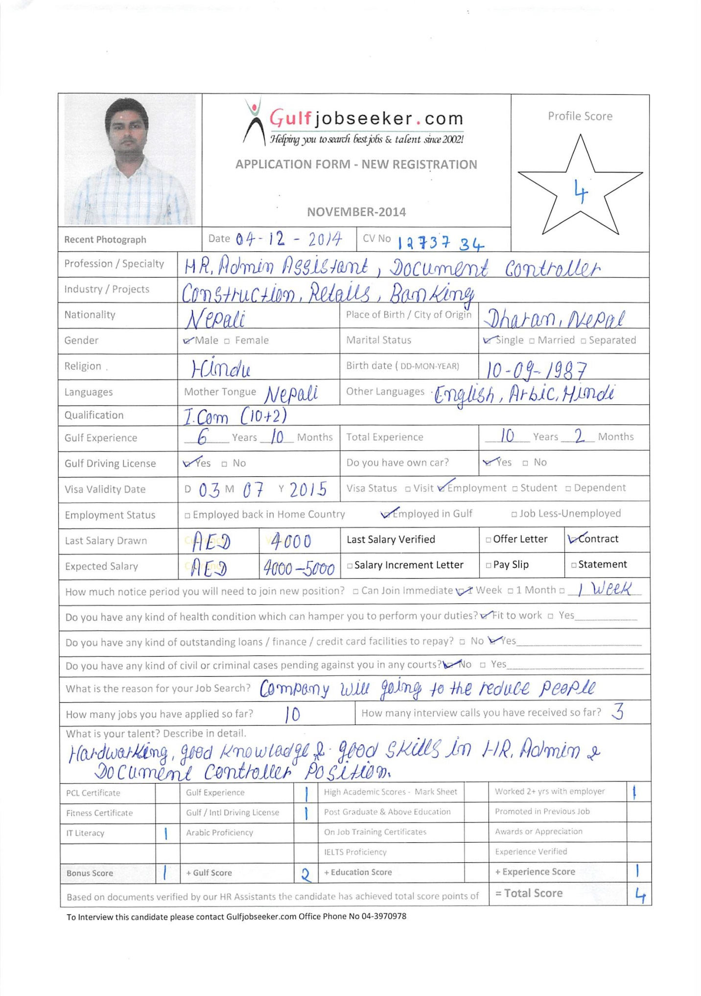

Career Objective:-
Willing to work in a challenging and creative environment where I can utilize my talents specifically and effectively to contribute towards the goals of the organization. Seeking a challenging job opportunities in a well-established National or Multinational Company, to be an active participant in a team where I can enhance my creativity and team work skills, to promote long-term growth and profitability of the company.

Work Experience:-
HR Assistant (H.R Coordinator) June 2013 to Present
Reputed Firm Dubai, U.A.E

Nature of work / Responsibility
- Coordinating with H.R officers with regards to human resources procedures and acting as a point of contact with employees and division heads.
- Maintenance of database containing employees’ records.
- Preparation of employees (both hard & soft copies) personnel files & compilation of data for same.
- Managing & issuing staff passport, labor card and labor contract.
- Coordinating with insurance company with regards to all employees’ insurance card. (Addition, Deletion and Release) for both Principal and Dependents.
- Preparation of letter correspondence as & when required.
- Preparing Salary certificate, Salary transfer certificate. No objection certificates etc.
- Handling letter request of employees in coordination with the division’s respective HR officers.
- Handling medical & emirates ID procedures in case of a group recruitment.
- Preparing correspondence, managing administration projects for executive management on request.
- Liaising with other department regarding any arising maters or problems.

Document Controller May 2009 to April 2013
Thermo L.L.C Dubai, U.A.E

Nature of work / Responsibility
- Responsible for all documentation in the work site. Controlling/dispatching drawings like Civil, Mechanical, Electrical, Plumbing and HVAC. Maintaining Site Reports, Daily Site Reports and Construction Change Reports to help billing purpose to Quantity Surveyor.
- Maintaining Drawing-Control Register, Job Review Register, Job Instructions to Sub-contractors. Working in close Interaction with Planning Engineer.
- Distribution of the documents to relevant engineers and staffs as per the Document Matrix Register.
- Organize and maintain incoming and outgoing documents such as IFC drawings, Material Approval Sheets, Technical Queries, Technical Data, Reports and Inspection Request.
- Ensure all project documents including Drawings, Quality Manuals, Method statements, Procedures and specifications are transmitted to relevant personnel including Clients and Consultant also Sub-contractors (if applicable).
- Coordinate with Consultant, Client and Sub-Contractors for on time submission.
- Maintain manuals, Catalogue, Test reports, CVs for the projects in compliance with all quality and regulatory requirements.
- Follow up the priority items (MAS) with relevant Engineers and Vendors.
- Assist completion of requests, searches and queries from any project members. Prepare meeting Agendas, Presentations, Reports, Minutes of Meetings.
- Monitor and update any change/modification to the technical documents and maintain register record accordingly.
- Preparation of correspondence & controlling for the project & all the related works of office secretary.
- To ensure that all corporate documents are well checked and submitted on time prior to the documents submission due date.

Data entry operator January 2008 to April 2009
Thermo L.L.C Dubai U.A.E

Nature of work / Responsibility
- Maintaining all Incoming/Outgoing filing system register and.
- Entering the letter, company related documents and response to incoming mails and calls..
- Performing Entry work, Documentation and Clerical duties for the senior Officers.
- Typing, filing, Photocopying, Scanning and faxing of documents when requested to do so by senior members of staff.
- Maintain an appropriate file of records, concerning Employee Status Change (ESC) such as salary adjustment, re-designation/promotion, resignation and termination.
- Prepare &amp; Check all price Invoices of the Contractor & delivery notes for getting final approval from Project department with ID code stamp & Manager signature, then forwarding all Invoicess to the Accounts department for payment release purpose.
- To ensure that all works is finished and handle it very well within a period.
- Answering, screening, filtering or transferring relevant Calls to other department staffs.
- Update and create the Database management system of Employee and organization details.
- Prepare Timesheet for the Employees and contractors.
- Ordering and maintaining office stationary and supplies.
- Create & modify the document as per company’s format using Datasheet.

Store Keeper December 2006 to October 2007
Surya Nepal Pvt. Ltd. Itahari, Nepal

Nature of work / Responsibility
- Handling incoming and outgoing correspondence.
- Maintaining an inventory of the items.
- Checking on weekly bases items expiry and availability.
- Dispensing of material.
- Maintaining accurate of stock records.
- Maintaining store image by proper display and follow visual.
- Ordering to suppliers as per site requirement.
- Receiving orders making sure they are executed in time.
- Weekly report submitting to Project manager.

Cashier January 2006 to November 2006
Shikhar Savings & Credit co-operative Society Dharan, Nepal

Nature of work / Responsibility
- Handling cash & cheque collection.
- Deposit cash & cheque in a particular bank
- Preparing outstanding statement of customer.
- To Handling the petty cash.
- Reporting to senior accountant.

Accountant August 2005 to November 2005
Junction Cyber Café Dharan, Nepal

Nature of work / Responsibility
- Posting all the journal voucher entries & payment voucher entries.
- Preparing the staff salary.
- Preparing outstanding statement of customers.
- Maintaining bank reconciliation statement.
- Making daily summary & posting in computer.
- Import & export documentation of the company as respective laws applicable.
- Month end report submitting to account manager.

Assistant Accountant February 2005 to August 2005
Biomed International Pvt. Ltd. Dharan, Nepal

Nature of work / Responsibility
- Data entry of sales & purchase using oracle based accounting software cactus.
- Debtor’s collection as per overdue & maintaining weekly payroll.
- Operated daily cash registers, bank books & Bank reconciliation.
- Reporting to the chartered accountant every month end.

Receptionist July 2004 to December 2004
M.I.C Computer Centre Dharan, Nepal

Nature of work / Responsibility
- Answering all phone calls/enquiries from clients and suppliers, taking the massages and transferring them to the appropriate associate/department.
- Typing correspondence, memos, report and other documents.
- Performing general office work such as filing, photocopying, sending/receiving faxes, sending/receiving e-mails and other administrative duties.
- Responsible for the creation and updating files.
- Assist in the administration and maintaining office records.

Education Qualifications:-
- Adv. Diploma in Computer Application From Microtech Solution Pvt. Ltd. – (2007) Kathmandu, Nepal M.S Access (Word, Excel, Outlook, PowerPoint, Publisher), Tally, General Hardworking & Networking & other Programmed.
- Higher Secondary Education (I. Com) - Shree Public Higher Secondary school - (2005) Dharan-12, Sunsari, Nepal
- School Leaving Certificate (S.L.C) - Shree Shiksha Niketan Secondary School - (2003) Dharan-6, Sunsari, Nepal

Additional Skills:-
- I.T.I Electrician From Itahari, Nepal
- Language Known : English, Hindi, Nepali, Arabic
- Driving License : UAE Valid Driving license (Light Vehicle – Manual)

Personal Information:- Age : 28 Gender : Male Marital Status : Single Nationality : Nepali Religion : Hindu

Declaration:-
In the undersigned declare that the above furnished statements are true & correct the best of my knowledge & experience.

