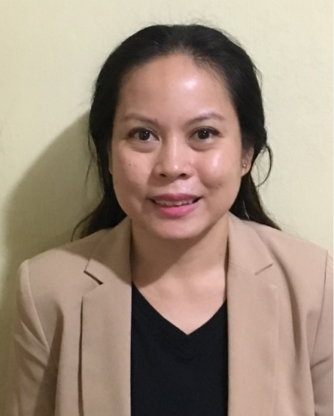
Yrene

Emails: Yrene.213097@2freemail.com

Value Statement: I have been in the workforce for 12 years and most of these experiences were support roles for Managers to Senior Leadership Team. Trust that I will deliver as I am very professional, articulate and an effective decision-maker.

Summary of Qualifications:

1. I have advanced analytical skills from collecting data, maintaining records and building reports. Being keen on details, I was able to provide useful data for effective monitoring, process improvement and critical decisions for the company.
2. My organizational skills are always on point when expected to handle big accounts, large data or high profile clients. Multi-tasking on planning, management and scheduling even resource coordination enabled me to meet deadlines with quality output.
3. I communicate well with my stakeholders and manage their expectations well. I have acted as a liaison between departments, counterparts and company partners and handled vendors from different countries.

Professional Experience

July 1, 2016 to March 31, 2017 | Microsoft Philippines | Makati City PH

Enterprise Services and Delivery Vendor Operations Support for South East Asia – Vendor and Relationship Manager for Services Delivery of Bangladesh, Brunei, Indonesia, Malaysia, Philippines, Thailand, Sri Lanka and Vietnam.

Responsible for Vendor profiling and sourcing in which I reach out to the vendors via phone call and email to get the necessary info needed for them to be an accredited partner of Microsoft as well as the actual processing (application and tool management) of accreditation requests. Once completed, I made sure they are empaneled and compliant-ready to start work. I also managed their contracting requirements, internal and external and help with rate negotiation for their resources. Since I am their primary liaison with the company, I help govern and monitor their delivery of services in behalf of the company.

List of all CRM, systems, programs and tools used:
CRM:

- Microsoft MyOrder – procurement and other finance-related portal
- Microsoft CRM – Main database for all accounts, partners and vendors
- Microsoft Explore
- Unicorn
- Navigator

PROGAMS & TOOLS:

- Microsoft Compass One (integrated online contracting tool), K360 (contracts, documents and forms) and Microsoft Enterprise Services Business Insight (integrated reporting tool)
- Microsoft O365 Office including Sharepoint and Power BI

March 5, 2013 – June 31, 2016 | Microsoft Philippines | Makati City PH

Business Excellence and Operations Analyst for SEA – Business Support and Data Analyst for Microsoft Services Team of SEA. Sales Support, Sales Coordination, Contracts Support, Document Controller, Compliance and Audit, Financial Analysis, Accounts Receivable, Collections, Project Management

- Provided timely reports, analysis and monitoring productivity goals, sales and audits. In-charge of all documentation by managing a Sharepoint site also used for form request submissions with workflows and approval embedded in the site.
- Performed account pre-checks (contracting tool, physical document and content) for agreement creation between customer and Microsoft. Facilitates internal approvals and contract countersigning as well as escalations to Legal and Senior Management. Helped secure documents needed by the Sales team to close the deal (PO, Accreditations, Exceptions, Bank Guarantees, Notarization, Certificates, Insurances and Permits).
- Handles change requests on Billing, Renewals, Extension, Refund/Rebill and Contract Content for proper entitlement of revenue and quota.
- Maintained processes compliant to services policies and addressed audit fails accordingly for remediation and elimination as well as for process improvement and standardization.
- Account and customer information maintenance in the CRM systems. Assists quota loading and management crucial for attainment and incentive pay outs of Sale Executives.
- Primary support for project planning, cascades, launch meetings (facilitates conference calls), track preparedness, participates in UATs, measure success and answer user queries and escalate issues.

February 9, 2012 – February 28, 2013 | Tech Mahindra Limited | Quezon City PH

Assistant Manager for Management Information System Team – Workforce, Forecasting, Capacity Planning, Resource and Reporting Management

- Head coach and mentor of MIS team, supported the MIS Manager in driving and tracking process parameters, building and maintaining reports, ensuring work capacity is maximized through proper forecasting and planning.
- Special assignment on managing POC phase of order/application processing accounts for GLOBE Telecoms (biggest telco network in the PH). From developing tools for data capture/ UAT, to reporting outputs and to maximize resources as per allocated budget

May 15, 2006 – August 30, 2010 | HSBC Electronic Data Processing (Phils) Inc., | Quezon City PH

Assistant Manager Operations Desk – Resource Analyst, Reporting and Scheduling Management

- In charge of monitoring, measuring and presenting productivity reports for schedule adherence and operational coverage. Maintained sales reports, trend analysis and performance evaluations for problem mitigation.

- Nov 15, 2003 – February 28, 2006 | Hinduja Global Solutions | Quezon City PH

Workforce Analyst – Resource Analyst, Reporting and Scheduling Management

- Updates daily, weekly & monthly reports site-specific for American Express Customer Service, Customer-Focused Sales and Pay-by-Phone departments.
- Provides analysis reports on site performance on a monthly basis.
- Directly liaises with client’s Contact Delivery Management (US-counterparts) for shift management and capacity planning
- Creates forecasts and schedules on a monthly basis in coordination with the client, operations, human resources and training.
- Maintains employee information and audits schedules in eWFM.

- Feb 15, 2003 – November 14, 2003 | Hinduja Global Solutions | Quezon City PH

Customer Service Associate– Troubleshooting, Phone Support, Data Encoding and Processing
- Handles in-bound calls for phone payments, customer service queries and services of credit card accounts for American Express.

- November 15, 2002 - Feb 14, 2003 | Ralph’s Wines and Spirits | Makati City PH

Retail Store Manager – Retail Operations, Inventory Management, People Management, Accounting
- In charge of entire store operations, employee management and performance, stock inventory, order management, sales and marketing promotions, and bookkeeping,
Education
June 1997 – October 2002 | University of the Philippines Diliman | Quezon City PH

Bachelor of Science in Food Technology

