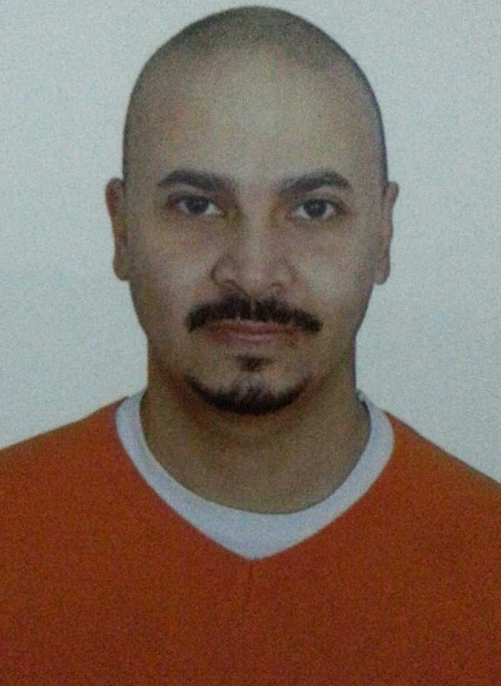
Karim

Personal Data:
Name : Karim
Gender : Male.
Date of Birth : 30/9/1982.
Nationality : Egyptian.
Marital : single.
Address : Dubai,UAE.
Email : karim.213285@2freemail.com
I have UAE driving license

Profile:
As a business operations Team leader, with a wide range of experience in the Management, E.Payment , Sales, able to make excellent plan for the market , then that increase company`s profit , motivate team, create the spirit team work, ability to give others my experience, able to help, flexible, outgoing personality, self motivated, eager to learn and grow, prefers always to work with others, working in a company with big name, working under strength and to give out all my power and skills in my job so I hope this curriculum vitae get

Objective:
Aspire to attain a challenging job, where I can apply my academic knowledge, enhance my personal experience and broaden my horizon through handling diversified tasks in a dynamic environment.

Education:
May 09
Modern Academy
Information System
Cairo, Egypt
Total degree: very good

Languages:
Arabic: Mother Tongue.
English: Good.

Professional Highlights:
- Capable of working effectively under pressure and managing stress while producing high quality end-results.
- Self motivated, self-starter with strong analytical and problem solving skills.
- A team player that pays particular attention to promoting a positive and productive working environment.
- Interested of traveling, adaptive with different culture and have a high sense of adventure and ambition.
- Expanding my job knowledge and constantly adding new skills.

- Excellent communication and interpersonal skills.

Personal Experiences:

March 2017-:
Working as relationship manager in at work department in ADIB in UAE

May 2015 -: January 2017
Working as sales in personal loan department in Emirates NBD in UAE

May 2014–; May 2015;
Working as relationship officer in CITIBANK in UAE

Sep 13–Feb 2014;
Working as business Operation Team leader in Destel (Payment solution Services).

September 09- – August 13;

April 12– August 13;
Working as Data center Operations Team leader in Fawry (Banking & Payment Technology Services).

September 10 – April 12;
Working as business Operations in Fawry (Banking & Payment Technology Services) .

Job summary in Fawry :

Marketing
• To understand and define customer segments and establish strategies for customer needs and wants
• To consistently understand customers needs through customer research to bring best in category product features
• Recruit partners and negotiate rewarding offers from merchants for bank's loyalty program
• Plan and coordinate joint promotions for merchants and banks cardholders
• To manage relationships to ensure alignment with the overall business
• Ensure training and continuous back support for merchant retail outlets

Acquiring

• Identify high value business merchants in the market for card acceptance services
• Prospect, evaluate, and acquire new merchants
• Improve market share by evaluating feedback from competition merchants
• Gather market information for future expansion from key market players and analyses potential growth areas for merchant acquiring until
• To work with sales to define acquisition channels and sales objective for overall Acquisition strategy year after year

September 09- July 10;
Working as a sales rep. ( personal loans) in Bank
Visiting potential customers to prospect for new business
Maintaining and developing relationships with existing customers via meetings, telephone calls and emails, convincing existing Customers to get extra benefits & loans, help the customer to be satisfied with theservice

July 07- September 09;
Working as Sales Man inVodafone (Part Time).

Job summary in Vodafone :
-Worked as direct sales executive.
-Achieved my plan and target by achieving about 2,000,000EGP per month.
Note: the store sets my target to be 1,500,000EGP per month.

Computer Courses:

- ICDL (International Computer Driving License).
- Computer Operating Systems.
- PC assembly.
- MS Data Base.
- HTML Fundamentals
- Using computer and managing files.
- Internet (Introduction, Advanced level, information and communication).

Personal Skills:

* Good leadership Skill
* Work under pressure
* Problem solver using analytical and logical thinking
* Excellent public speaking
* A team player
* Flexibility in multi tasking
* Quick learner

Community Services:

Participated in various blood donation campaigns

Various Fund Raising campaigns and heritage area field visits

Goals:

Willing to be a member to gain more experience to be an active member in the society

References and support documents:

- Available upon request

