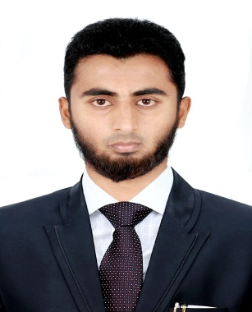

Gulfjobseeker.com CV No: 1281588
Mobile +971505905010 cvdatabase[@]gulfjobseeker.com

To contact this candidate use this link
http://www.gulfjobseeker.com/feedback/contactjs.php
Professional Profile:

A competent professional with experience in the areas of Maintenance. A well-organized, reliable and enthusiastic office administrator with a wealth of maintenance experience in both large and small companies. Hard-working and self-reliant, with the ability to remain calm and good humored under pressure. Enjoys working on own initiative or as part of a team.

Objective

Seeking to find a position as an Any Suitable Job in a development-oriented company, which allows me to use my talents and gifts to fill the needs of its members and clients and to use proven skills and ambition in a career with potential for long-term advancement.

Career Summary

May 2013 - March 2014 Susruta agencies (MAS) Pvt.ltd, India Service Engineer
Chief Tasks Handled:

- Repaired and calibrated dialysis equipment’s as part of preventative maintenance.

- conducted bi-monthly checking and maintenance on dialysis equipment’s in hospitals.

- participated in the company's international campaign of installation of biomedical devices.

- conducted quality control procedures to prevent unexpected breakdowns of machines.

- To operate an all types of dialysis equipment's in hospitals and dialysis units.

- If any materials failure in dialysis equipment's, check the materials and serviced.

- Smooth & hassle free monitoring of dialysis equipment's, with no major issues or Complains.

- conducted workshops and trainings on medical equipment operation for hospitals.

Page 1 of 2

Academic Chronicles

- Bachelor of Engineer- Electronics and Communication Engineer.
Mohamed Sathak A. J. College of Engineering, India.
Anna University in 2013.

Computer Proficiency

- AutoCAD 2D
- Microsoft Office, Microsoft Windows

Project

Feasibility of Intelligent monitoring of Construction worker for poisonous Gas using ZIGBEE.
The project is about a protection of construction workers, mining workers from poisonous gas CO, CO2 and earth based temperature. The CO, CO2 sensor is an H-550 it is world’s smallest sensor and thermistor can be using for sensing the temperature. Microcontroller is an 8bit PIC16F877 controller with MAX-232. We have used RS-232 for telecommunication between DTE and DCE, LCD display for our application.

Areas of Interest

Microprocessor & Micro-controller, Digital electronics.

Personal Skills

Comprehensive problem solving abilities, good verbal communication and ability to deal with people diplomatically, willingness to teach and learn, Team facilitator, Leadership capability.

Personal Details

Date of birth : 7th May 1992
Marital status : Single
Languages known : English and Tamil (Read, Write and Speak), Arabic (Read and Write)
Nationality : Indian

Page 2 of 2

