SHAMEER 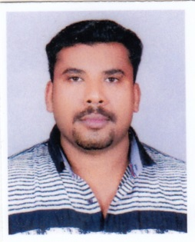

Shameer.213908@2freemail.com]

CAREER OBJECTIVE.

To obtain a position whereby my experience and skills are explored for the growth of the organization and my career and to obtain challenging position with a market leader and to contribute to its growth and development.

PERSONAL SKILLS .

- Easily adaptable to any environment, able to work under pressure producing the required results
- Good communication skills.
- Self-motivated, responsible, confident and poised in interactions with individuals at all levels
- Skilled organizer and problem solver with the ability to consider all options before making a decision.

EMPLOYMENT RECORDS .

AL MADINA GROUP OF COMPANY .

- COMPANY DRIVER- 8 YEAR IN SAUDI ARABIA
2008 TO 2016
STORE KEEPER-DP WORLD DUBAI, U.A.E. .
01 OCT 2005 to 2007.

- Manage stores.
- Worked as acting Tally clerk.
- Coordination with Store and Purchase for timely deliveries.
- Keep necessary Stock level in company.

SRM EXPORTING INDIA

- Marketing – 4 year in INDIA-2001-2005

- Exporting and marketing of embroidery products.

EDUCATIONAL QUALIFICATION.

- SSLC CERTIFICATION
- Higher Secondary Course (CBSC) from, Kerala, India.

TECHNICAL SKILLS.

- Platform & Packages : Windows XP/2003/2000/98/95 /DOS
- Other : Well versed with usage of Internet and e-mail.
- MSword and MS office.

LICENSE .

- Having valid Driving License issued from Saudi Arabia,
- Good knowledge of Roads rules.
- Indian driving License.

PERSONAL DETAILS.

Nationality : Indian.
Sex : Male.
Marital Status : Married.
Languages known : fluent Arabic, English, Hindi & Malayalam

-----------------------------------

