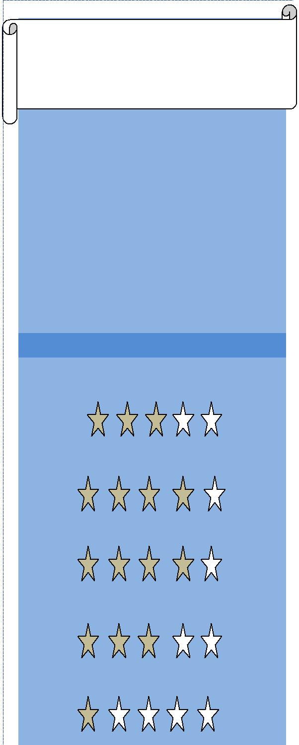
MUSHIR

HVAC engineer

Contact:

Mushir.215752@2freemail.com

D.O.B:

1986

SOFTWARE SKILLS

AutoCAD 2010

Microsoft word

Excel

Elite Chvac7.01.37

Revit MEP 2014

PROFESSIONAL CERTIFICATE

PMP
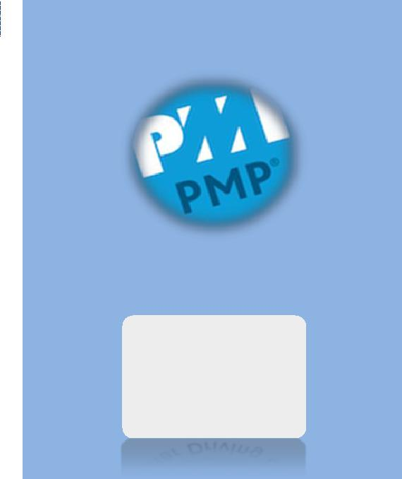

#2039619

ICDL

#GCC 060 107525

EDUCATION

- BSc in Mechanical engineering – University of Khartoum 2003 – 2008, SUDAN.

- PMP – Project Management Professional, PMI – USA.

- ICDL – International Computer Driving License – DUBAI.

WORK EXPERIENCE

- ALTAKAMUL ALHANDASI CONSULTING COMPANY –SUDAN

Duration: July 2009 till July 2013

Designation: Mechanical engineer

I worked as mechanical engineer at Bio-remediation projects (Produced water treatment – hydrocarbon removal from oil field produced water using Reed Bed treatment system) at GREATER NILE PETROLEUM OPERATING COMPANY (GNPOC).

Duties and Responsibilities:

- Supervising the Work as per Client’s requirements in accordance with Contract documents.

- Receiving drawings for the pipeline system transferring produced water from the field production facility (FPF) to the bioremediation area.

- Follow up the client's procedures & method statement for pipeline construction & equipments installation in the following projects:

  - Diffra Bioremediation project: constructing of hydrocarbon contaminated water line of low carbon steel 20” Dia, delivering 30000 barrels per day.

  - Munga Bioremediation project: 20” Dia, delivering 25000 barrels/day.

  - Unity Bioremediation project: 20” Dia, delivering 50000 barrels/day.

- Coordinate between client & contractors.

- Making daily reports about work progress

- Performing Hydrostatic test in accordance with GNPOC procedures.

- Hand over the system to the client for final operation.

LANGUAGES

English

Arabic

DRIVING LICENSE

UAE D/L

HOBBIES

Reading

Swimming

REFERENCES

Available upon request

- M-ARSLAN CONSTRUCTION COMPANY – SUDAN.

Duration: Apr 2014 to May2017

Designation: HVAC Site Engineer

Duties and Responsibilities:

Execution of HVAC projects, in Chilled water system.

- Supervising the Work as per Shop Drawings, Project Specifications and International Standards.

- Scope includes installation of air cooled chillers, chilled water pumps, ducting & piping systems.

- Materials submittal in order to get consultant's approval.

- Ensure that Chillers, AHUs, FCUs, Ducts, Pumps and piping system are installed & functioning as per approved shop drawings & manufacturer’s instructions.

- Prepare relevant documents to conduct inspection for completed installation activities, issue request for inspection (RFI) to appropriate personnel in order to verify the quality and the quantity of the work performed.

- Attending meetings with client, consultants & construction team.

- Managing site activities in accordance with time schedule.

Last Year Project

- Qualification of welding different metals. Scope of project:

  - Welding two metals (cast iron & carbon steel) using Arc welding, DC machine & 69% nickel alloys electrode.

  - Determine the qualification of welding using destructive tests according to American Welding Society standard (AWS).

