CURRICULUM VITAE
Gulfjobseeker.com CV No: 1298436  Mobile +971505905010 / +971504753686  To get contact details of this candidates  Submit request through Feedback Link  http://www.gulfjobseeker.com/feedback/submit_fb.php  Nationality : Ugandan  Date of Birth : 29th June 1974 | 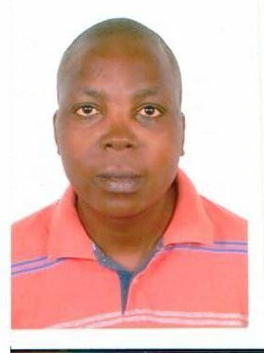
SALES MAN
OBJECTIVE.
To focus on the needs and demands of the sales industry to have a strong impact on the employer reviewing the job application and resume in question. Focus on your abilities, skills and goals in sales when writing your career objectives for a sales person position.

SUMMARY OF QUALIFICATIONS
- Vast experience (over seven years) of selling motorcycles of different sizes and makes
- Tremendous sales aptitude with huge interest in motorcycle selling
- Pleasant personality with extraordinary command over the language
- Great convincing skills and negotiation abilities
- Enormous information of the previous statistics and the current trends in the motorcycle sales market
CORE COMPETENCIES
- Ability to welcome customers by greeting them and offering them assistance.
- Ability to direct customers by escorting them to racks and counters and suggesting items.
- To advise customers by providing information on products.
- Helping customer make selections by building customer confidence and offering suggestions and opinions.
- Documenting sale by creating or updating customer profile records.
- Processing payments by totaling purchases; processing checks, cash, and store or other.
- To keep clients informed by notifying them of preferred customer sales and future merchandise of potential interest.
- Contributing to the team effort by accomplishing related results as needed.

EXPERIENCE
GORTIM Uganda LTD
Sales manager | 1999 – 2004
- Purchased auto inventory from auctions and wholesalers.
- Conducted appraisals
- Directed the reconditioning of trade-in motorcycles for resale, and assisted with new motorcycles sales.
- Created innovative promotional marketing strategies
- Hired, trained, supervised and mentored 12 sales people
- Motivated staff to meet/exceed established sales goals and objectives by developing effective sales incentives.
- Gave final approval on all sales, trade-ins, financing and credit arrangements.
- Monitored and reported sales volume, financial and business transactions. [Generated sales of 70-90 motorcycles per month.]
BMK Uganda LTD
- Salesman Heavy Construction Machinery. | 2005– 2013
- Drove sales of new and used vehicles by reviewing and approving sales deals by all sales associates.
- Ordering new Construction Machinery inventory and negotiated with auto wholesalers to purchase used Construction Machinery.
- Taught employees successful sales and closing techniques.
- Designed and placed advertising featuring Construction Machinery inventory and appeared in dealership television commercials.
- Created promotional marketing strategies to stimulate sales growth such as off-site tent sales events, special finance mailers and a first time buyer program.
- Developed strong customer relations, appraised trade-ins, orchestrated financing, and gave final approval of all sales.
- Provided highest standards of customer satisfaction and quality service at all times.

EDUCATIONAL BACKGROUND
DBA | Ndenje University | 1997-1999
U.A.C.E | Rutoma Secondary School | 1994 - 1996
U.C.E | Katerero Secondary | 1990 - 1994
P.L.E | Nabbingo Primary School | 1982 - 1989

