CURRICULAM VITAE
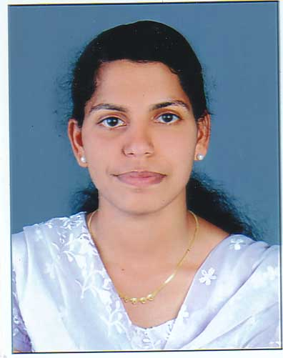

Gulfjobseeker.com CV No: 1298964
Mobile +971505905010 cvdatabase[@]gulfjobseeker.com

To contact this candidate use this link
http://www.gulfjobseeker.com/feedback/contactjs.php

Objective

Seeking the position of critical care nurse in a hospital where I can help the patients by making effective use of my patient care skills acquired during my long period of experience.

Summary

- More than 7 years of experience in providing critical care and surgical unit
- Handled the critical situations and worked under the supervision of expert doctors

Skills

- Well trained in the use of the medical equipments for providing critical medic care
- Knowledge of medical documentation and medical records
- Intense knowledge of critical care and general nursing care practice
- Ability to diagnose and provide the pharmacologic treatment on the health related
issues
- Ability to do multi tasking and function independently
- Effective organizational skills and managerial skills
- Ability to design the treatment plan for the patient according to the need
- Strong interpersonal skills

Responsibilities

- Planned the effective medical treatment program for the patient and assisted in
performing daily routine activities
- Maintained the hygienic environment in the intense care unit
- Made effective use of the medical equipments for helping the patient
- Monitored the health of the patient and kept the track of the medicines to be given
to the patient
- Kept the record of hospital supplies and surgical equipments
- Monitored the health of the patients and provided medical help after the surgeries
- Helped the doctors in performing critical surgeries
- Checked the blood pressure, blood sugar level, etc. and ensured to maintain the
health of the patient
Professional Qualification

Diploma in nursing and midwife

Department Worked in : 1. Neuro Intensive Care Unit
- Intensive Coronary Care Unit
- Intensive Care unit
- Dialysis
- Nephrology Ward
- Gynac Ward
- CT Scan
- Causality with Minor Operation Theatre
- Endoscopy Unit
- Medical & Surgical Ward Especially total 3 years experience medical ICU and 2 years experience surgical ward

Work Experience : Worked as a Staff Nurse in Unity Health
Complex, a 250 Bedded Multi Specialty
hospital from 23rd December 2005 to
23rd December2007

: Worked as a Staff Nurse in Trikkara
Grama Panchayath Co-operative Hospital, Cochin from
23rd July 2008 to 12th April 2008

: Worked as a Staff Nurse in Al-Thawra
Modern General / Teaching Hospital Sana’ Republic of Yemen, In surgical Ward from 20th 2009 to 17th February2011.
: working as a staff nurse in
Evershine Hospital Edappally,surgical icu since 01-06-2011 to present

Sex : Female
Age : 30 yrs
Date of Birth : 29-03-1983
Marital Status : married
Nationality : Indian
Visa : husband visa
Religion : Christian
Languages Known : English, Hindi, Malayalam &Arabic
Profession : Registered Nurse & Midwife

DECLARATION

I, hereby declare that the above information are, complete and correct to he best of my knowledge and belief.

