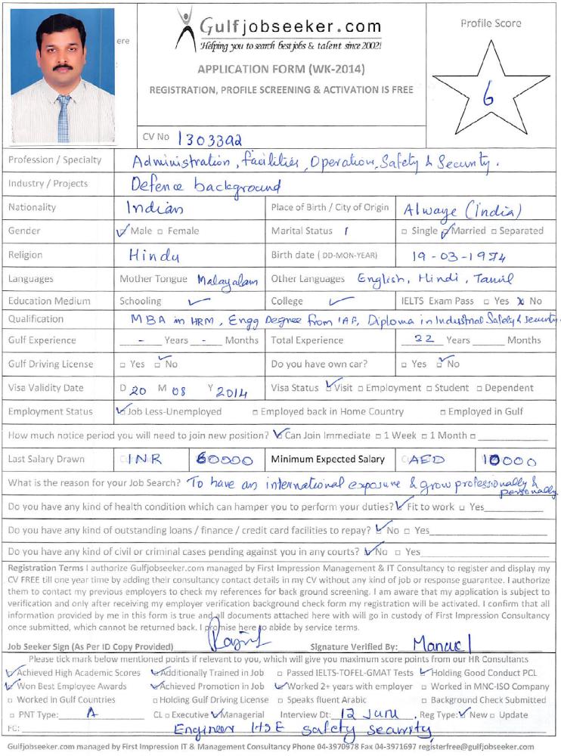

RAJESH

RAJESH.217232@2freemail.com

Profile Overview

An experienced professional with 22 years of diversified experience in Human Resources, Administration, Operations, Facility Management, Training & Development, Safety & Security Management from Indian Air Force. Looking for challenging opportunities where I can demonstrate my skills & abilities, contribute to organization goals and grow professionally.

Extensive HR experience in Strategic, Generalist and HR operations role in a dynamic environment including experience in staff development, work force planning, talent management, employee relations, on job training, mentoring, performance management and appraisal, HR Records management, HR policy implementation and review, orientation and on boarding. Demonstrated success in team building, training and development, job evaluations, job descriptions and HR Administration. Excellent organizational skills with attention to detail and can effectively prioritize to meet deadlines.

40 years old with defence experience, disciplined, self-driven, result oriented with leadership skills. Available in UAE till mid of August with immediate availability.

Educational Qualification

- MBA in Human Resource Management from ICFAI University, India
- Engineering Degree (Aerial & Cine Photography) from Indian Air Force, India
- Diploma in Industrial Security & Safety Management from NISM Institute, India
- Aviation Technical Diploma from Indian Air Force

Certifications & Trainings

- Certification in Hardware Technician from CDAC, India
- Certification on Adobe Photoshop & Flash by Animaster, Bangalore, India
- Certification course in System / Network Administration course from NIIT, India
- Aviation technical training on fighter aircraft by Indian Air Force
- Experienced & trained on MS Office

Awards and Achievements

          - Accredited with Best Air Warrior award two times for the contribution towards Aerospace Safety
          - Promoted to (Jr.) Warrant Officer for excellent service, superseding 90% of the peer group strength
          - Received appreciations letters from Commanding Officer for professional excellence
          - Ensured 100% compliance to information warfare security norms in my department
          - Received high ratings from Air Force inspection team for implementing employee training/orientation program for new recruits

Key Functional Areas

HR Department Management | HR Policies and procedures | Employee relations
Succession Planning | Orientation and onboarding | Training and Development
Performance Management | Organizational Development | Staffing and Planning
Office organisation | Filing and correspondence | Talent Management
Leave/ attendance/Employee Files
Professional Experience. Indian Air Force – Jan 1992 to Dec 2013

Key Appointments & Responsibilities Held.

- Manager (HR and Administration) - January 2012 – December 2013
- Training Program Supervisor / Trainer / In Charge of IT Department - April 2009 – January 2012
- Assistant Manager Administration and HR - Jan 2006 to March 2009
- HR/Admin/Tech Support Executive – Jan 2003 to Jan 2006
- Aviation Technician, Supervisor and Team Leader- Jan 1992 to Jan 2003

Area of Expertise

Human Resources

- Provided direction to over 180 member aviation technical team by implementing effective staff and resource management strategies in line with workflow requirements.
- Planning and execution of training and development of staff to meet the organizational requirements
- Manpower planning and succession planning and change management
- Executed competency based manpower management to suit the organizational requirement
- Training Manager, course supervisor and member of trainers team in charge of providing training to 1000-1300 aviation technicians per year
- Managed performance and appraisal of the aviation technicians in co-ordination with field supervisors, managers
- Conducted counseling to increase productivity & quality with inputs from line managers
- Mentoring, training staff to deal with uncertainties and adverse circumstances
- Ensured HR policies are implemented successfully with help of various communication methods
- HR generalist role like staff personal file, leave system, knowledge & skill management
- Hands on experience in crisis management and managing hostile situations within the given time frame
- Experience in Policy review, manpower review and job evaluation and job descriptions.

Administrative and Office Service Professional

- Managed entire gamut of office administration and back office operations
- Handled Top Secret, Secret and Confidential Data
- Management reporting, statistics & Indicators
- Handled IT consumables procurement from external agencies within the allotted budget.
- Proficient in delivering comprehensive analyses and reports to facilitate site wide improvements and maintains continuity.
- People Management, Asset Management, Inventory Management, Facilities Management & Infrastructure Management
- Management of training facilities & information technology (computers, network)
- General Administration functions including Asset Management, Inventory Management, Facilities Management & Infrastructure Management

Facilities, Infrastructure, Safety & Security Management

- Responsible for planning, directing and overseeing building and campus operations and services
- Managed and ensured facilities, infrastructure and environment are upto the health & safety standards and conducive environment
- Over 5 years’ experience in administrating IT infrastructure management in a vast environment.
- Good liaising skills, negotiation skills, people skills for upkeep of all maintenance services also ability to develop working relationship with a wide range of people
- Adequate skills and expertise in campus area security methods with exposure to latest digital means of access control systems.
- Initiated preventive maintenance practices to ensure that there is no downtime
- Managed IT consumables procurement, contracts management, vendor management.
- Implementation of safety & security norms and ensuring compliance and supervised security staffs.
- Proactive inspections to prevent accidents, incidents resulting in improved safety environment
- Developed standing orders to ensure security during emergency situations
- Conducting programs, trainings for employees to generate safety awareness

Personal Details

Date of Birth | 19 March 1974
Gender | Male
Nationality | Indian
Marital Status | Married
Languages Known | English, Hindi, Malayalam, Tamil
References | Will be provided upon demand
Availability | Immediate

