.

Gulfjobseeker.com CV No: 1304178
Mobile +971505905010 / +971504753686

To get contact details of this candidates
Submit request through Feedback Link
http://www.gulfjobseeker.com/feedback/submit_fb.php
Date 01-June-2014

To,

The HR Manager

Dear Sir

Subject: Application for the Post of Accountant

I am a Mcom Post Graduate’ is interested to applying in your company as an Accountant. My resume is being attached for your review.

With full confidence, my skills and experience in this field for 2 years with reputed firms
for the last two year .

Truly, I am looking forward to be of service to your reputed organization

Yours sincerely

CURRICULUM VITAE  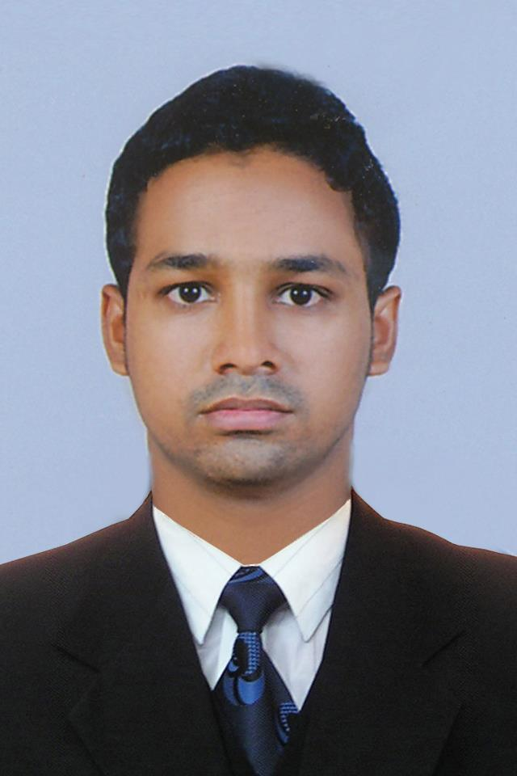  PRESENT ADDRESS: P.O BOX:13842. OPP.OLD FIORIDA HOTEL.SABKHA ROAD. DEIRA . DUBAI-UAE  Personal Data:  Date of Birth: 20th MARCH 1989  Nationality: Indian  Marital Status: Single  Languages; Known  English Malayalam, Hindi (Fluent In Speech, Read &Write,)  Arabic (Read, Write)  Indian Driving license: LMV and light four wheel | Career Objective.  Seeking a challenging position that utilize my knowledge in a variety of field including accounting procedures and administrative functions; To join in a company where both my qualification and technical skill can promote development contributing to a higher level of achievement both to my career and to the company.  Highlights of professional Experience:  I have more than 2 years of experience in Accounts and Financial related job with reputed organization.  Professional experience:  Company : ALMIS INTERNATIONAL .KANNUR .KERALA.INDIA.  Designation : Accountant  Duration : APRIL 2012 –MARCH 2014  Duties and responsibilities:  - Maintaining accounts and cash of day to day activity.  - Prepare daily, weekly and monthly report.  - Prepare purchase returns, debit & credit memos.  - Preparation of Delivery NOTE, F-form and C- form etc.  Preparing various report required by the management  - Preparation of petty cash book.  - Wages and salary list preparation.  - Assign duties and targets for the sales team and follow up.  - Recording sales, Purchases, Receivables and payables in daily transaction.  - Creating supplier and clients records.

Academic Qualifications:
- Master of Commerce (MCOM) MK UNIVERSITY INDIA
- Bachelor of Commerce ( Bcom ) University of Kannur, Kerala
- Higher Secondary Certification from State Board, Kerala
- Secondary School Certificate from state Board, Kerala

Professional Certification:
SAP : (FICO ) FROM DALLAS INSTITUTE BANGLORE.INDIA.
Technical Skills:
- Operating Systems : MS-DOS, WINDOWS (9x/2000/XP/Vista/7)
- Office APPLICATIONS: MS-Word, Excel, Power Point, Project, Publisher etc.
- Accounting Programs : Tally, Peachtree, and QB.

Declaration:

All the information provided above is true and correct to the best of my knowledge & belief. If you provide me an opportunity to serve your organization, I promise I will try my best by discharging my duties towards the betterment of organization.

