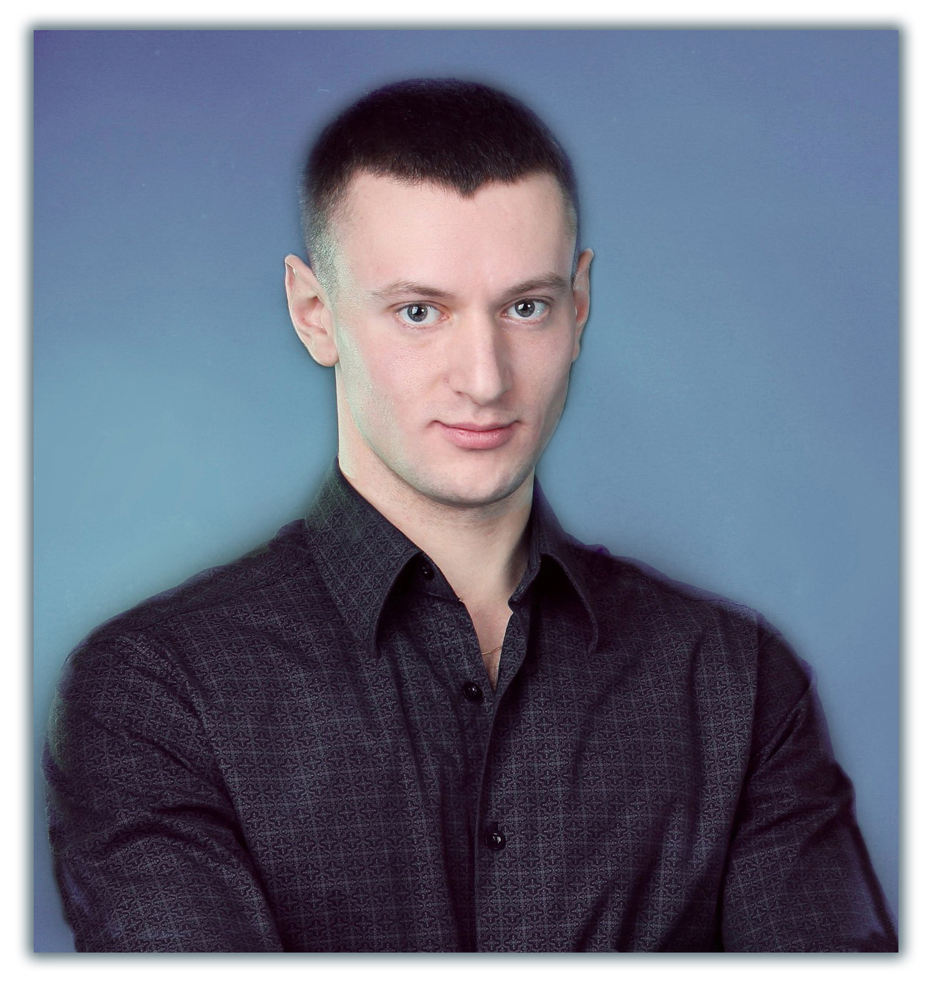
Personal information:
Date of birth: 30.11.1986
e-mail: vitalii.218675@2freemail.com

Vitalii

Key information

Customer Service Representative with over 8 years of experience of face-to-face sales manager and administrator. Aiming to use my proven customer service, sales and communication skills to effectively fill the role in your company.

Professional experience

Alfa-Group Service LLC
(Repair and service center steel industry)
Sr. Customer Service Representative
aug 2009 - present

Main responsibilities:
- Provision of services for maintenance and repair of metallurgical equipment my team.
- Establishing contacts and agreements with partners for further joint activities.
- Provision detailed information on services to customers.
- Signing of contracts agreements.
- Meeting with other team managers to discuss possible improvements in level of provided customer service.
- Constant customer support.

DIISW (PJSC Dneprovsky Integrated Iron&Steel Works named after Dzershinsky)
Industrial and Manufacturing (Production and sales of steel products)
Sales Assistant, Sales Manager
oct 2005 – sept 2006 sept 2006 – aug 2009

Main responsibilities:
- Sales of steel products.
- Search for new clients and serving existing.
- Provision of information about the products.
- Prepare and maintain electronic and paper catalogs for information and product availability.
- Inspection of production in a warehouse, receiving and shipment
- Telephone and e-discussions to serve client requirements and other service issues.
- Meetings with potential customers and negotiating face-to-face.
- Work at exhibitions, product presentation.
- Response to all customers inquiries and complaints.
- Conduct client or market surveys in order to obtain information about potential customers.

Professional skills

- Great communication skills • Ability to analyze
- Use of positive language • Have tenacity
- Be a great listener • Ability to negotiate and persuade
- Be honest • Ability to work in a team
- Ability to work under pressure • Leadership experience
- Ability to learn from mistakes • Ability to close the deal
Education

National Metallurgical Academy of Ukraine (Dnipropetrovsk, Ukraine)
2008 - 2009
"Metallurgical Equipment" Specialist

National Metallurgical Academy of Ukraine (Dnipropetrovsk, Ukraine)
2005 - 2008
"Mechanical Engineering" Bachelor

Dniprodzerzhyns'ky Metallurgical College (Dniprodzerzhyns'k, Ukraine)
Graduation Year 2005
"Maintenance and repair of metallurgical enterprises" Junior specialist

Language Skills

English - intermediate
Russian - native
Ukrainian - native

Training courses

Customer service courses (Dnipropetrovsk, Ukraine)
sept 2009 - feb 2010
Completed voluntary customer service training to learn ways to enhance customer satisfaction and improve productivity.

General Information

Computer skills
- Knowledge of PC (advanced user) Windows XP, 7, 8; MS Office: Word, Excel, Outlook, PowerPoint, Internet, experience in using graphical editors: Paint.NET, Adobe Photoshop.

Driving license
- Category: B, C. Driving experience: from 2009.

Hobbies and interests
- Outdoor activities (running, swimming, soccer, tennis), photographing, visiting interesting places.

Personal qualities

Focus on results, the ability to obtain and analyze the necessary information, communication, organization, responsibility, fast learning and adaptation, the ability to further development, constant self-education process.

