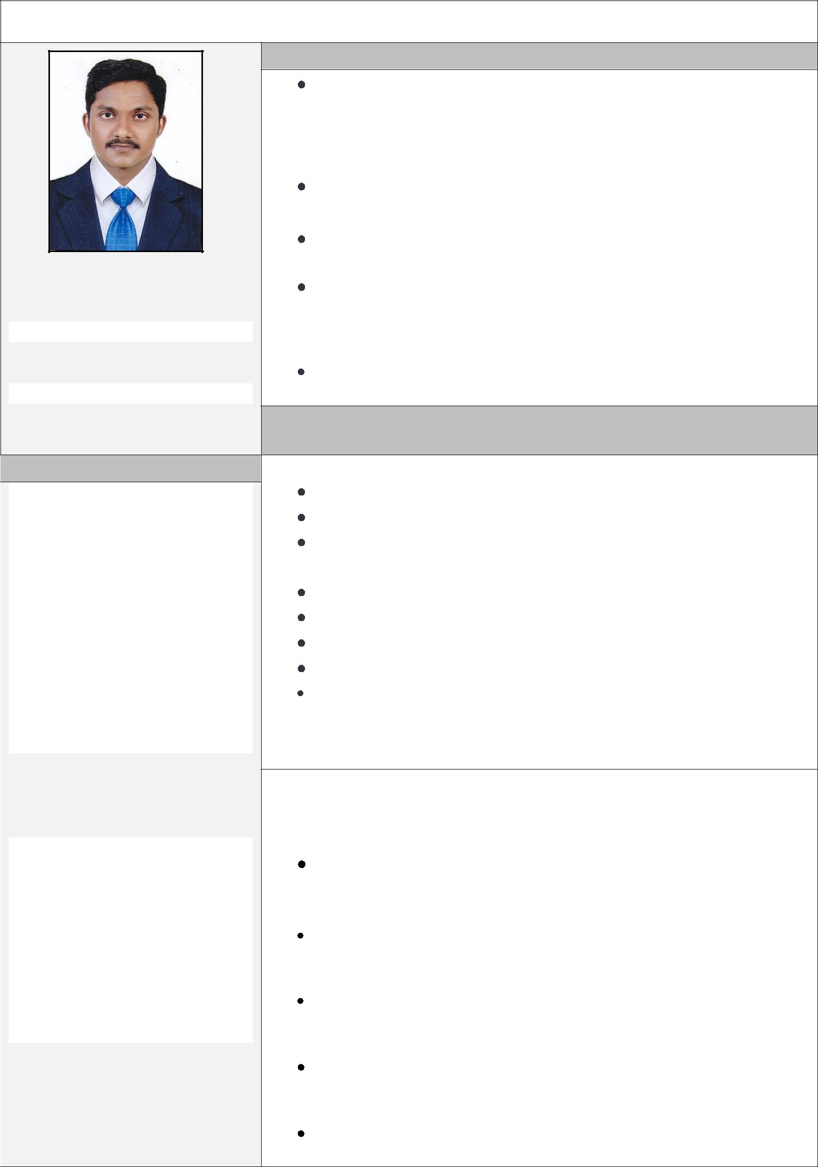
PROFILE OF CHEF

 |  |  | EDUCATION
 | BSc in Hospitality and Hotel Administration – 2007-2010
 | (Asan Memorial Institute of Hotel Management,
 | Chennai)
 | Diploma in Hotel Management |  |  | (2007 – 2010)
 | Plus Two Board of Higher secondary Kerala |  |  |  | 2005-2007
NELSON | S.S.L.C Board of Public Examination, Kerala |  |  |  | 2004-2005
 | COMPUTER KNOWLEDGE:
 | MS-OFFICE | : | 2006
 |  | SKILLS BY EXPERIENCE

PERSONAL DETAILS
 |  |  |  | 7 Years of experience in Hotel and Hospitality field
MARITAL STATUS - Single |  |  |  | Complete opening and closing procedures for the Kitchen
- |  |  |  | Responsible for overseeing all operational aspects of the
 |  |  |  | Kitchen and staff in the absence of the Head Chef.
 | : |  |  | Preparing and planning all kind of food and beverages.
 |  |  |  | Maintaining and managing kitchen
 |  |  |  | Controlling Kitchen costing
 |  |  |  | Preparing shift roster for team
RELIGION: Christian |  |  |  | Preparing daily food menu
COMMUNITY: | Pentecost |  |  | INDUSTRY EXPERIENCE
Pearl Continental, Cochin, Kerala
As Trainee chef : 2008 to 2009

Lulu ICC,Thrissur, Kerala
As COMMI III:2010 to 2011
ABAD PLAZA , Cochin
As COMMII II from 2011 to 2012
SPOON INTERNATIONAL ,Thrissur
As COMMI II from 2012 to 2013

TEYSEER W.L.L, Qatar
As II CHEF 2013 to 2015

QSATCO, Qatar

As CHIEF CHEF from 2015 to 2016

FUNCTIONAL RESPONSIBILITIES UNDERTAKEN

- Efficient & effective Kitchen handling.

- Planning ,directing, coordinating & Budgeting for Kitchen

- Establish and administrate policies & procedures for events.

- Coordinate activities & events with Internal and external clients.

- Supervise Facility usage, operations, equipments, maintenance, etc.

- Prepare & maintain annul budget for kitchen.

- Over all hygiene related areas of Food. Beverages etc ,

- Coordinate with all the office representatives to ensure that they get proper service from the maintenance crew.

- Supervising the kitchen for efficient productivity.

- Inventory management.

- Generating operational reports.

- Training process for the new team members.

- Conducting induction for new joiners in the department.

- Maintain usage records & Invoice clients accordingly

Specialization

Continental ,Chinese, Arabic ,Sandwich etc

LANGUAGES KNOWN

LANGUAGE | SPEAK | READ | WRITE
Malayalam | Fluent | Yes | Yes
English | Fluent | Yes | Yes
Hindi | Yes | No | No
Tamil | Yes | No | No

DECLARATION

I do hereby declare that the details furnished above are correct and genuine to the best of my knowledge and belief. I am confident that, with my skills, I would be able to contribute significantly.

Yours Sincerely.

Place: Thrissur

Date: -1 -2017

NELSON

