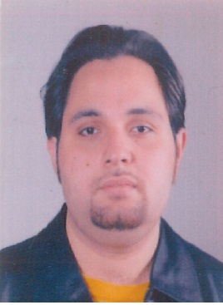
Curriculum Vitae

BILAL
E- mail: bilal.218832@freemail.com

Professional with a progressively responsible experience and professional skills in the
Field of Environmental and civil Engineering, with a solid engineering methodology and technical knowledge
Objectives:
Willing to use my expertise to help make human life simple and preserve the environment for coming generations. Wish to be a part of development activity that help in developing environment friendly products.

Personal Information:
Date of Birth: 4.4.1985
Nationality: Syrian.
Marital status: Single.
Education
Aleppo University, Syria Arab Republic.
Bachelor degree in technology environmental engineering
(Water treatment, sanitary works and pollution control)
Year of Graduation 2010.
Computer Skills
- AutoCAD.
- MS-Office.
Additional Skills:

Languages:
Arabic: Mother language.
English: Fluent.

Training & Certification:

ABU DHABI URBAN PLANNING COUNCIL Estidama: Pearl Building Rating System Certificate
Pearl Qualified Professional (PQP)

U.S Green Building Council: LEED GA Certification
(Leadership in Energy & Environmental Design)

Working Experiences:
UAE
Al Nasr Contracting
From May 2016 – Present:
Working as Environmental Engineer
- In charge of all health , environmental and safety issues of the company
- Assessed the Environmental Impact of project construction , Coordinated with regulatory agencies
To facilitate environmental action and develop Environmental Plans
- Processed and evaluated available environmental data , Prepared Environmental Monthly Report
- Provided training & awareness to the staff regarding hazardous substances ( storage – handling – disposal ) , Explained & discussed material safety data sheet with the staff
- Supervised waste management of the company , Monitored waste generation , implemented waste segregation in place and controlled hazardous waste
Achievements
- Participated achieving the company goal Zero – Incidents
- Received Appreciation Certificate from the client for my efforts at the field of HSE
- Reduced construction waste , potable water consumption and fuel consumption
Site Working:
Project: 10 Electrical Substations
Location: Abu Dhabi, Kizad
Client: Emirate Global Aluminum EGA
Main Contractor: Bechtel Petrofac Joint Venture BPJV
UAE
Raslan General Contracting EST:
From February 2012 – May 2016:
Working as Environmental Engineer
- Complied with all environmental standards and controlled environmental documentation
- Co-designed and developed a site environmental plan
- Participating in meetings with agencies and members of the organization in advancement of key projects
- Preparing of all environmental reports required by consultant
Site Working:
Project: Construction, Completion & Maintenance of a Forensic Warehouse
Location: Abu Dhabi
Client: Police College
Project area 15000 SQM with a total cost of 100 000000 AED

Syria
Government Environmental Department (General Authority for Combating Desertification):
From January 2011 - December 2011:
Working as Environmental Engineer
- Analyzed the contamination source, Installed deep monitoring wells and Gathered water-level measurements
- Utilized low-flow ground water sampling techniques and passive bag diffusion samplers to obtain groundwater samples for laboratory analysis

References available upon reques

