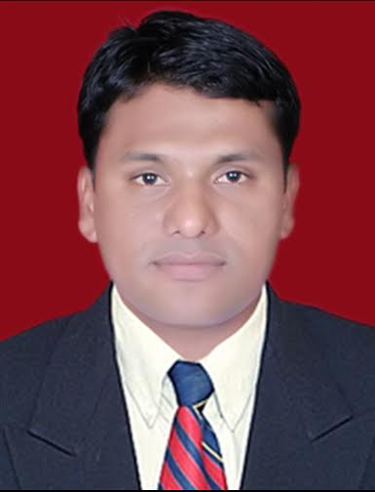

CURRICULUM VITAE
Gulfjobseeker.com CV No: 1316610
Mobile +971505905010 / +971504753686

To get contact details of this candidates
Submit request through Feedback Link
http://www.gulfjobseeker.com/feedback/submit_fb.php

CAREER OBJECTIVE
To best utilize my skills and knowledge acquired throughout my studies & 4+ years of work experience In Accounts & Finance towards building-up my career and adding up value to the organisation.
PROFESSIONAL EXPERIENCE
Organization : MAERSK Global Service centre, Pune. (India)
Period : Feb 2013 to May2014
Designation : Accounts Executive
Job Profile: Accounts Payable
JOB RESPONSIBILITIES
- Pull Invoices,PO into SAP & Process by 3 way matching check the all documents like purchase order, invoice, and Reference documents.
- Posting of invoices in MIRO with tolerance limit.
- Auditing of wrong postings within or outside MIRO.
- Investigates and resolves problems associated with processing of invoices and purchase orders.
- Reconcile vendor statements, research and correct discrepancies.
- Vendor data Management.
- Making correct & timely vendor payment run.
- Handling all exceptions in sap/ocr and communicate with Locations.
- Reports run for PO-search, manual status work allocation.
- All prepayment activities.

PREVIOUS EXPERIENCE
Organization : Computer Age Management Services Pvt Ltd (Cams India)
Period : May, 2009 to August, 2011
Designation : Senior Executive
JOB RESPONSIBILITIES
- To Attend Mutual Fund Investors & Brokers, Sub Brokers, Bankers.
- Mutual Fund and Insurance Applications processing.
- Process time stamp Applications without fail for NAV.
- Banking Process (Cheques Clearing).
- Quality checking of generated Folios.
- Follow up for NIGO transactions and resolution of other queries.
- Reporting’s to Regional & Head Office.
- Maintain Record Of all Financial & Non-Financial Transactions.
- Training to new joiners.

PREVIOUS EXPERIENCE
Organisation : KABRA & MALIWAL (CA India)
Period : Dec,2007 to Nov,2008
Designation : Junior Accountant
Key Responsibility : Posting of entries on daily basis , preparing reports of debtors And creditors,
Reconciliation, entries in Tally.
Results & Achievements
- Managed the accurate & timely Closing Data every month.
- Always maintained the accuracy & timeliness of the records without fail, which helped to Back Office & Asset Management Company.
- Have got rewarded for best performance of quarter.
- Customer Delight award.
Academics
- Passed M.B.A with 63.75% marks (Year 2012) from SRTM University Nanded Maharashtra India.
- Passed B.Com with 64% marks (Year 2008) from SRTM University Nanded Maharashtra India.
- Passed HSC in Commerce with 62.17% marks (Year 2005) from Latur Board Maharashtra India.
- Passed SSC with 57.60% marks (Year 2003) from Latur Board Maharashtra India.
Technology Summary
- SAP 102-RP1-R/3
- MS Office (MS Outlook)
- Tally 7.2
Strengths
- Ability to work in multi-cultural environment.
- Quick learner & executor.
Personal Details
Nationality : Indian
Gender : Male
Marital Status : Single
Date of Birth : 17 July 1987
Linguistic Ability : English, Hindi, Urdu, Marathi.

