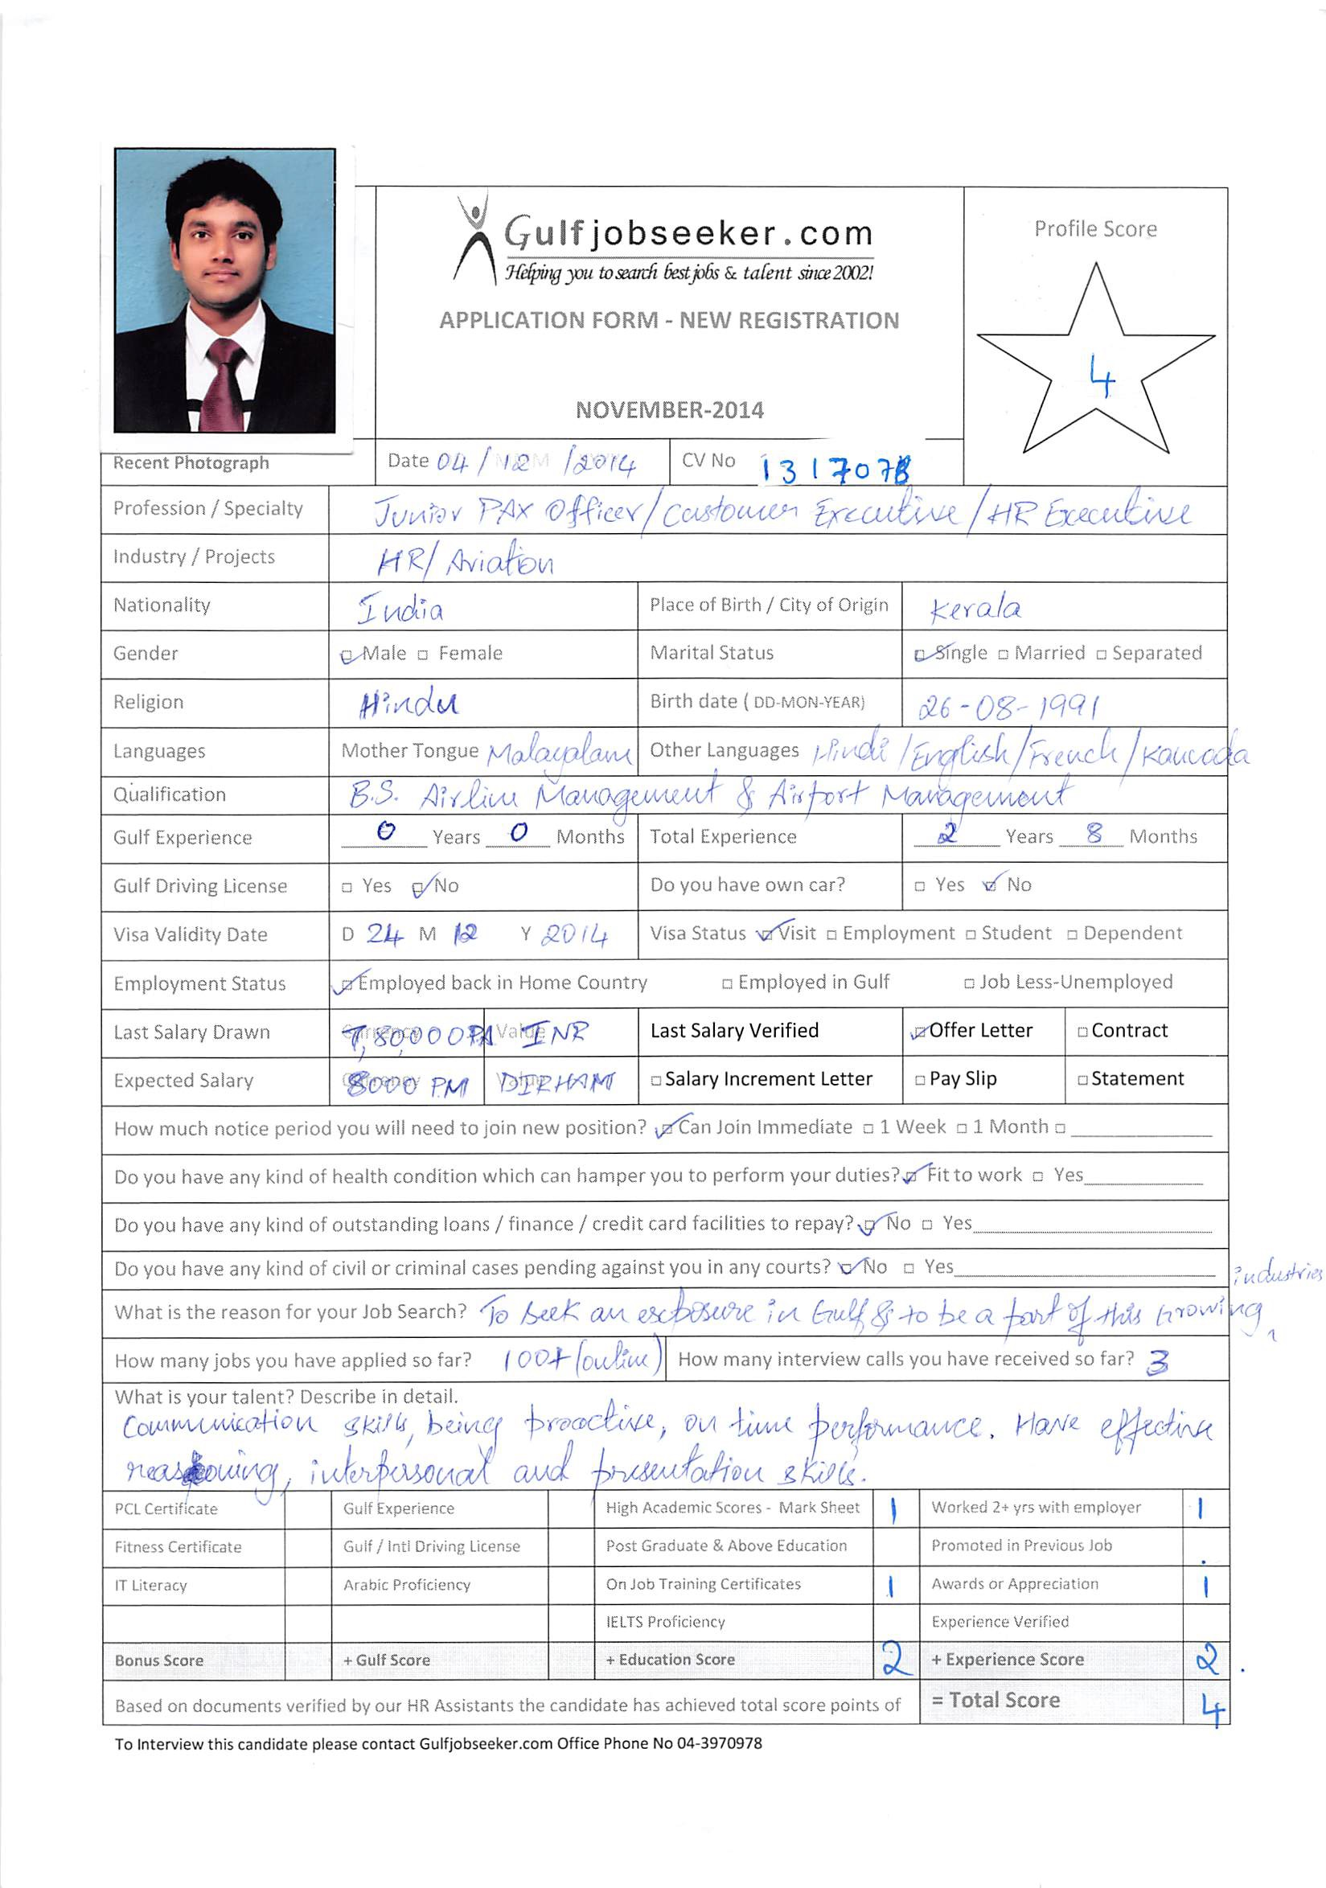

PERSONAL PROFILE
Date of Birth : 26th August 1991
Marital Status : Single
Nationality : Indian
Languages Known : English, Hindi, Malayalam, Kannada, Tamil, Telugu,
Sanskrit and French.

ABSTRACT

A dynamic professional with nearly two years of experience in Customer Service Operations; last associated with Air Costa, Bengaluru International Airport as Customer Service Executive. Completed BS in Airlines and Airport Management from Sreenidhi Vaughn Institute of Aeronautics and Technology. Proficient in managing a wide array of customers with best possible service. An astute professional with practical exposure to terminal operations and flight dispatch having completed apprenticeship at Rajiv Gandhi International (GMR) Airport Terminal, Hyderabad and Internship at Jet Airways, BIAL. An excellent communicator with effective reasoning, interpersonal and presentation skills.

PROFESSIONAL EXPERIENCE

International Airport | Customer Service Executive
Key Deliverables:
- Facilitated passengers to fly to their destination so as to experience comfortable journey.
- Looked after the terminal operations and ramp operations which consisted of check in, boarding gates, safety of customers and guests other persons any time they are on or in company property or aircraft; or within the ramp operations area.
- Provided assistance to passengers in need.
- Met company and social standards of dress and conduct standards as all times while representing the company either on or off the job.
- Developed daily, weekly and monthly reports and records as required for the efficient aircraft operations.
- Provided information, reservations and ticketing services to customers.
- Post flight work at the ramp office.
AIESEC, Hyderabad |Business Development Manager.
Key Deliverables:
- Learned to lead a team, manage large projects and run a local and national organization along with people from all over the world.
- Managed various professional and social events to market the business operations.
- Handled HR Operations having dealt with internships of foreign students.
- Conducted events such as International conference, Balakalakaar, Global Village, Youth to Business Forum.

APPRENTICESHIP
Rajiv Gandhi International (GMR) Airport Terminal, Hyderabad | Junior PAX Officer.
Key Learnings:
- Worked in the GMR corporate office with the Business Excellence department.
- Supervised the routine functions of the ground staff at airport.
- Interacted with Executives, Managers and other professionals in HR and Finance function in handling different problems and providing solutions.
- Learned the professional way of managing and communicating with different customers and higher officials.

INTERNSHIP
Jet Airways, BIAL (Bangalore)
- Worked for nearly 2 months and coordinated with professionals at HR and dispatch
department and learned the process and steps followed during the dispatch.

EDUCATIONAL QUALIFICATION

2013 BS in Airlines and Airport Management (Dual Major) from Sreenidhi Vaughn Institute of Aeronautics and Technology, Vaughn University America, Hyderabad
2009 12th from Maharishi Composite Pre-University College, Vishweshwaranagar, Mysore, Karnataka
2007 10th from Bharathiya Vidya Bhavan, Karnataka Secondary Education Examination Board, Vijayanagar, Mysore, Karnataka

EXTRACURRICULAR ACTIVITIES

- Organizer and representative of Management team UDAAN at the National level
Aviation Management Fest.
- Participated in Aviation Fest UDAAN as an event coordinator.

TECHNICAL SKILLS

- Possesses sound knowledge of Windows, C++, MS Office and Internet Applications.

