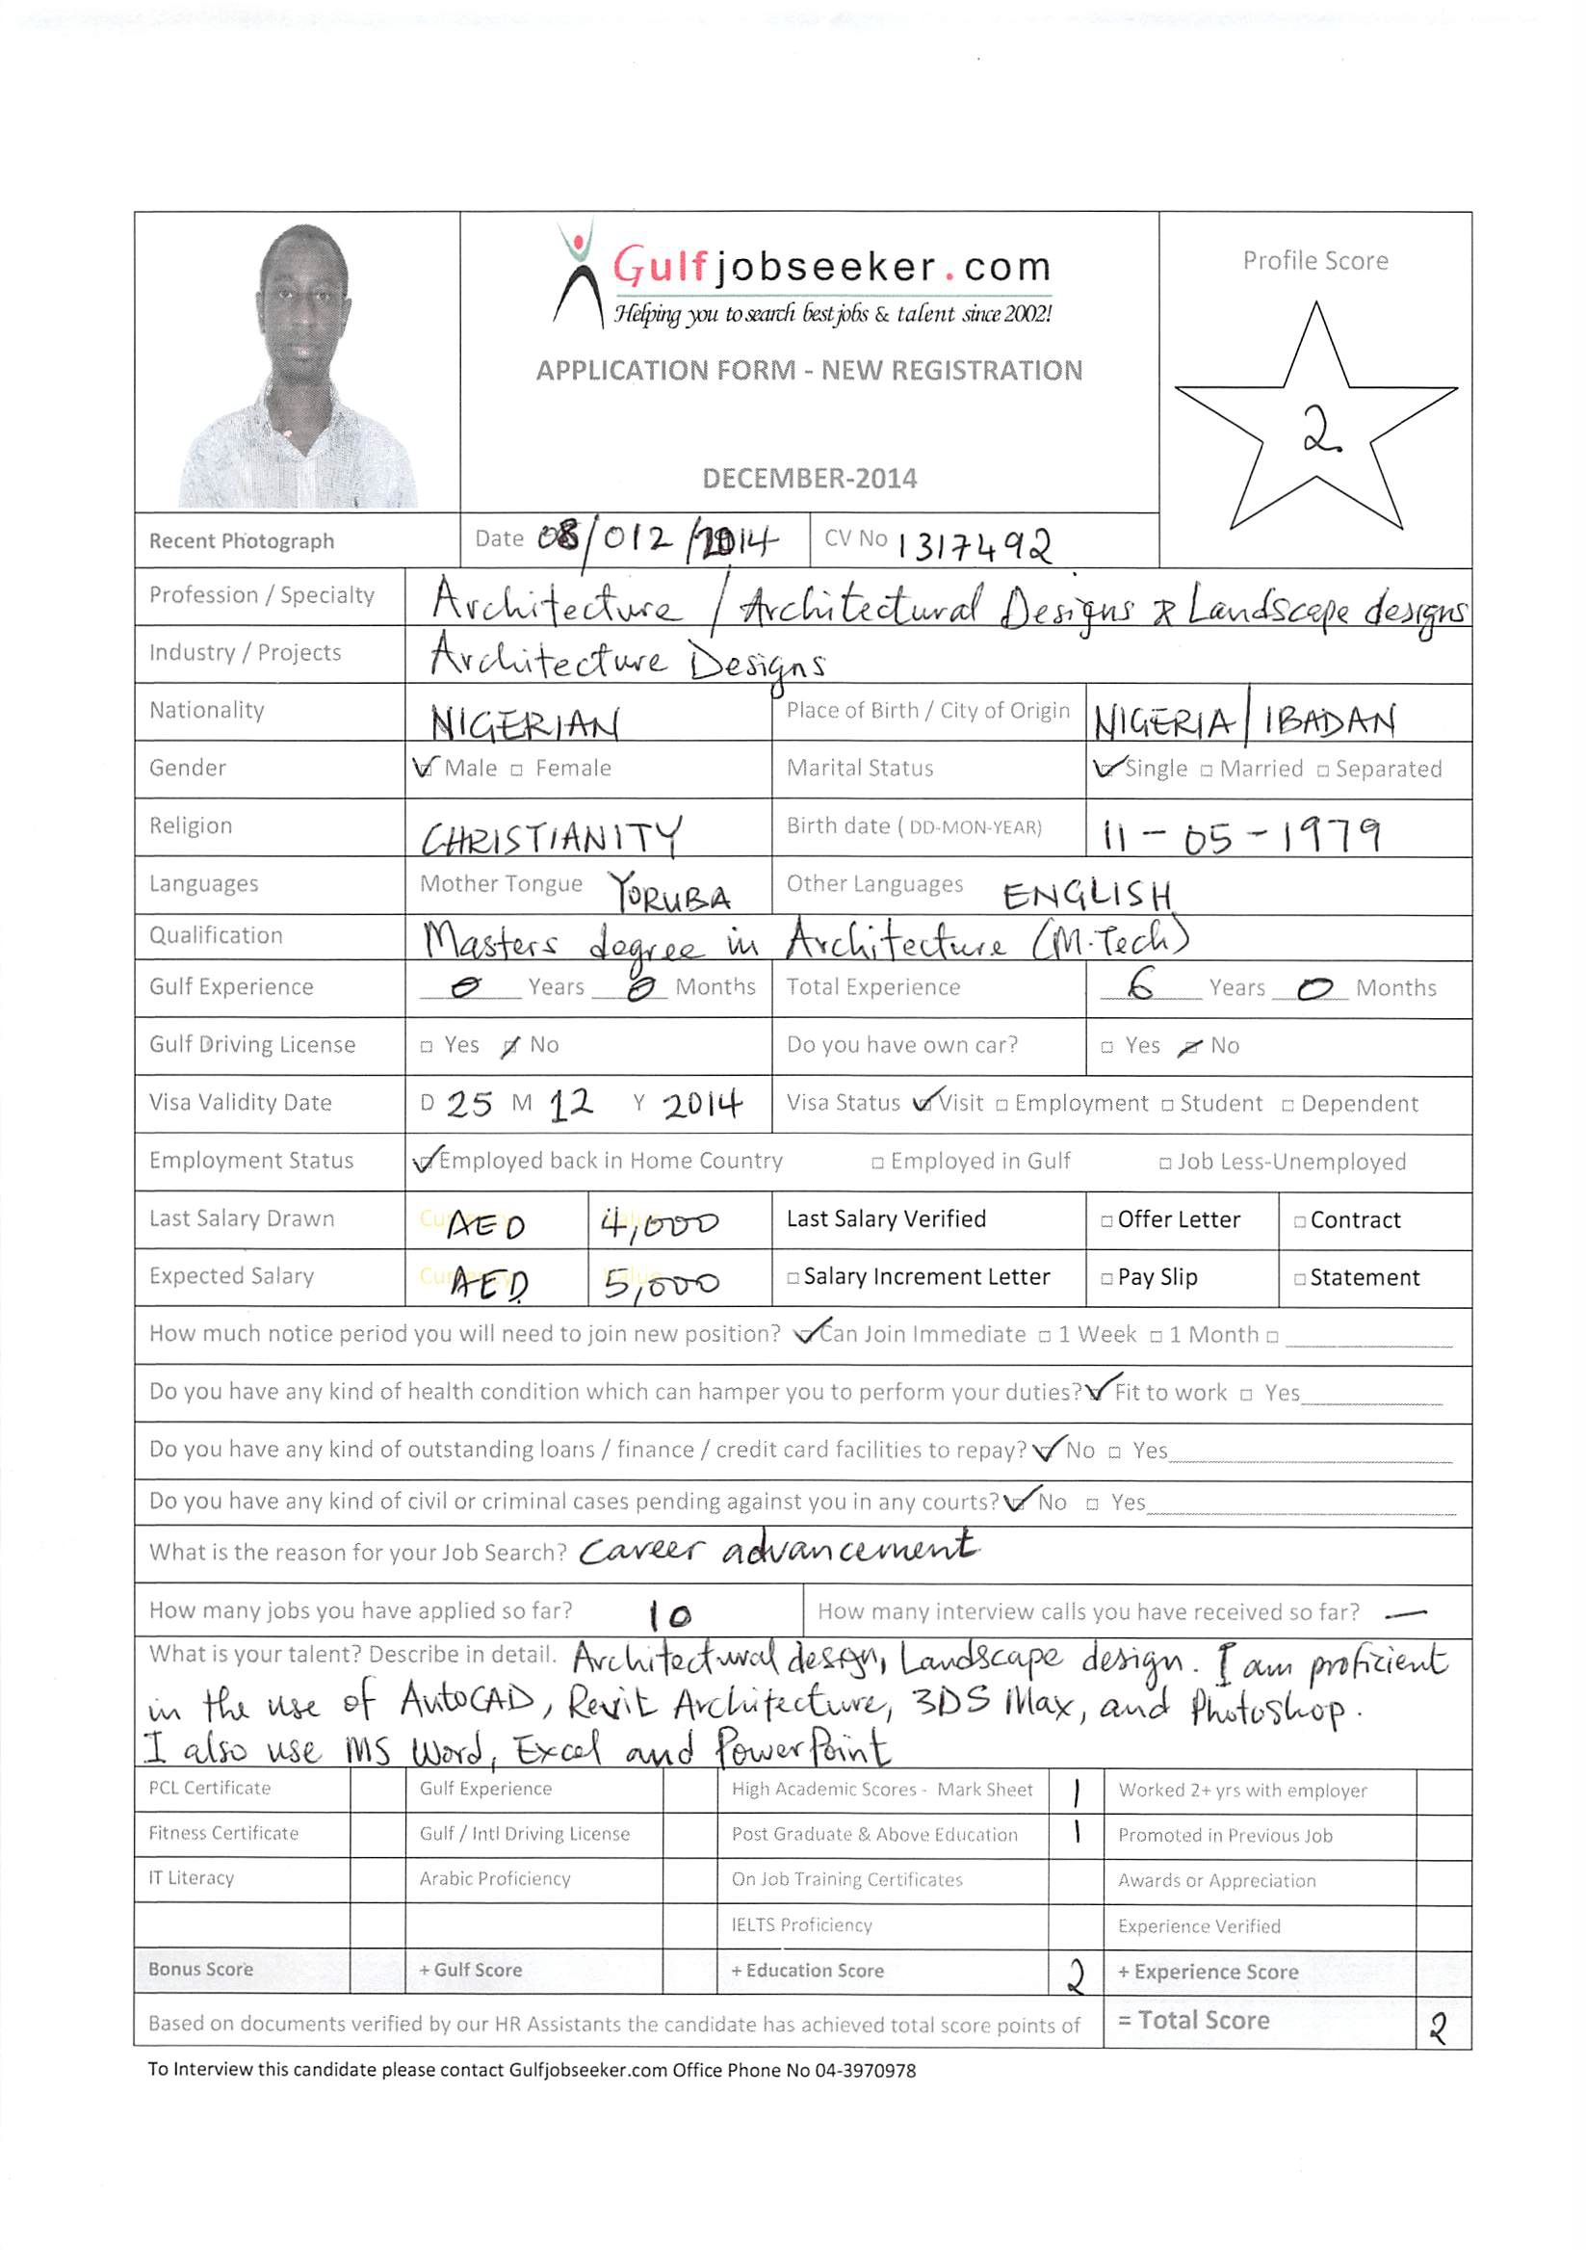

Career Objective

Seeking placement in a challenging environment where integrity, team work, honesty and professionalism is highly valued in order to improve my career and achieve the organization’s highest goal.

Education
2010 – 2012, Master of Technology in Architecture, The Federal University of Technology, Akure, Nigeria
2001 - 2008, Bachelor of Technology in Architecture, The Federal University of Technology, Akure, Nigeria.
1991 -1997, West African Secondary School Leaving Certificate, Command Day Secondary School, Odogbo Military Cantonment, Ibadan, Nigeria.

Awards

Certificate of Participation as Commander-in-Chief, NYSC/Federal Road Safety Corps.

Work Experience

AutoCAD Chief Instructor
November 2013 till October 2014

Job Description:

- To provide quality AutoCAD instructions to students, mainly made up of engineers and architects and other professionals in the building construction industry.
- Prepare a viable and workable AutoCAD syllabus to fit the needs of the students’ professional affiliation
- Oversee and supervise other AutoCAD instructors working for NIIT, Ibadan.

Arki Design Consultants, 2nd Floor, 77, Iwo rd., Ibadan
Email: arcjobi@yahoo.com
Associate Architect
September 2012 - September 2014 (2years and 1month)

Job Description:
- Meeting with clients and taking briefs from clients and development of briefs
- Helping the firm with professional fees negotiations with clients
- Writing and presenting reports and proposals, applications and contracts
- Helping the firm with design development
- Preparation of construction documents which include working drawings, schedules and specification writing
- Preparation of different design options
- Presentation of various design options to clients
- Draughting with various design software packages which include AutoCAD and Revit
- Design and planning of landscape around buildings
- Assisting clients in engaging the services of other professionals such as engineers, quantity surveyors and land surveyors.
- Assisting clients in selecting competent contractors via bidding process
- Site reconnaissance survey and Site analysis
- Carrying out spatial analysis for building designs
- Liaising with construction professionals about the feasibility of potential projects
- Making informed decision on materials to be used for building
- Adapting plans according to circumstances and resolving any problems that arise during construction
- Production and presentation of 3d renderings using such design tools like AutoCAD, Revit, and 3D Studio Max
- Conversion of existing buildings to other uses.

Archecrest Nigeria Limited, No.2 Ladoke Akintola Avenue, New Bodija Ibadan.
Graduate Architect
April 2010 – August 2010 (4 months)

Job Description:
- Meeting clients and discussing the brief and brief development with them.
- Preparation of conceptual design
- Interpreting clients’ briefs and translating such into a workable and feasible design to the client’s satisfaction.
- Site reconnaissance and site analysis
- Preparation of construction documents
- Building design analysis and critiquing
- Design and planning of landscape features for building designs
- Relating with local artisans, both skilled and unskilled workers

Ministry of Works, Mikang Local Government Secretariat, Plateau state
Graduate Architect (National Youth Service Corp)
February 2009 – March 2010 (1 year 2 month)

Job Description:
- Preparation of working drawings
- Office managerial duties

Segun Labiran & Associates, Civil and Structural Engineers
Graduate Architect
June 2008 – February 2009 (9 months)

Job Description:
- Preparation of conceptual design
- Production of working drawings
- Design and planning of landscapes around buildings
- Liaising with other building construction professionals especially civil engineers on design feasibility and practicability
- Relating with local artisans, both skilled and unskilled on site.
- Travelling regularly to building sites, proposed locations and attending site meetings
- Playing a part in project and team management
- Production of 3D imaging and rendering for a better appreciation and understanding of the design proposal
- Collaborating with structural engineers on durable and sustainable yet affordable building materials
- Adapting plans accordingly to circumstances and resolving any problems that may arise during construction.
Languages
English - Fluent
Yoruba - Fluent

Computer Skills
Windows and Office Tools
AutoCAD Architecture
Autodesk Revit Architecture
Autodesk 3ds Max
Adobe Photoshop

Organizational and Personal Skills
Good communication skills oral & written
Ability to analyze a problem intelligently
Good Interpersonal relations
Cultured and self disciplined
Careful worker
Strong Microsoft Experience
Loyal, Obedient, and willing to work under pressure.
Good aptitude for team work
A good listener
A very fast learner
Can conveniently work with people in a multicultural set-up.
Needs minimum supervision on any task given.

Additional Skills
Ability to communicate in fluent English in any office or social institution together with excellent verbal and written communication skills.
Proper ability to work well with different nationalities & cultures.
Team player with proven leadership qualities, creative, flexible and effective work habits.
Reserved, easy & out going, good communication skills with others.
Responsible involvement of social cultural activities.
High aptitude for languages
Ability to Multitask
Success oriented, positive attitudes, strong sense of responsibility and self motivation

References
Available on request.

