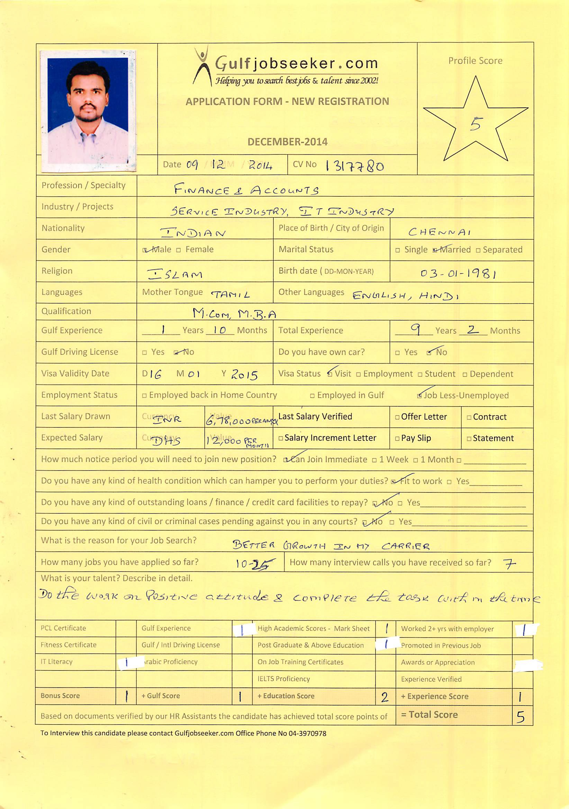

Objective

To attain a professional and challenging career in the field of Finance & Accounts., so that I can transform my skills into real-time industrial practice. Capable of working / handling team with people at all levels as well as working independently.

Profile:

- 9+ years of experience in Finance & Accounting.

- Knowledge of Accounting principles, practices & procedures involving General Ledger, Accounts Payable, Accounts Receivable, Payroll, Income Auditing, Reporting and Reconciliation of Accounts.

- Highly proficient in using SAP, Oracle, Fidelio, Tally & MS Office Applications.

- Good communication and interpersonal skills

- Ability to work efficiently under pressure, meet deadlines; adapt to a fast paced and multicultural environment.

- Having Overseas Experience in U.A.E, Saudi Arabia

- Successful Onsite Transition of General Accounting process from UK, Norway

& Remote transitions from US & Asian Region’s.

Last Work Experience:

Mar’ 2013 till Date 10th Oct 2014.

Worked as a Financial Analyst

Previously worked with the Organization’s

Sr. Executive –Accounts
Executive - Accounts
Financial Associate
Senior Process Associate (Accounts)
Income Auditor

Roles and Responsibilities in Finance and Accounts

General Ledger:

- Preparing Journal entries and posting as per client’s specifications.

- Review of adequacy of accruals made for payables and other charges

- Performing all regular, month-end and year-end activities (monthly journals, cross charges reporting etc.).

- Balance Sheet account Reconciliations and clearing of open-items.

- Doing Variance Analysis for Accounts schedule by client.

- Reviewing the reconciliation prepared by team members.

- Ensuring that performance service metrics are met and in time

- Preparing dash board report for various activities and sent to client.

- Responding to queries, resolving issues in the daily business activities

- Seeking advice and escalating issues which are beyond scope of work.

- Regular updating of Desktop Procedures if there are any changes.

- Co-operation with manager & process champions to improve processes & deliver higher quality service.

Accounts Payable:

- Receive and verify invoices and requisitions for goods and services & Collection of IR ,PO and for making the payment

- Processing Payments for all the Suppliers and Preparing LC Documents for submission in the bank.

- Posting Journal entries for Bank charges, LC Charges other charges related to the bank.

- Prepare manual cheques as and when required and preparing the ageing report.

- Preparing Bank Reconciliation Statement on a monthly basis and posting the reconciling entries.

- Handling queries of Suppliers and Customers on a daily basis

- Reconciling the Supplier statement and the Customer statements

- Processing Payroll for all the employees on a monthly basis.

Accounts Receivable & Income Auditing:

➢ Verify the night audit report with Fidelio and make final revenue report for the Management.
- Check the outlet checks and officers' checks with F & B sales summery.

- Check the paid outs, miscellaneous, discount vouchers and apartment control sheets with Fidelio.

- Keep the records in proper order for financial controller and external auditor’s verification.

- Updating the register where previous days’s cheques will be entered & preparing the bank challans

- Handling the Account Receivable and verify the Account Receivable Vouchers and Previous day’s bill to be checked for the availability of billing letter from the company, Travel agent Voucher, supporting food bills, and the amount of the bill.

- Check the Credit Report & the Credit Invoicing

- Sending reminders to parties & collect the payment on time.

- Making receipts for the payment received from the parties.

- Reconciles accounts with customers to resolve any disputes or discrepancies.

- Preparing month end inventory for the main store & other outlets & preparing the valuation reports.

- Checking all staff time cards and making the payrolls with the pay slips.

- Preparing Daily Cashier Summary Report and submit to the Management.

- Preparing Incentive’s for Front Office Receptionist’s and preparing Sales Commission for the Sales Executive’s.

- Handling Petty Cash Expense of the Hotel & Preparing Petty Cash Summary Report and submit to the Management.

- Checking the Laundry Bills & Laundry Statement and preparing Guest Laundry Report.

Intercompany Receivables and Payables:

- In-charge of Inter-company for Nordics region.

- Preparing Intercompany Charges Allocation for various region and raising invoice’s to the client and follow-up with various Inter-companies for resolution of inter-company differences/issues.
- Handling Inter-company reconciliations

- Responding to queries, resolving issues in the daily business activities.

- Seeking advice and escalating issues which are beyond scope of work.

Reporting:

- Reporting as per the schedules of the Client (Line of Business and Essbase Reporting).

- Managing and updating GL Master Data and Hierarchy Data’s.

- Preparing the Reports which pertains to Business Requirement.

- Preparation of SLA Matrix reports for various activities.

Educational Details

- Master of Commerce

- Master of Business Administration

IT and Other Skills

- SAP, Oracle, Fidelio,Tally

- Proficient in working with MS Office Applications

- Excellent financial, interpersonal, analytical and organizational skills

- Typewriting - English Higher Grade

Personal Details
➢ Nationality | : | Indian
➢ Sex | : | Male
➢ Date of Birth | : 03-01-1981
➢ Marital Status | : | Married
➢ Languages known | : English, Tamil & Hindi

