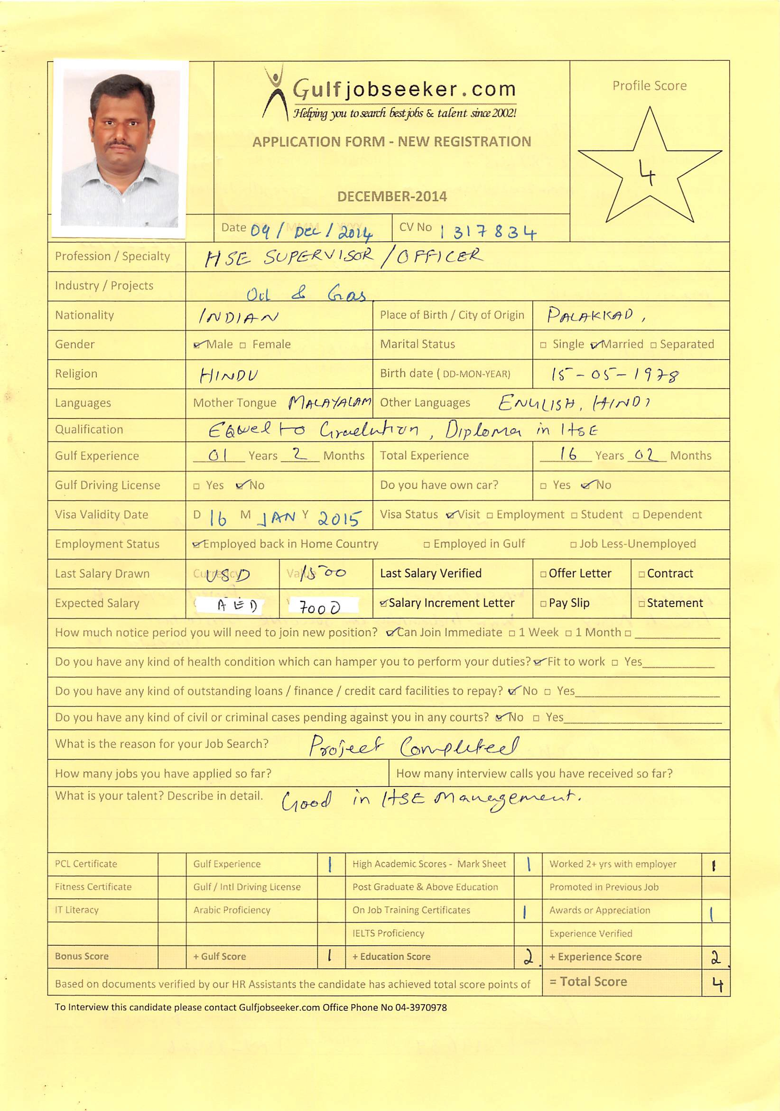

**RESUME**



# Objective

Looking for a challenging position as a HSE Supervisor/ Officer in which my skills in safety management and training experience will be used to exceed organizational program goals and to help people.

***Career Summary***

Over 16years experience in heavy construction and engineering and which have been in the field of Health, Safety & Environment. Has strong supervisory and management skills, complemented by an extensive experience from various internationally recognized organisations.

Job experience has been in high-risk environments such as drilling and well servicing structures, onshore & offshore construction, installation of fixed and floating offshore oil & gas energy related Jackets, Topsides, Spar hulls, Oil Platforms, Flash Gas Compression Barges and Civil constructions. Provides training in advanced safety concepts. Well up to date on international standards and have continually upgraded qualifications and trainings throughout the career.

## PROFESSIONAL EXPERIENCE

**DESIGNATION: HSE Supervisor**

**DURATION: 04/09/2013 TO 13/10/2014**

* **Developing and Administering the company Safety Program**,

1. Designing a complete program

ii) Stimulating and coordinating the work of others.

iii) Taking the lead in setting up safety regulations

* **Risk Assessor**

Trainee for employees on risk assessment techniques, assessments on new machinery, manual handling, procedures and various systems of work and conducting assessment compliance with COSHH, HSE, ACOP and company safety guidelines.

* **Lead Auditor** for internal and external audits carried within the company.
* Responsible for acquisition and maintaining certification.
* **Auditing and review of HSE procedures , policies and Project plan**

Responsible for periodical review of company procedures and policies, conduct audits internal and external (Sub contractors and suppliers)

* **Manual handling instructor and assessor**

In-house training and assessment of manual handling techniques

* **COSHH instructor and assessor**

Compile full COSHH assessment on all hazardous substances held and used in company.

* **Chairperson for health and safety committee**

Chair quarterly HSES meeting with management and safety representative.

* **Deliver HSE presentations**

To compile presentations for senior management and prospective clients.

* **Accident Investigation**

Conducting a comprehensive investigation to determine the causes of an accident, Make appropriate, meaningful recommendation for the corrective action for every possible cause, complete an accurate and useful accident investigation report. Make recommendations about improving the company’s health, safety and environmental approach.

* **Handling Emergencies**
* **Performing a Job Hazard Analysis (JHA)**

Breaking a job down into its basic steps, Selecting an appropriate JHA teams, identifying the existing and potential hazards associated with each job step, Developing recommendations to eliminate or control existing and potential hazards, Use the information from a JHA to improve their health and safety management approach.

* **Emergency Respond Team Leader**

Acting as an emergency respond team leader to tackle emergency situation in our yard and conducting regular mock drill to keep always emergency team in alert position.

* **Reviewing of Procedure and Policy**

Review company policy and procedure regularly, when audit find procedure failed and as per client requirements.

* **Portable Appliance Tester**

Testing all portable electrical appliances in Yard and sites operation for electrical safety

* **Fire risk assessor**

Trainer for employee on fire fighting and emergence escape techniques and conducting regular fire risk assessments in the workplace.

* **Implementing and assessor LOLER**

Lead set up in LOLER implementation in heavy lifting of up to 1500 Tons and monitoring the process through out.

* **Identification and assessment of hazards by HAZID**

Carry out a straightforward HAZAN activity, Prepare for HAZOP team membership.

* + Preparing report for various members of management on current safety experience of the company and justifying safety measures
  + Analyzing records for clues to prevention of future injuries and illness
  + **Inspection of Hazardous Condition**

Organizing an inspection program that helps keep employees focused on health, safety and environmental protection, preparing a check list for specific hazard categories, Inspection to locate unsafe condition and unsafe practices, conduct and verify thorough inspection of the work area.

* **Organizing Safety Meetings**

Planning safety meeting that help achieve health and safety management goals, Prepare agenda to keep safety meeting focused on what they need to accomplish, Use meeting to provide effective employee training, Conduct safety meeting that promote active employee involvement in the company’s health and safety program.

* **Environmental management System and Auditing**

Initiate establishment of sound environmental policy. Identify and recommend remedial measures to control actual and potential environmental effects. Design an impact-monitoring scheme. Conduct a strategic environmental assessment.

1. **ORGANIZATION: Indian Navy**

**DESIGNATION: Safety Officer/ Mechanical Supervisor**

**DURATION: 23/01/1998 TO 31/01/2013**

Job Responsibilities

* **Risk Assessor**

Trainee for employees on risk assessment techniques, assessments on new machinery, manual handling, procedures and various systems of work and conducting assessment compliance with COSHH, HSE, ACOP and company safety guidelines.

* Responsible for acquisition and maintaining ISO 18001 and 14001 certification.
* **Auditing and review of HSE procedures , policies and Project plan**

Responsible for periodical review of company procedures and policies, conduct audits internal and external (Sub contractors and suppliers)

* **Manual handling instructor and assessor**

In-house training and assessment of manual handling techniques.

* **Deliver HSE presentations**

To compile presentations for senior management and prospective clients.

* **Accident Investigation**

Conducting a comprehensive investigation to determine the causes of an accident, Make appropriate, meaningful recommendation for the corrective action for every possible cause, complete an accurate and useful accident investigation report. Make recommendations about improving the company’s health, safety and environmental approach.

* **Handling Emergencies**

Implementing an emergency plan , identify relevant and important criteria for decision making under stress for a mass of data, respond flexibly to feedback for the incident, organizing and manage liaison between different emergency resources both internal and external, handling incidents ,which are a threat to life or property.

* Management of 20 safety officers, 25 departmental fire watches/job watches and provide them with sufficient information and training to enable them to fulfil their roles.
* **Emergency Respond Team Leader**

Acting as an emergency respond team leader to tackle emergency situation in our yard and conducting regular mock drill to keep always emergency team in alert position.

* **Reviewing of Procedure and Policy**

Review company policy and procedure regularly, when audit find procedure failed and as per client requirements.

* **Portable Appliance Tester**

Testing all portable electrical appliances in Yard and sites operation for electrical safety

* **Fire risk assessor**

Trainer for employee on fire fighting and emergence escape techniques and conducting regular fire risk assessments in the workplace.

* **Identification and assessment of hazards by HAZID**

Carry out a straightforward HAZAN activity, Prepare for HAZOP team membership.

* + Preparing report for various members of management on current safety experience of the company and justifying safety measures
  + Analyzing records for clues to prevention of future injuries and illness
  + **Inspection of Hazardous Condition**

Organizing an inspection program that helps keep employees focused on health, safety and environmental protection, preparing a check list for specific hazard categories, Inspection to locate unsafe condition and unsafe practices, conduct and verify thorough inspection of the work area.

* **Organizing Safety Meetings**

Planning safety meeting that help achieve health and safety management goals, Prepare agenda to keep safety meeting focused on what they need to accomplish, Use meeting to provide effective employee training, Conduct safety meeting that promote active employee involvement in the company’s health and safety program.

* **Environmental management System and Auditing**

Initiate establishment of sound environmental policy. Identify and recommend remedial measures to control actual and potential environmental effects. Design an impact-monitoring scheme. Conduct a strategic environmental assessment.

* **Project Load outs**

In charge of conducting JSA’s of load outs of modules , Production Platforms, FPSO topside Modules, Buoys ,Turrets and organizing safe transportation and sea fastening.

* **Project Commissioning**

In charge of conducting JSA’s for Electrical / Solar Energisation, Nitrogen /Helium pressure test and monitoring the process.

#### ACADEMIC &PROFESSIONAL QualificationS:-

|  |  |
| --- | --- |
| Graduation | Ministry of Personnel ,Govt .of India. |
| Diploma in HSE Management & Fire Engineering | CISM Institute of HSE MGMT & Laws. |
| NEBOSH International General Certificate 3 | Dept. of Labour, UK |
| Behavioral Observation & Intervention Observer | Japan Gas Corperation, Barzan Onshore Project, Qatar. |
| Core Investigation Team (CIT) Training | JGC, Barzan Onshore Project, Qatar |
| Helicopter Underwater Escape Techniques | YAK Institute of Management PVT.LTD, Mumbai |
| H2S & Breathing Apparatus Training Course | Global Safety Development Association |
| STCW ’95 (Holding Indian CDC) | Univan Maritime Training Academy |
| Basic Safety &Fire fighting Course | Indian Navy, Lonavala. |
| Direct Entry Mechanical Engineering (dip) | Indian Navy, Lonavala |

#### ACHIEVEMENTS/PROFESSIONAL RECOGNITION:-

|  |
| --- |
| **Certificate of Appreciation from JGC, Barzan onshore Project, Qatar.**  **Certificate of Recognition for 100 Million Safe Manhours Without LTI.**  **Appreciation certificate from Nasser S. Al- Hajiri Co. Ltd.**  **Cash Award from the Flag Officer Commanding-in-Chief, Southern Naval Command, Kochi, Kerala.**  **Proficiency Award from the Commanding Officer, INS Bangaram,Port Blair, Andaman .** |

#### Personal Profile:-

Date of Birth : 15 May 1978.

Marital Status : Married.

Nationality : Indian.

Languages Known :English, Hindi, Malayalam& Tamil.

Notice Period : Immediate

#### DECLARATION:-

I hereby declare that the above furnished statements are true and correct to best of my knowledge and belief.