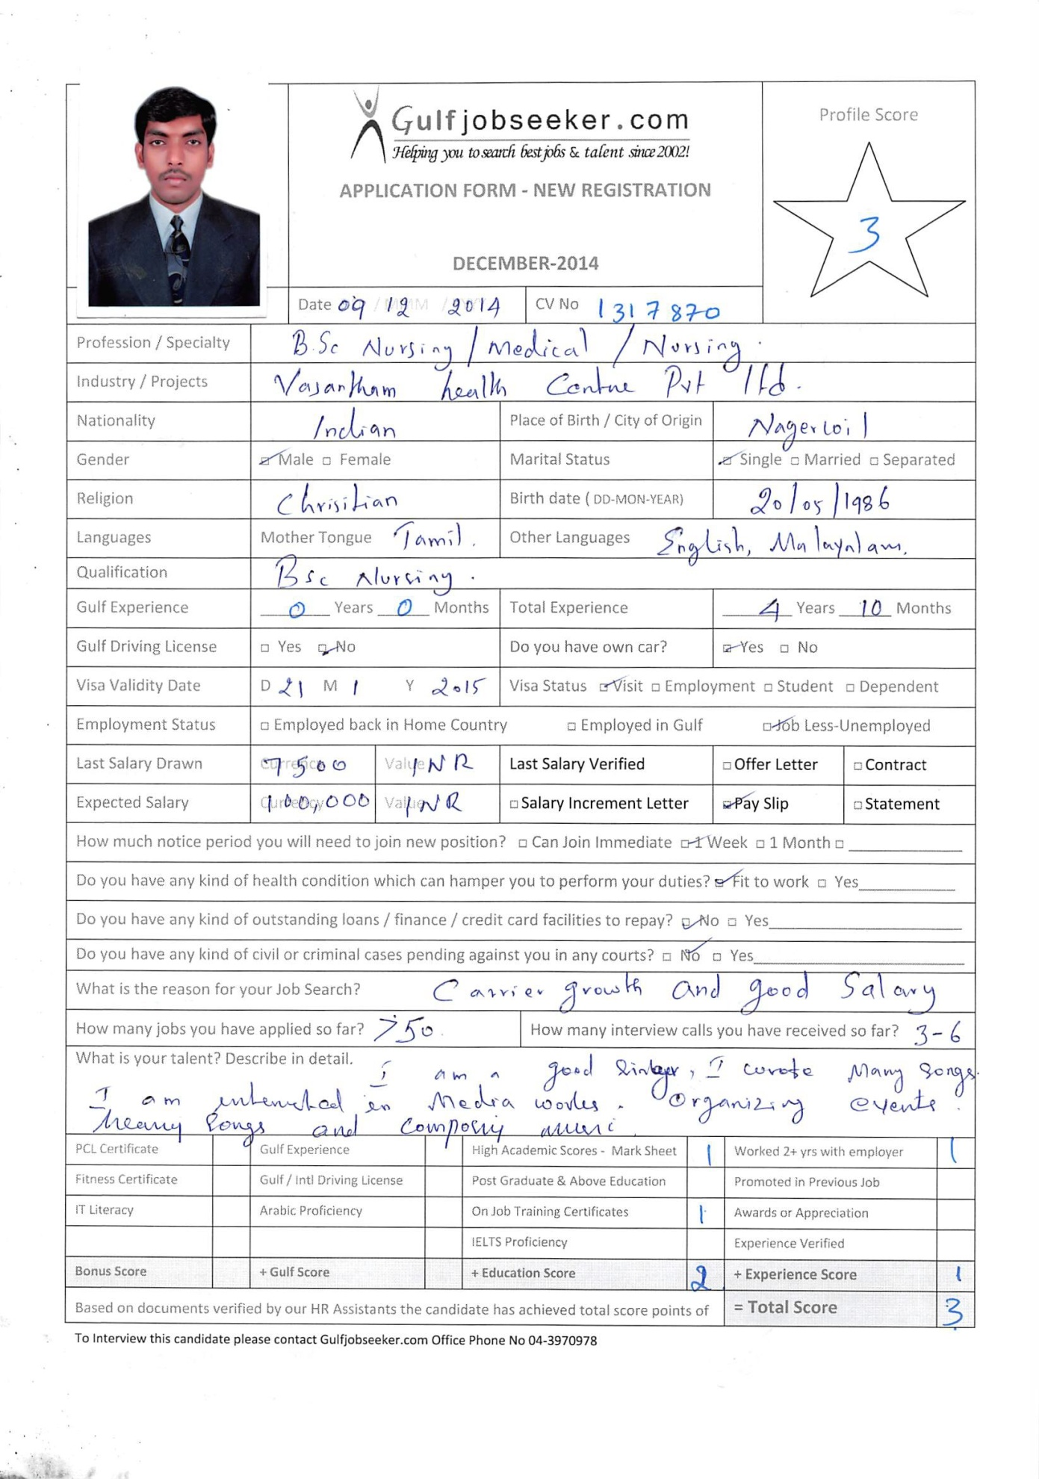
RESUME FOR THE POST OF REGISTERED NURSE.

OBJECTIVE:

To work as a dedicated nurse by providing good physical care and emotional support for the sick and the disabled.

PERSONAL PROFILE

Date of Birth | : | 20/05/1986
Sex | : | Male
Religion | : | Christianity
Marital status | : | Single
Nationality | : | Indian
Languages known | : Tamil &English (read ,write &speak)
 |  | Malayalam (speak only)
Qualification | : | B.SC,NURSING
UNIVERSITY | : Rajiv Gandhi University Of Health Science,Karnataka,India.
Experience | : | 4 years and 10 months

CLINICAL EXPERIENCE:

Period | Institute | Work
15-1-2009 TO | Vasantahm health centre (p) ltd,dennison road, | Worked as a
 |  | staff nurse in
21-06-2009 | nagercoil..(multi speciality hospital) | post operative
 |  | ward.
 |  | Working as a
17-07-2009 to |  | staff nurse in
 | Apollo Hospitals.( 1600 bedded hospitals, JCI | PAEDIATRIC
28-09-2012 |  | cardio
 | Accrediation), Greams road, Chennai.
( 3.3YEARS) |  | Thoracic ICU
 |  | (CTICU)
02-08-2013 to 25- | Chellam Hospital | Worked as a
07-2014 | (100 bedded),Kappukadu,kanyakumari District. | staff nurse in
 |  | Adult ICU

4-08-2014 to | . | Working as a
Till date |  | staff nurse in
 |  | post operative
 |  | ward.

STRENGTHS :

- Certified ACLS and BCLS provider by AHA.

- CERTIFIED FOR CARDIOTHORACIC NURSING COURSE .

- Very comfortable with basic computer operationsAdaptability to various situations

- Good team player

- Well planned and more organized

- Medical Camps

- ELGIBLE TO GET DUBAI HEALTH AUTHORITY LICENCE

ACADEMIC ATTAINMENTS:

EXAM | BOARD/ UNIVERSITY | NAME OF THE | YEAR
PASSED |  | INSTITUTE | OF
 |  |  | PASSING
S.S.L.C | Board of Public Examination | St.mary goretty | 2001
 |  | highersecondary
 |  | school,manalikar
 |  | ai.
H.S.C | Board of Public Examination | Govt.H.S.C | 2003
 |  | Thuckalay
Bachelor | Rajiv gandhi University of | Noorie college of | 2009
of | health | Nursing,K.G.F,
Nursing | science,Bangalore,karnataka | Kolar,
 |  | Karnataka.

REGISTRATION:

 |  | Registered in
 | Registration as a | karnataka Nurses | March 2009
 | nurse/midwife | and Midwife
 |  | Council
 | Registration as a | Registered in
 |  | Tamilnadu nursing | March2010
 | Nurse & Midwife
 |  | council
LICENCING DETAILS
 | Dubai Health |  | June 2014
 | Authority | Dubai

Skills:

- Ability to collect and analyze medical data or reports.

- Good interpersonal and communication skills.

- In depth knowledge of radiation safety.

- Profound ability to work with cardiothoracic surgeon.

- Exceptionally able to provide routine nursing care.

- Advance knowledge of latest medical trends.

- Great ability to provide appropriate information about cardiac treatment.

- Good capability to coordinator health care plans.

- Extremely professional with helping and caring nature.

- Outstanding capability to effectively operate medical equipments and machines.

- Fine organization and management skills.

- Possess strong capability to handle urgent situation.

- Ability to assess patient's medial status.

- Capable to create comfortable environment for patients and visitors.

- Exceptional problem solving ability.

- Well developed analytical and logical skills.

SPECIAL EQUIPMENTS USED:

- Pulse Oximeter

- Infusion Pumps

- Glucometer

- Laryngoscope

- Ambu Bag

- Suction Apparatus

- Pulmonoid

- Temporary pacemaker

- Cardiac profiler

- Flowtron

- Defibirilator

- External Cardiac Monitor

- Alpha Bed

- C PaP

- Ventilator

DECLARATION

I here by declare that above given information are true and correct to the best of my knowledge and belief.

