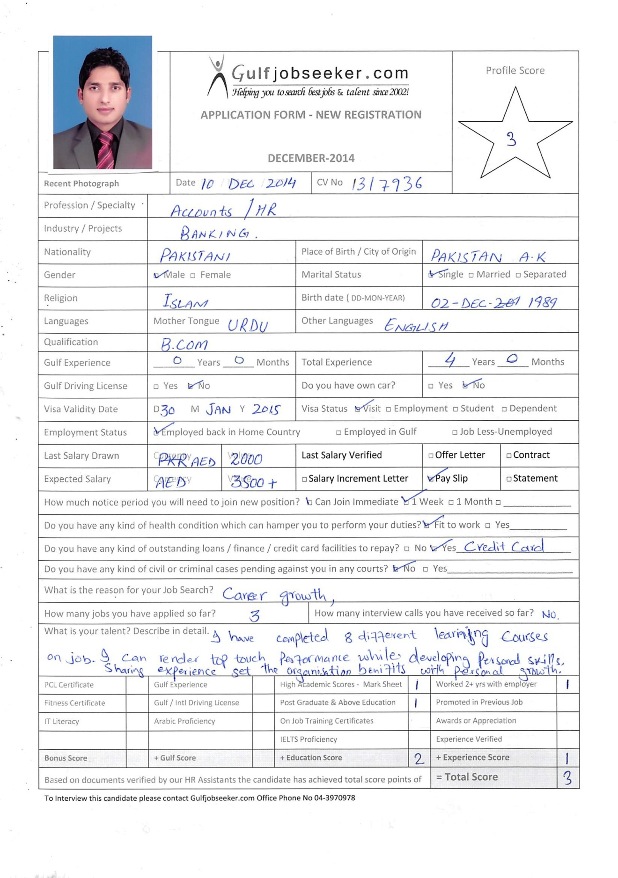



Visa status: Visit

Martial status: Single

***OBJECTIVE***

To find a challenging position to meet my competencies, capabilities, skills, education and experience, can contribute through my knowledge, effectiveness and efficiency of a growth-oriented organization.

To render top touch performance while developing personal skills, sharing experience get the organization benefits with personal growth.

***PERSONAL PROFILE***

A confident, versatile, smart, energetic and dedicated young man with excellent more than **4** **years banking sector experience**, with leadership qualities and always ready to take up challenges with smiling face to turn the situation in organization favor and for personal exposure as well.

***COMPUTER SKILLS***

Currently working as Universal Teller, from 21 Dec 2013 to date.

**KEY RESPONSIBILITIES:**

* Accounts and Administration.
* Cash & transactional banking, which is core responsibly up to the customers satisfactions.
* Staff management.
* Time management.
* Internal and external reporting including SBP Returns and NRA Reporting.
* Cash management as per SBP regulations.
* Inward/outward (local and foreign) remittances.
* Clearing processing, transactional Banking & Remittances.
* Issuance of PO, DD.
* GL balancing and reconciliation.
* Financial Accounting system balancing.
* Managing cash as per branch’s requirement and in line with limit.
* ATM Operations.

**E-Learning:**

Under SCB learning environment I have successfully completed 9 different E-Learning courses including

01: Anti-Money Laundering Policy,

02: Operations Risk Management.

03: Islamic Banking knowledge.

Worked in as officer grade III, from 23 Feb 2012 to 20 Dec 2013.

Also worked Limited, as Officer since 17th Nov. 2010 to 22 Feb 2012.Worked in operations i.e. Cash for 6 months, Clearing, Account opening, SBP Reporting and customer Services.

***PERSONAL DETAIL***

1.

Date of Birth: December 02, 1989.

***QUALIFICATION***

2. B.Com. Graduation: Year: 2010 Division: Ist, AJK University Muzaffarabad.

Fsc. HSSC: Year: 2008 Division: 2nd, BISE Mirpur Azad Kashmir.

Metric. SSC: Year: 2006 Division: Ist, BISE Mirpur Azad Kashmir.

MS Office: (MS Word, MS Excel, MS Access, MS PowerPoint)

***REFERENCES***

***REFERENCES***

Personal references will be gladly furnished upon demand.