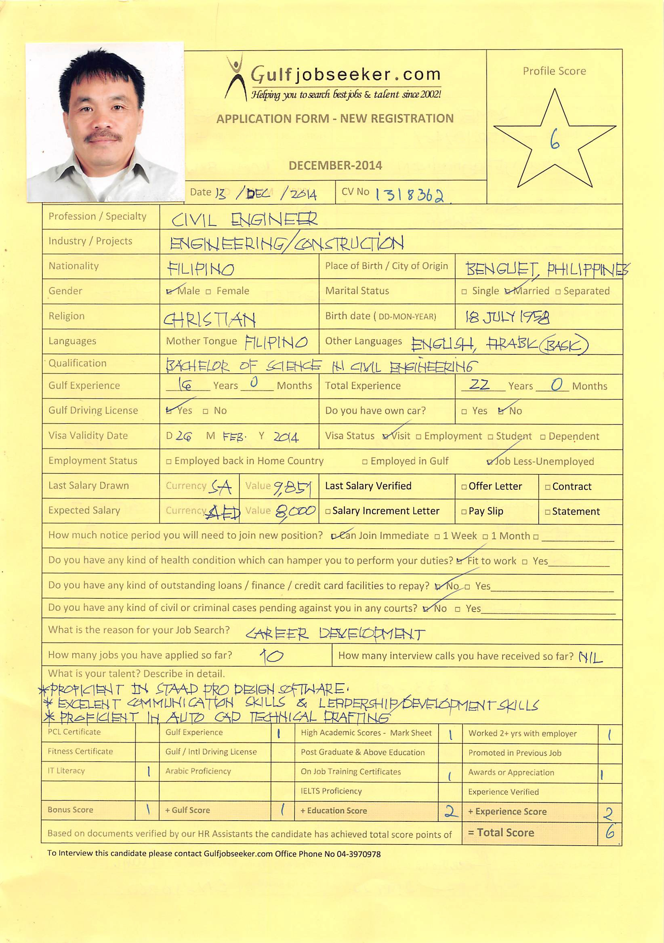

22 years experienced Civil engineer accustomed in meeting deadlines of project schedules with quality standards, Experienced in engineering practices for oil & gas industry, Acquired good knowledge in AUTO CAD & STAAD PRO. 15 years involved in infrastructure projects. A Civil engineer. Proficient in managing erection of precast concrete structures
EXPERIENCE
CIVIL ENGINEER- (2011-2013)
▪ Assigned as constituent of project management team to oversee the proper implementation of Natural Gas Liquid refinery project in Shaybah, Saudi Arabia
▪ Requested meetings with contractors twice in a month to discuss issues of work progress & advance schedules that resolved delays in work activities, Inspected contractor’s jobsite activities resulting in work that is compliant to contract requirements and project execution plan, resolved issues & coordinated activities among contractors or involved parties which allowed construction to progress according to schedules, Provided guidance, advice & clarification to contractor resulting in timely completion of construction activities.
▪ Received safety certificate of appreciation in preventing near miss situation that might have caused fire at night shift work, prevented unsafe acts on job site which contributed safe working environment and minimal damage to company properties
▪ Assisted QC personnel in inspections resulting in quality standard accomplishments, reviewed contractor’s drawings, method of statements, design calculations that ascertained compliance with ARAMCO standards. Utilized computer to communicate project status information to Saudi ARAMCO executive management

ENG’G. CONSULTANT-, UAE (2010-2011)
▪ Inspected jobsite frequently to observe that concrete is properly placed, cured & test for quality assurance are made resulting in a quality residential villas for proponents of Sheikh Zayed housing project, Conducted site inspection on structural re-bars, form works, scaffolding stability, electrical, air conditioning works that ascertained compliance of design with all applicable standards/regulation
▪ Reviewed drawings & contract documents that contributed to minimal errors prior to start of construction, Liaised with engineering office of Sharjah municipality concerning submittal of documents, inspections and approval of drawings that lead to early start of activities.
▪ resolved issues between clients & contractors during construction stage, provided clients with engineering guidance that enhanced trust in company-client relationship

ERECTION ENGINEER- United Precast Concrete, Qatar (2006-2008)
▪ Ascertained site preparedness prior to erection of precast elements by conducting site visits to evaluate job site situation
▪ Coordinated fabrication of precast elements for the following projects:
[A] Barwa city phase I, Doha, Qatar
[b] 150 villa housing project, Mesaieed, Qatar
[c] Quarantine buildings. Abu Samra, Qatar
[d] 2-Carpark buildings at west bay area. Doha, Qatar.
resulting in early preparation of materials, constantly communicated with transport department which contributed to the timely delivery of precast elements to job site
▪ Organized erection of precast structures, Prepared construction schedule, manpower & material requirements for each particular project. Ensured that materials on site have been approved by consultant based on contract specifications
▪ Wrote down important concerns during meetings with proponent & giving priority consideration that resolved issues in construction progress

CIVIL ENGINEER-Dubai Connection Group, UAE (2005-2006)
▪ Passed Dubai municipality examination for demolition engineers resulting in additional demolition projects that increased company revenues to 12%, Enforced safety procedures during demolition of commercial/residential buildings attaining safety work environment at job site
▪ Prepared estimates & program of works for bidding of projects, Inspected frequently ongoing construction of residential villas that ascertained compliance to quality standards and applicable regulations
▪ Liaised with Dubai municipality for approval of designs, drawings, permits, clearances & other important documents prior to start of construction, Received commendation from company manager for obtaining occupancy documents of newly constructed villas from Dubai municipality

SITE ENGINEER-Ministry of Agriculture & Waters, Hofuf, KSA (1998-2004)
▪ Completed 3-water pipeline projects originating from sewage treatment plant and terminating to elevated reservoir that resolved the shortage of irrigation waters, organized construction of valve boxes/manholes that synchronized construction schedule with pipeline installation, coordinated with supply department for needed materials which contributed to timely delivery of construction materials to jobsite.
▪ Supervised excavation of trenches for pipelines to ensure grade lines & elevations of laid out pipe are compliant to drawings
▪ Prepared designs, drawings & material estimates of irrigation structures, pipelines that facilitated conveyance of water. Conducted regular maintenance activities on irrigation structures to ensure adequate supply of water

▪ Provide weekly report to immediate supervisor thus, communicating project status of work at jobsite to management.

SITE ENGINEER-Hatahal Al Otaibi Est. Saudi Arabia (1993-1997)
▪ Managed earthwork activities on well site development of Oil/Gas industry including construction of access road to well sites and petroleum pipelines, Facilitated excavation, back filling ,compaction of well pads & site preparation of RIG/drilling camps that resulted in early preparation of site prior to drilling operation. Planned daily schedules of heavy equipments, signed work permits required by ARAMCO operations prior to start of work and enforcing safety precautions written thereon
▪ Supervised "work over” job activities when drilling operation has been completed
▪ Conducted site inspection on reinforcing bars, form works, embedded items, painting & water proofing for industrial support buildings of LUBE-REF II project at YANBU, Saudi Arabia which attained quality standards.
▪ Relied on drawings & specifications in implementing construction of heavy structural members, pipe racks & industrial furnace which ascertained compliance of design with all applicable regulations.

CIVIL ENGINEER- None-Government Organization, Philippines (1991-1993)
▪ Prepared feasibility studies for rural development projects, providing designs, cost estimates, drawings for rural water work utilities which improved the water supply of rural areas, conducted preliminary surveys gathering necessary information as basis for design of water reservoirs and piping system
▪ Supervised installation of piping for water works system
▪ Conducted seminars on project proponents that enhanced community cooperation & involvement in project execution

PLANNING ENGINEER-DPWH, Baguio city Philippines (1987-1990)
▪ Utilized PERT/CPM method in scheduling work activities for the construction of school buildings, national roads, rural health clinics, flood control that contributed to minimal time execution of project & minimal budget
▪ Prepared drawings, cost estimates & support documents prior to public bidding of infra-structure
projects.
▪ Conducted site visits which ascertained construction activities adhere to drawings & specifications.
SKILLS
Auto CAD 3D technical drafting, STAAD PRO design software, Ms Office. Excellent communication skills, Fast learner, Leadership & development skills, Holder of GCC driving licenses

EDUCATION
UNIVERSITY OF THE CORDILLERAS (formerly Baguio Colleges Foundation)- (1977-1985), BAGUIO CITY, PHILIPPINES
BS Civil Engineering

GMS TECHNOLOGY- (November-December 2013), BAGUIO CITY, PHILIPPINES
Computer Science – NC II (Auto CAD & STAAD PRO)
LICENSE
CERTIFIED CIVIL ENGINEER- (Mar.2010) SHARJAH, UAE
License no. 5597

PROFESSIONAL REGULATION COMMISSION – (Apr.30, 1987) PHILIPPINES
License no. 0049153

CERTIFIED CIVIL ENGINEER- (Apr.2005) DUBAI, UAE
License on file

SOCIETY OF ENGINEERS-(Feb.2010
TRAINING
DOHA INDUSTRIAL SERVICES- (November 2007) QATAR
Medic First aid & Safety training

